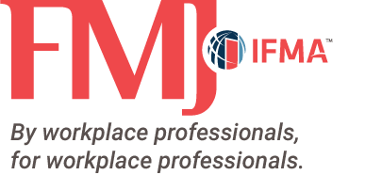
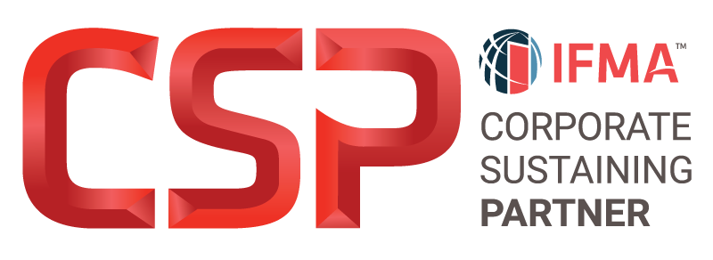

Behind the Brand
Silver-level and higher Corporate Sustaining Partners (CSPs) have the exclusive opportunity to be featured in a CSP Behind the Brand spotlight article in IFMA’s FMJ magazine, showcasing information about their companies. Great Behind the Brand features tell the story – who you are and why FMs should trust your organization and what sets you apart from your competition. Silver level or higher partners are eligible to showcase their brand to readers of the FMJ. Silver CSPs receive a half-page feature, while Gold and Platinum CSPs receive a full page.
Below you will find questions you may answer or use as thought-starters. Please answer at least three questions and your brand will be selected for an upcoming issue of FMJ by the editorial team. We encourage you to include details that may not be common knowledge or shared in typical marketing materials. We’ll work with you to determine the best issue based on editorial themes and available space.
Remember, please respond to at least three questions (responses to all questions are welcomed). Suggested word count for each question’s response is 150-200 words.
- How is your company responding to the ever-changing needs of the FM world?
- What research or product innovations is your company working on that will help facility managers be more successful in their roles?
- How is your company/product changing/improving the FM industry?
- Tell us your “why” in the FM world.
- What’s on the horizon in your field/industry, and how is your company meeting those challenges and opportunities?
- Tell us about your corporate social responsibility and environmental, social and governance efforts or projects. How have these contributed to the community?
- Why should FMs pick you as a partner?
- Create your own question (optional). What question(s) specific to your company is not included above? Please submit both the question(s) and answer(s).

SPECIFICATIONS:
- Word count: responses per question should be limited to 150-200 words (see Editorial Policy below)
  - Silver – approximately 300 words total
  - Gold & Platinum – approximately 600 words total
- High-resolution company logo (minimum 300 dpi)
- Product/service category
- Preferred web address to list with the profile
- Materials deadline: Content is due within two months of the partnership term.
- IFMA reserves the right to edit content as needed.
- Submit your completed questions online: https://airtable.com/shrfle2KrdghW8Rlz

Editorial Policy
IFMA’s FMJ editor reserves the right to edit any submissions and make corrections, omit material, or minor reorganization as required to achieve a reasonably consistent look and feel, to any submitted work. If the revisions required are major, the editor will request the answer to be rewritten according to some suggested guidelines.
The editor also reserves the right to select from the questions/answers submitted. Please note there may not be room for all questions/answers to be included in the article. This does not reflect badly on the quality of the submitted material but rather on the amount of space available and the theme of the FMJ issue.

