Vaccine messages for parents of vaccine-eligible children

Recommendation for everyone 12 years and older
Although fewer children have been infected with COVID-19 compared to adults, children can:
- Be infected with the virus that causes COVID-19
- Get sick from COVID-19
- Spread COVID-19 to others
CDC recommends everyone 12 years and older should get a COVID-19 vaccination to help protect against COVID-19. Widespread vaccination is a critical tool to help stop the pandemic. People who are fully vaccinated can resume activities that they did prior to the pandemic. Learn more about what you and your child or teen can do when you have been fully vaccinated. Children 12 years and older are able to get the Pfizer-BioNTech COVID-19 Vaccine.
Source: https://www.cdc.gov/coronavirus/2019-ncov/vaccines/recommendations/adolescents.html

Help Protect your child and your family
Getting a COVID-19 vaccination can help protect your child from getting COVID-19. Early information shows that the vaccines may help keep people from spreading COVID-19 to others. They can also help keep your child from getting seriously sick even if they do get COVID-19. Help protect your whole family by getting yourself and your children 12 years and older vaccinated against COVID-19.
Source: https://www.cdc.gov/coronavirus/2019-ncov/vaccines/recommendations/adolescents.html

get a covid-19 vaccine for your child as soon as you can
- COVID-19 vaccines are safe and effective.
- COVID-19 vaccines have been used under the most intensive safety monitoring in U.S. history, which includes studies in adolescents.
- Your child will need a second shot of the Pfizer-BioNTech COVID-19 Vaccine 3 weeks after their first shot.
- Your child can’t get COVID-19 from any COVID-19 vaccine, including the Pfizer-BioNTech vaccine.
- Your child may get a COVID-19 vaccine and other vaccines at the same visit or without waiting 14 days between vaccines
Source: https://www.cdc.gov/coronavirus/2019-ncov/vaccines/recommendations/adolescents.html

Prepare for your child’s vaccination visit
- Get tips for how to support your child before, during, and after the visit.
- Talk to your child before the visit about what to expect.
- Tell the doctor or nurse about any allergies your child may have.
- Comfort your child during the appointment.
- To prevent fainting and injuries related to fainting, your child should be seated or lying down during vaccination and for 15 minutes after the vaccine is given.
- After your child’s COVID-19 vaccination, you will be asked to stay for 15–30 minutes so your child can be observed in case they have a severe allergic reaction and need immediate treatment.
Source: https://www.cdc.gov/coronavirus/2019-ncov/vaccines/recommendations/adolescents.html

Q&A: Is it safe for my child to get a covid-19 vaccine?
Yes. Studies show that COVID-19 vaccines are safe and effective. Like adults, children may have some side effects after COVID-19 vaccination. These side effects may affect their ability to do daily activities, but they should go away in a few days. Children 12 years and older are now eligible to get vaccinated against COVID-19. COVID-19 vaccines have been used under the most intensive safety monitoring in U.S. history, including studies in children 12 years and older. Your child cannot get COVID-19 from any COVID-19 vaccine.
Source: https://www.cdc.gov/coronavirus/2019-ncov/vaccines/faq.html#child-safe

Q&A: why should my child get vaccinated against covid-19?
COVID-19 vaccination can help protect your child from getting COVID-19. Although fewer children have been sick with COVID-19 compared to adults, children can be infected with the virus that causes COVID-19, can get sick from COVID-19, and can spread the virus that causes COVID-19 to others. Getting your child vaccinated helps to protect your child and your family. Vaccination is now recommended for everyone 12 years and older. Currently, the Pfizer-BioNTech COVID-19 Vaccine is the only one available to children 12 years and older.
Source: https://www.cdc.gov/coronavirus/2019-ncov/vaccines/faq.html#child-safe

Social Media Messages
The following messages have been cleared and used by CDC. You are welcome to share them, find them on the relevant CDC channel and re-share them, or put your own spin on them. Graphics can be found in an accompanying folder.
Channel | Message | Graphic
Messages for parents of adolescents (kids ages 12-17)
Twitter | #Parents: Everyone 12 years and older is now eligible for #COVID19 vaccination.  Help protect your family by planning to get everyone who’s eligible vaccinated against COVID-19 as soon as you can.  More: https://www.cdc.gov/coronavirus/2019-ncov/vaccines/recommendations/adolescents.html | 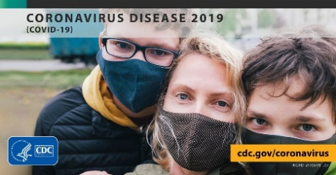
Instagram | Parents: Everyone 12 years and older is now eligible to get a #COVID19 vaccine.  Help protect your family and get everyone who’s eligible vaccinated against COVID-19 as soon as you can. Widespread vaccination is a critical tool to help stop the pandemic and get back to the things we love.  More: https://www.cdc.gov/coronavirus/2019-ncov/vaccines/recommendations/adolescents.html  #CDC #PublicHealth #Coronavirus | 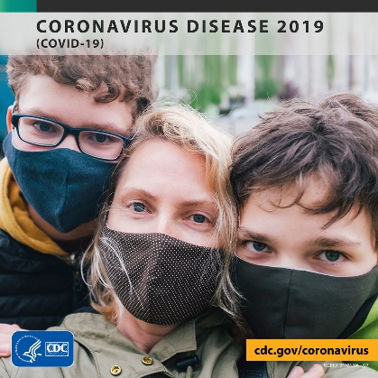
Facebook | Parents: Everyone 12 years and older is now eligible to get a COVID-19 vaccine.  Help protect your family and get everyone who’s eligible vaccinated against COVID-19 as soon as you can. Widespread vaccination is a critical tool to help stop the pandemic and get back to the things we love.  More: https://www.cdc.gov/coronavirus/2019-ncov/vaccines/recommendations/adolescents.html
#SleeveUp
Twitter | #Parents: Your children 12 years and older are eligible to get a #COVID19 vaccine.  Have your family #SleeveUp for their vaccine as soon as they can and join millions of others across the United States in helping stop the pandemic.  More: https://www.cdc.gov/coronavirus/2019-ncov/vaccines/recommendations/adolescents.html | 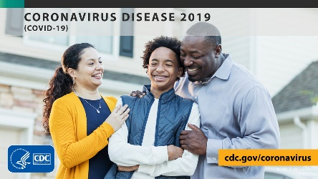
FB | Parents, your children 12 years and older are now eligible to get a COVID-19 vaccine.  Have your family SleeveUp for their vaccine as soon as they can and join millions of others across the United States in helping stop the pandemic.  More: https://www.cdc.gov/coronavirus/2019-ncov/vaccines/recommendations/adolescents.html | 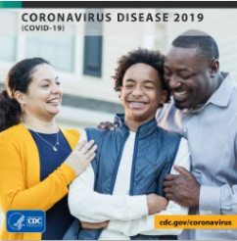
IG | Parents, your children 12 years and older are now eligible to get a #COVID19 vaccine.  Have your family #SleeveUp for their vaccine as soon as they can and join millions of others across the United States in helping stop the pandemic.  More: https://www.cdc.gov/coronavirus/2019-ncov/vaccines/recommendations/adolescents.html  #CDC #PublicHealth #Coronavirus
Missed Moments
Twitter | #Parents: Now that your children 12 years and older are eligible for a #COVID19 vaccine, you’re one step closer to enjoying moments you miss, like visits with grandparents! Get your family vaccinated as soon as you can.  More: https://www.cdc.gov/coronavirus/2019-ncov/vaccines/recommendations/adolescents.html | 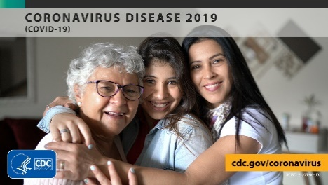
FB | Parents: Now that your children 12 years and older are eligible for a COVID-19 vaccine, you’re one step closer to doing many things you had stopped doing because of the pandemic.  Get your whole family vaccinated, so you can start enjoying moments you miss, like visits with grandparents!  More: https://www.cdc.gov/coronavirus/2019-ncov/vaccines/recommendations/adolescents.html | 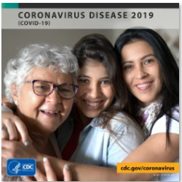
IG | Parents: Now that your children 12 years and older are eligible for a #COVID19 vaccine, you’re one step closer to doing many things you had stopped doing because of the pandemic.  Get your whole family vaccinated, so you can start enjoying moments you miss, like visits with grandparents!  More: https://www.cdc.gov/coronavirus/2019-ncov/vaccines/recommendations/adolescents.html  #CDC #PublicHealth #Coronavirus

