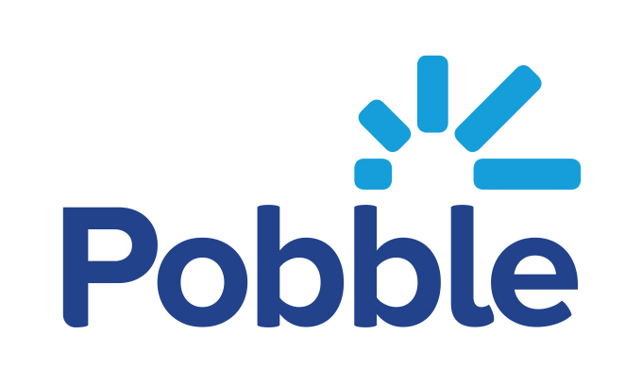

Your child is about to
become a published author!

Dear Parent / Carer,
Congratulations! We are delighted to tell you that your child’s writing has been chosen as one of our school entries for Pobble’s Mighty Write 2022 writing competition. To celebrate their achievements, we will be publishing their work with Pobble, an award winning writing platform. We will let you know once the final judging for the competition is completed.
If you have any questions or would prefer for your child not to be published, please contact your class teacher. You will be able to view their work at www.pobble.com.

Yours sincerely

