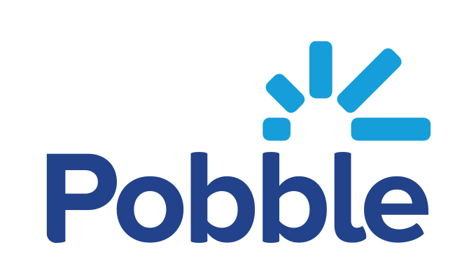

Your child is about to
become a published author

Dear Parent / Carer,
We are delighted to tell you that your child’s writing has been chosen to be one of our school entries for this year’s COBIS (Council of British International Schools) writing competition. To celebrate their achievements we would like to publish their work with Pobble, an award winning writing platform, who support the excellent work of COBIS.
For your child to be published, could you please:
- Review Terms of Use (pobble.com/terms-of-use) and our e-safety policy (help.pobble.com/knowledge/introduction-e-safety-at-pobble)
- Sign the below slip to give your permission, and hand it back to your child’s class teacher
If you have any questions, please contact your child’s class teacher. We will let you know when your child’s work is published.
Yours sincerely,

Please return to your class teacher
Child first name: Child surname: Age
School ________________________ Class _______________
Parent / carer name: Signed:
☐Yes, I want my child to be published on Pobble

