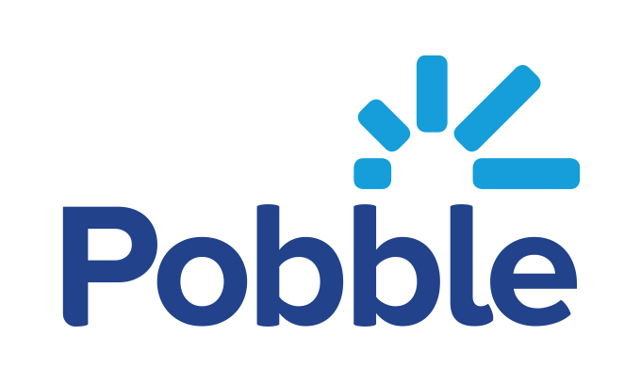

Your child is about to become a published author
Suggested parent permission letter – updated Feb 2021
Dear Parent / Guardian,
We are excited to be using Pobble in our school. Pobble is an award-winning approach to teaching writing, which is part-funded by the UK Department for Education’s EdTech Innovation Fund. Pobble is shown to improve pupils’ speed, confidence and enjoyment of writing, leading to improved attainment.
One unique feature of Pobble is the sharing of children’s writing on our own online school writing celebration page (“Publishing”). As well as providing an authentic audience for your child (a key factor in raising engagement and attainment in writing), publishing will allow you to view and comment on your child’s work. It is a lovely way to share your child’s work with their peers within the Pobble community and to celebrate your child’s achievements.
Since published work may be viewed by registered Pobble users outside our school community, we would like to ask your permission for us to include your child in publishing. If you’d like your child to participate, please do one of the follow:
- Inform your class teacher that you are happy for your child’s work to be published.
- Sign the below permission slip, photograph it, and return it to your class teacher.
- Sign up for a free Pobble account at https://my.pobble.com/, select the “parent” role and when prompted, input your unique parent code which will be distributed by your class teacher. By registering and linking your account, you will be emailed each time your child’s work is shared (around once a half term).

Please note, all work is published anonymously, so no personal details of your child will be shared online. By signing up and activating your Parent Account, you can remove your linked child’s published work from the public view at any time. Please read Pobble’s terms and conditions (https://my.pobble.com/legalintroduction) for more information.
If you have any questions, please do not hesitate to contact your class teacher. We are excited to be using Pobble in our school and look forward to your support and participation.
Yours sincerely,

Head teacher
 Please return to your class teacher
I want my child to participate in publishing on Pobble.
Child first name: Child surname: Class:
Parent / carer name: Signed:

