Coming Soon: New NECAnet.org Website
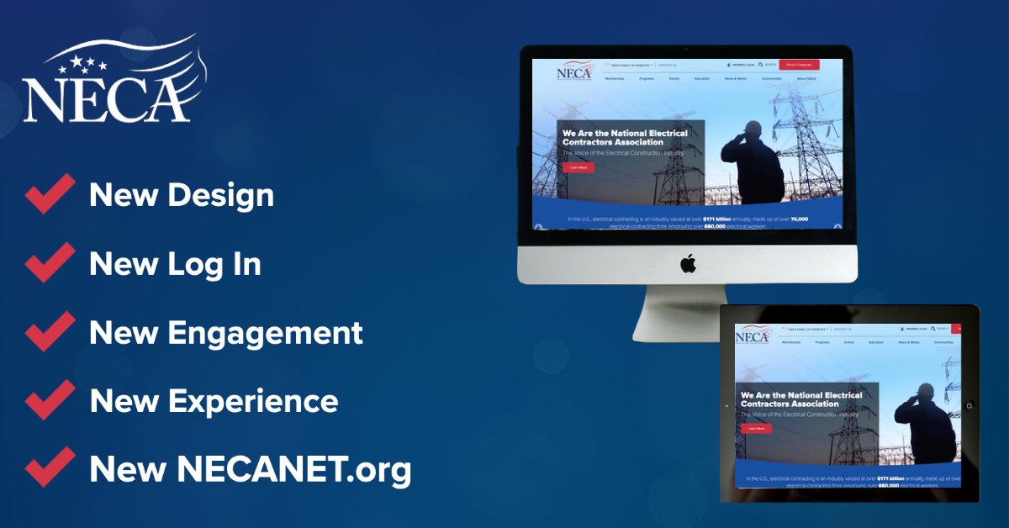

This fall, NECA will be launching a new experience on necanet.org. Beyond a redesign, this new website will provide users with brand-new ways to interact with NECA’s web resources.

What can I do to get ready?

Log in to your current NECA profile with your USER ID and password. Ensure that your profile’s email address is completely up to date—this will make the transition to the new login experience as seamless is possible. This email address will be your username for the new website.

This update is being conducted with security in mind, and will enable users to more easily use necanet.org.

