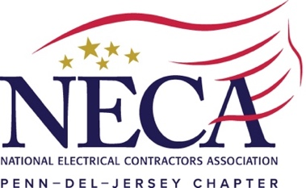

For Immediate Release Contact: Aaron Kelley
December 15, 2021 akelley@neca-pdj.org / 267-872-5890

Penn-Del-Jersey Chapter Hosts Diversity, Equity, and Inclusion Summit

KING OF PRUSSIA, PA – On Monday, December 13, 2021, the Penn-Del-Jersey Chapter, NECA hosted a Diversity, Equity, and Inclusion (DEI) Summit.

This event featured an “Inclusive Leadership” training session with Dr. Shannon Mason of Exude, Inc., a DEI consulting firm headquartered in Philadelphia.

During the highly interactive session, participating Contractor and Associate Members learned how to create more inclusive environments in their companies.

Following the session, NECA Vice President of Industry Development Ronald Bailey offered remarks on the intersection of DEI work and workforce development.

The Chapter also presented its 2021 Diversity, Equity, and Inclusion Award to Joseph Kaluhiokalani of Aloha Communications Contractors for his excellent DEI work in our industry.

Eastern Region Field Representative Jack Savage presented a letter from NECA CEO David Long congratulating Kaluhiokalani on his selection for this award.

The Penn-Del-Jersey Chapter thanks all Summit speakers and participants. It also congratulates the Members of its 2021 DEI Committee, listed below, for making the event a success:

- Joseph Kaluhiokalani - Aloha Communications Contractors, Inc.
- Christine Meyer and Neena Anderson - Battaglia Electric, Inc.
- Rob Wertz - Carr & Duff, Inc.
- Ken Copeland – Charles H. MacDonald Electric, Inc.
- Kathryn McCoy and Niquan Lee - Milwaukee Tool

For more information on the Penn-Del-Jersey Chapter, NECA Diversity, Equity, and Inclusion initiative, contact Aaron Kelley at akelley@neca-pdj.org.

[Event Photo Attached on Following Page]
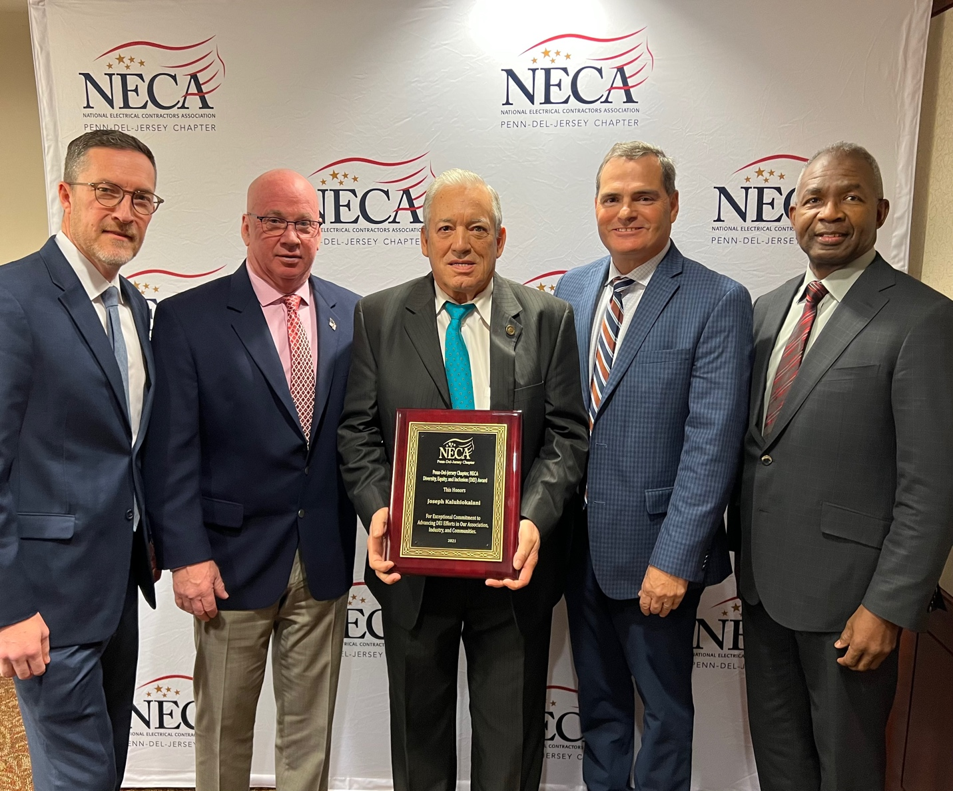
From Left: Jack Savage (Field Representative, NECA Eastern Region), Charles H. MacDonald III (President-Elect, Penn-Del-Jersey Chapter), Joseph Kaluhiokalani (CEO, Aloha Communications Contractors), Jeffrey P. Scarpello (Executive Director, Penn-Del-Jersey Chapter), and Ronald Bailey (Vice President of Industry Development, NECA) during an Award Ceremony at the Penn-Del-Jersey Chapter’s 2021 Diversity, Equity, and Inclusion Summit.

