## 

## What hardware is your organization using? This worksheet can help you inventory and anticipate technology issues that may arise and better prepare you to help solve them. Don’t let the number of items overwhelm you – start with what you know and work from there.

## Workstations

Workstations are the desktop and laptop computers that your staff use. The model number for desktop computers is typically on the front of the unit. Frustratingly, many laptops only list the model number on the bottom of the machine.

|  |  |
| --- | --- |
| C:\Users\Jay\Pictures\TechPyramid\desktop.jpg | C:\Users\Jay\Pictures\TechPyramid\laptop.jpg |

|  |  |  |  |
| --- | --- | --- | --- |
| **Type (desktop/laptop)** | **Brand (and model # if possible)** | **Age of machine (approximate)** | **How many do you have?** |
|  |  |  |  |
|  |  |  |  |
|  |  |  |  |
|  |  |  |  |
|  |  |  |  |
|  |  |  |  |

## Printers

By ***type***, we mean either personal printers (connected directly someone’s computer) or network printers, which are connected to your network with a gray or blue network cable.

|  |  |
| --- | --- |
| C:\Users\Jay\Pictures\TechPyramid\networkPrinter.jpg | C:\Users\Jay\Pictures\TechPyramid\printer.jpg |

|  |  |  |  |
| --- | --- | --- | --- |
| **Type (personal/network)** | **Brand (and model # if possible)** | **Age of printer (approximate)** | **How many do you have?** |
|  |  |  |  |
|  |  |  |  |
|  |  |  |  |
|  |  |  |  |

# Telephone Equipment

## Handsets

These are just the phones on our desks.

|  |  |
| --- | --- |
| C:\Users\Jay\Pictures\TechPyramid\phone.jpg | C:\Users\Jay\Pictures\TechPyramid\phones.jpg |

|  |  |  |
| --- | --- | --- |
| **Brand** | **Model # (if possible)** | **How many do you have?** |
|  |  |  |
|  |  |  |
|  |  |  |

## PBX

A private branch exchange, or PBX, controls access to external phone lines by your organization’s telephone handsets. A PBX is what allows a ten person organization to share less than ten phone lines effectively. If you have to dial 8 or 9 to get an outside line, then you have a PBX. PBXs are not always easy to spot, but here are a few examples:

|  |  |  |
| --- | --- | --- |
| C:\Users\Jay\Pictures\TechPyramid\PhoneSystem.jpg | C:\Users\Jay\Pictures\TechPyramid\pbx.jpg | C:\Users\Jay\Pictures\TechPyramid\pbx2.png |

|  |  |
| --- | --- |
| **Brand** | **Model # (if possible)** |
|  |  |

## Voicemail unit

Many PBXs have built in voicemail so you won’t necessarily have a separate voicemail unit. If you have one, it will be connect to your PBX, typically either by a telephone cable or a computer network cable.

|  |  |
| --- | --- |
| **Brand** | **Model # (if possible)** |
|  |  |

## Telephone gateway

If you use Vonage or some other phone system that uses the Internet for phone calls rather than copper phone lines, you’ll have a telephone gateway that should be inventoried. This gateway can be a computer, or simply a small box.

|  |  |  |
| --- | --- | --- |
| C:\Users\Jay\Pictures\TechPyramid\PhoneGateway1.jpg | C:\Users\Jay\Pictures\TechPyramid\PhoneGateway2.jpg | C:\Users\Jay\Pictures\TechPyramid\PhoneGateway3.jpg |

|  |  |
| --- | --- |
| **Brand** | **Model # (if possible)** |
|  |  |

# Back-end Equipment Computer Equipment

In addition to the workstations and printers you see and use daily, computer networks have components that do their work largely out of view. While unseen, they are critical to your organization. We list routers, wireless routers, firewalls, and switches individually, a single hardware unit might perform all or any combination of these roles for smaller organizations.

## Modem

You’ll have one of these if you get small business Internet service through a cable or telephone company. The modem lets your network access the Internet over lines meant to carry cable TV or telephone signals.

|  |  |  |
| --- | --- | --- |
|  |  | C:\Users\Jay\Pictures\TechPyramid\cableModem3.jpg |

|  |  |
| --- | --- |
| **Brand** | **Model # (if possible)** |
|  |  |

## Router

Routers are devices that determine how information gets from your network to destinations on other networks (including the Internet). Routers talk to other routers to do this. For example, every time you go to [www.google.com](http://www.google.com), your computer looks to your local router, which talks to your Internet service provider’s router, which then finds the best possible *route* from your network to the servers that house Google’s website. Routers are connected to modems.

|  |  |  |
| --- | --- | --- |
| C:\Users\Jay\Pictures\TechPyramid\linksysRouter2.jpg | C:\Users\Jay\Pictures\TechPyramid\netgearRouter1.jpg | C:\Users\Jay\Pictures\TechPyramid\CiscoRouter1.jpg |

|  |  |
| --- | --- |
| **Brand** | **Model # (if possible)** |
|  |  |

## Wireless Router

Wireless routers allow wireless devices—i.e., wireless-enabled computers, smartphones, printers, etc—access to your network. The wireless router may be the same device as the above router, or be connected to the switch.

|  |  |  |
| --- | --- | --- |
| C:\Users\Jay\Pictures\TechPyramid\linksysRouter2.jpg | C:\Users\Jay\Pictures\TechPyramid\netgearRouter1.jpg | C:\Users\Jay\Pictures\TechPyramid\dlinkSwitch.jpg |

|  |  |
| --- | --- |
| **Brand** | **Model # (if possible)** |
|  |  |

## Firewall

A firewall is what lets machines on your organization’s network access the Internet safely. At a minimum, firewalls hide your “trusted” organization network from the “untrusted” Internet. The more sophisticated the firewall, the more functionality it has make decisions about what incoming information is safe and what is potentially harmful. Physically speaking, the firewall is either in the same device or standing between your switch and the router and/or modem.

|  |  |  |
| --- | --- | --- |
| C:\Users\Jay\Pictures\TechPyramid\linksysRouter2.jpg | C:\Users\Jay\Pictures\TechPyramid\netgearRouter1.jpg | C:\Users\Jay\Pictures\TechPyramid\sonicwall.jpg |

|  |  |
| --- | --- |
| **Brand** | **Model # (if possible)** |
|  |  |

## Switch(s)

Switches tie together all of the devices on your network. Switches are easy to spot; they are the devices with four or more spaces (or ports) for computer network cables. The firewall and all workstations and network printers are connected to the switch via the ports.

|  |  |  |
| --- | --- | --- |
| C:\Users\Jay\Pictures\TechPyramid\linksysSwitch.jpg | C:\Users\Jay\Pictures\TechPyramid\CiscoSwitch.jpg | C:\Users\Jay\Pictures\TechPyramid\hpSwitch.jpg |

|  |  |  |
| --- | --- | --- |
| **Brand** | **Model # (if possible)** | **How Many Do You Have?** |
|  |  |  |
|  |  |  |
|  |  |  |

## Server(s)

Servers are computers on your networks that carry out specialized roles like allowing access to shared files, controlling jobs sent to printers, running particular applications, or many other functions. Servers are connected to the switch.

|  |  |
| --- | --- |
| C:\Users\Jay\Pictures\TechPyramid\server1.jpg | C:\Users\Jay\Pictures\TechPyramid\server2.jpg |

|  |  |  |  |
| --- | --- | --- | --- |
| **Brand** | **Model # (if possible)** | **Age (approximate)** | **How Many Do You Have?** |
|  |  |  |  |
|  |  |  |  |

# A Simple Network Diagram

# In the space provided for each component, jot down at least its brand. For your computers and printers, also add a count by brand.

What kind of internet connection?

Modemm

The Internet



Network Printers

Laptops

Router/Switch/Firewall

Desktops

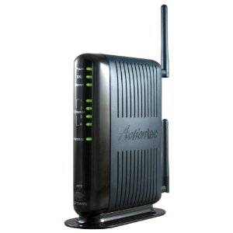

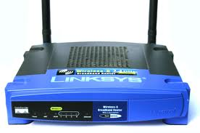

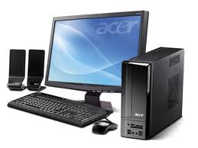

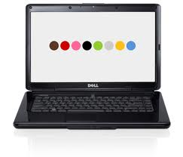

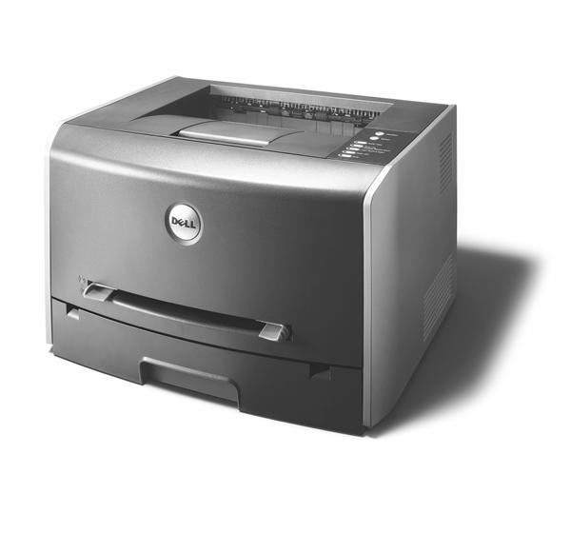

Servers

