*(Your Company logo here)*
Updates to your Courses
When we update your courses, you may see a notification at the top of your screen advising you of a new version.
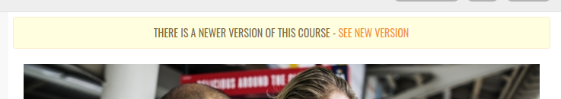
To view the updated material please click “See New Version”
You will then see the following pop-up.
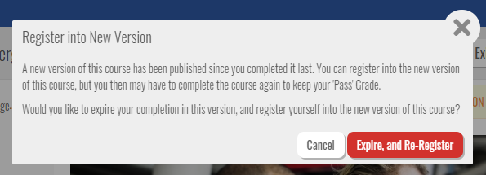
Click “Expire, and Re-Register” to see the updated course.

If you have any questions please contact:
*(Your support details here)*

Kind Regards,
*(Your company details here)*

