Top 5 Customer Experience Challenges and Solutions According to 102 Experts

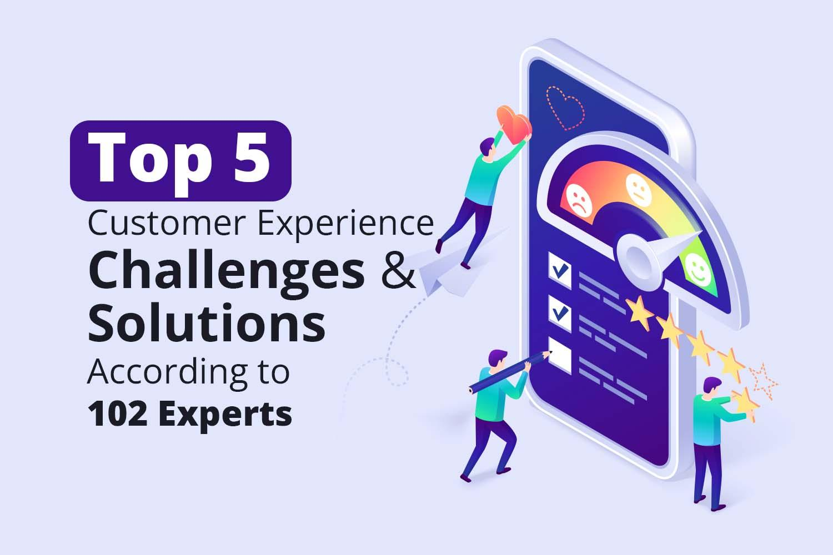
How to overcome the top 5 challenges that may be getting in the way of executing a successful customer experience (CX) program and how to overcome them.

CX is at a pivotal phase in its development. Undoubtedly, most businesses have improved end-to-end customer experience over the previous two decades. Product innovation and digital technologies have played a significant role in the progress.

Despite this, too many customers continue to have 'random' or 'unexpected' experiences due to inconsistent end-to-end customer journey delivery. And, sometimes, a good product is not good enough since customers have other options to choose from. Some brands win to attract customers, but some fail due to the surge of challenges they face daily.

Clootrack surveyed 102 top customer experience professionals to demystify the challenges that brands face in various industries across the globe, and list down the solutions they recommend to overcome them.

The participants were in the capacity of Directors, Vice Presidents, CEOs, Founders, CMOs, CXOs, Business Development Leaders, Strategy Heads, CX Experts, Marketing Leads, and Head of Analytics and Insights.

This report intends to analyze the top 5 challenges and solutions discovered in the study.

Top 5 Customer Experience Challenges According To 102 CX Experts
The importance of offering an exceptional customer experience has never been greater than it is today. Despite this, the majority of CX teams continue to encounter formidable CX hurdles.

What are the long-standing customer experience challenges while still progressing toward CX excellence?

Over 100 CX, marketing, and analytics experts from around the world were interviewed by Clootrack to learn more about the challenges faced by CX teams.

Here, we'll look at the top 5 customer experience challenges that were highlighted by the 102 CX experts:
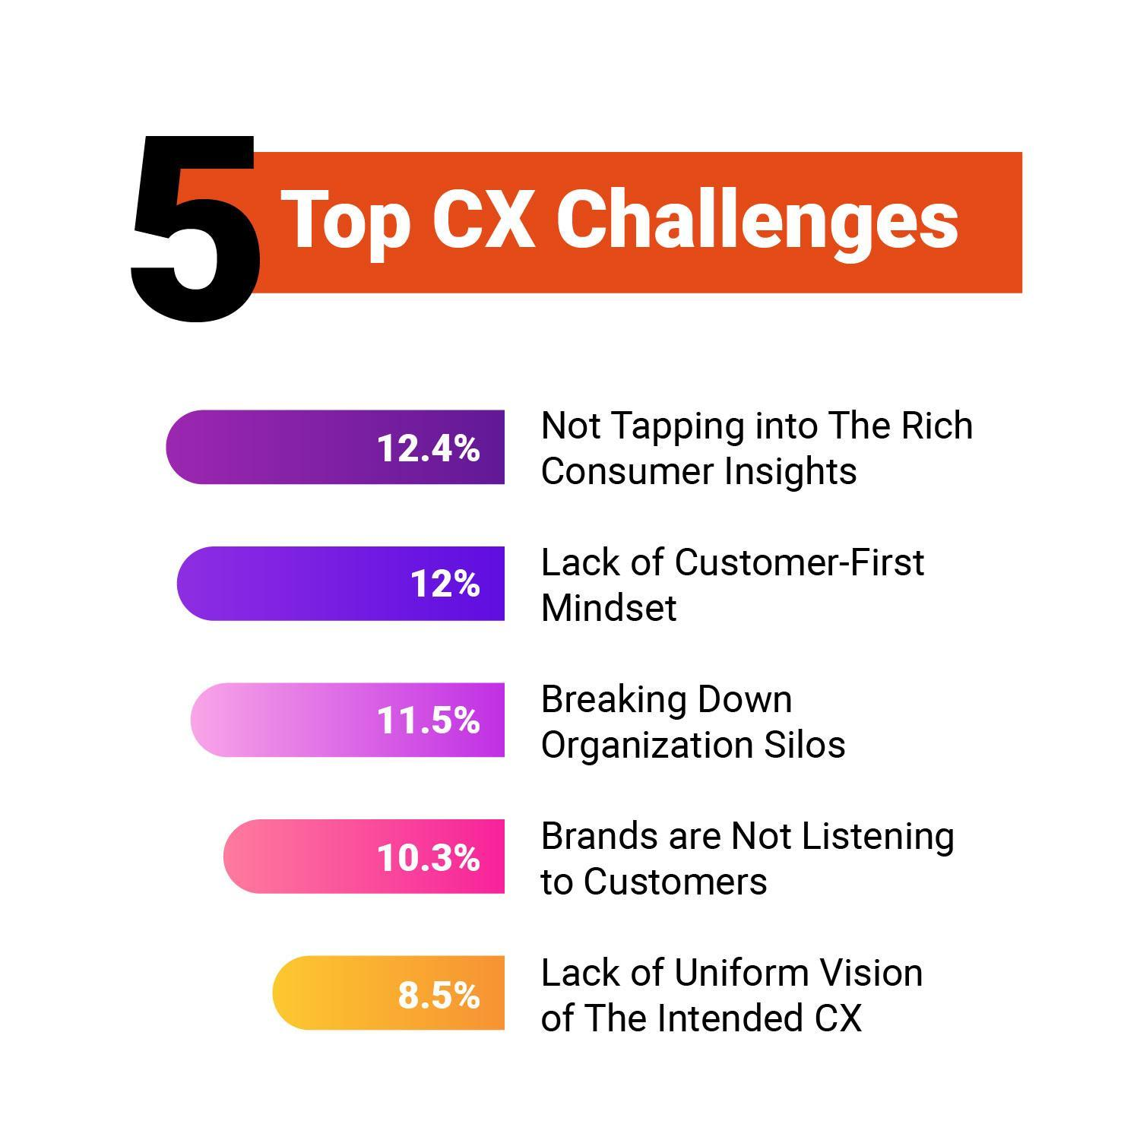

Challenge #1 - Not Tapping Into The Rich Consumer Insights

44.8% of CX experts pointed out 'not tapping into customer insights and data as the topmost CX challenge.

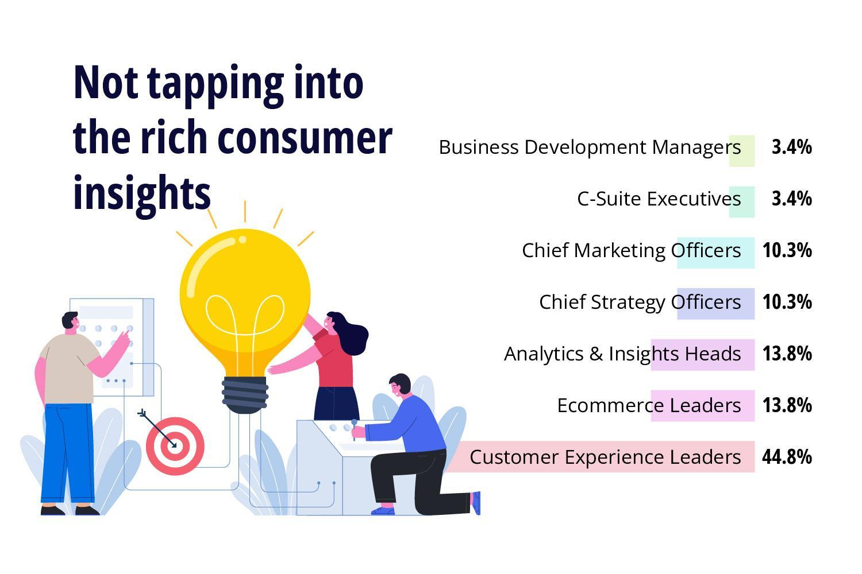
When there is customer interaction, there is data. It's all about how brands capture, analyze, and use it effectively. Many brands rely on surveys that will pop up on customers' screens after or during the purchase to check their satisfaction.

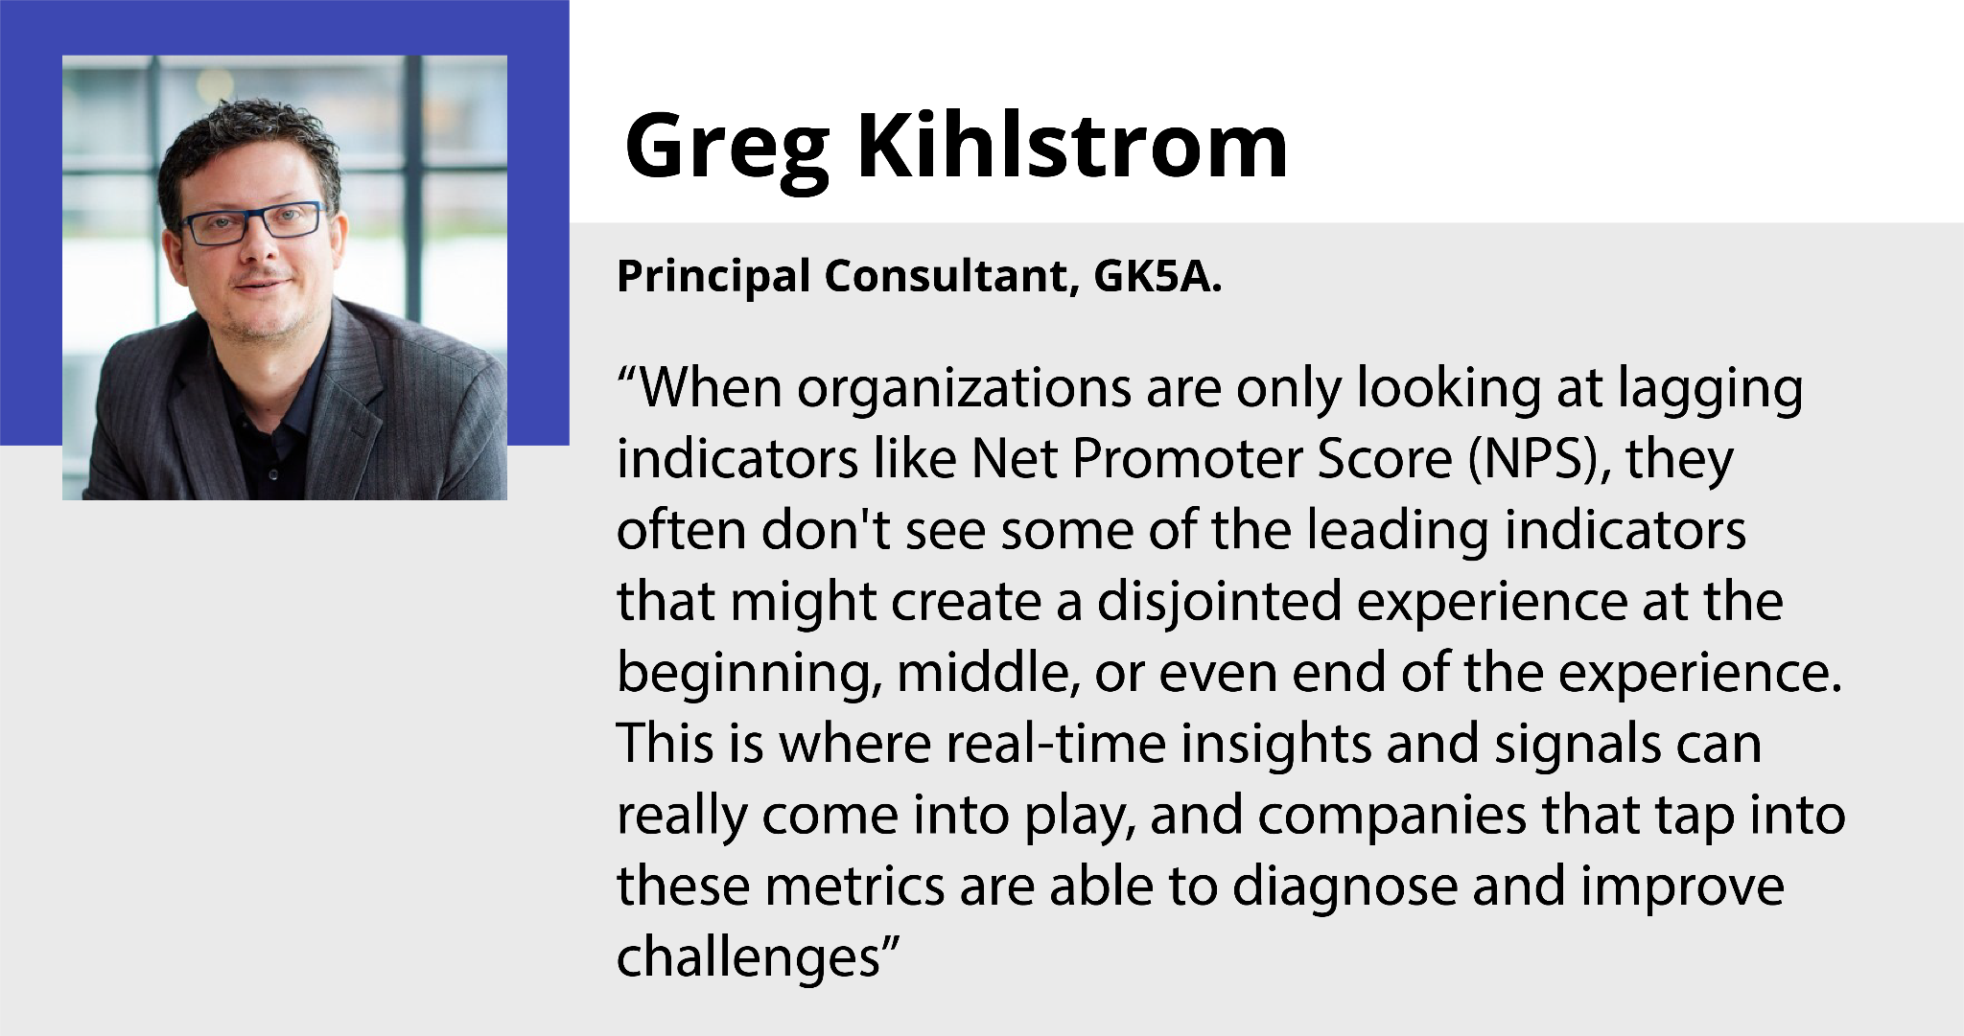

But finding the reason behind each survey score is impossible, and they can't reveal the natural emotion and reaction of customers says Greg Kihlstrom, Chief Strategist, GK5A.

Real-time data and consumer insights show the experience, pain points, and friction in the customer journey. The effective use of customer data is the greatest asset that helps to navigate sales. Granular insights on consumer behavior can be used for product innovation which brands can interpret and use to delight and add value for their customers.

Challenge #2 - Lack Of Customer-first Mindset

The lack of a customer-centric organizational culture is the most common, and perhaps the most significant, impediment to following a customer-first approach. Most firms' cultures are still product- or sales-driven, and customer-centricity is only a priority for a few departments, such as marketing.

54% of CX experts raise a concern that lack of a customer-first mindset is a significant hindrance towards delivering great CX experiences.

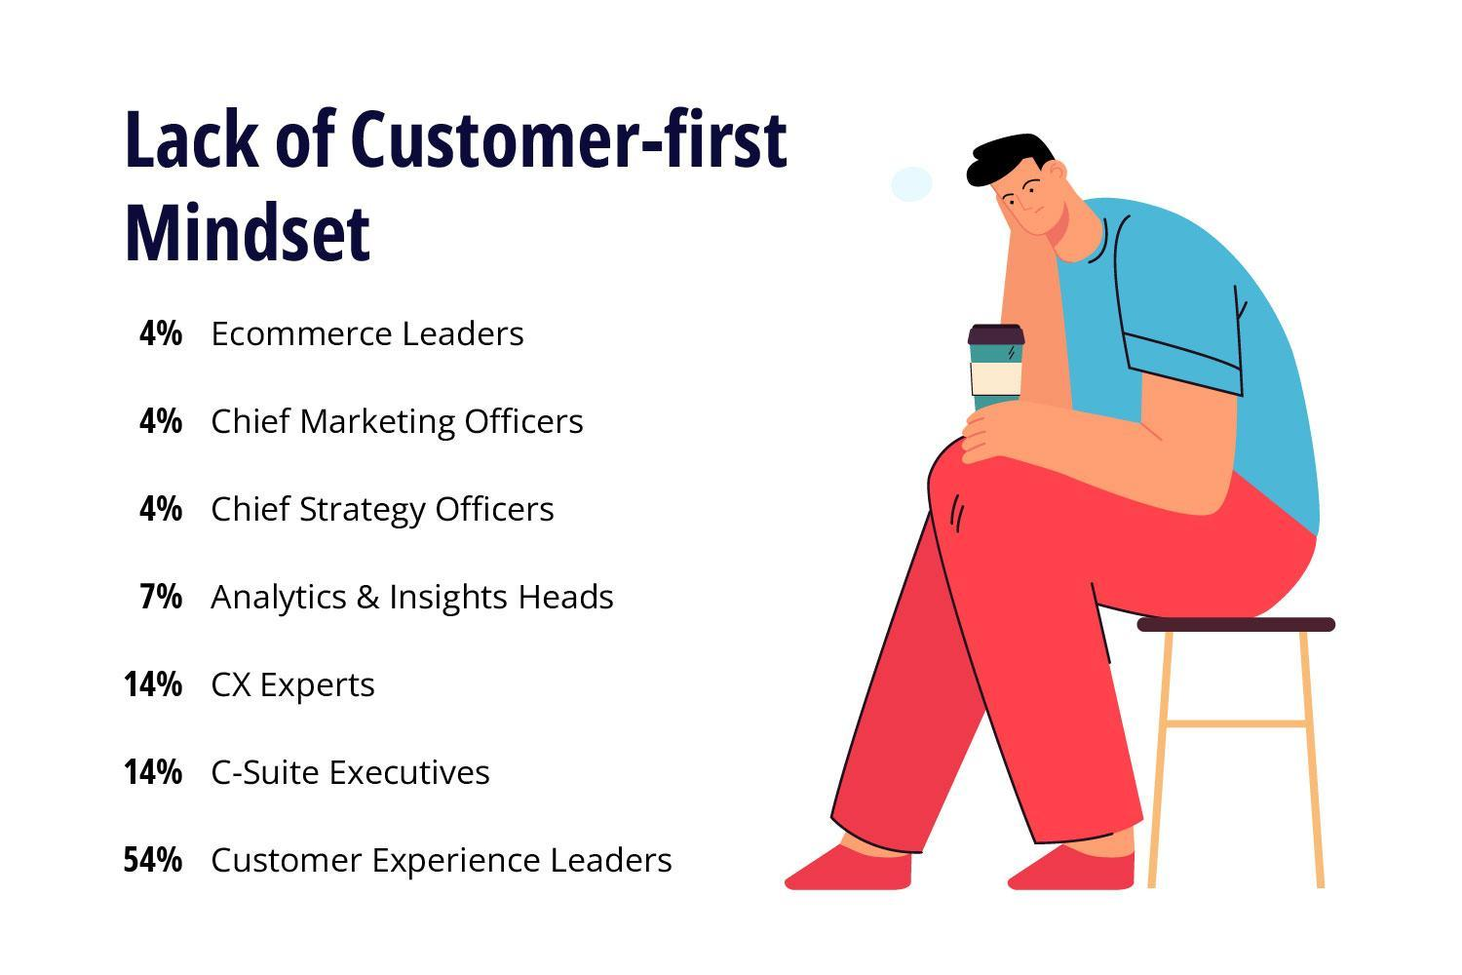

Seeing your product or service through your client's eyes is the best approach to thrive at it and instill a customer-first mindset. You won't grasp your customer's pain points unless you put yourself in their position.

Many brands still focus more on uplifting revenue and generating more sales than their customers’ experience. There is no success in the long term unless brands focus on delivering what their customers want.

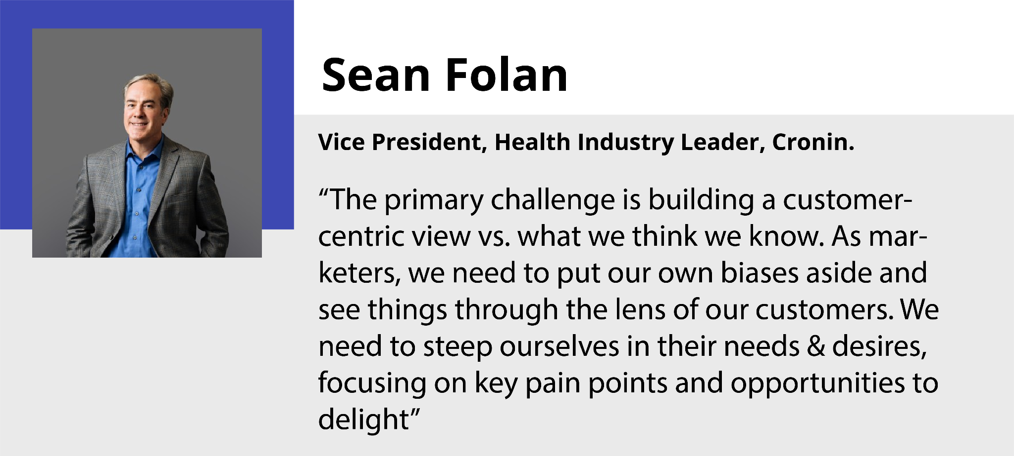

Brands must leave their biases and gut instincts aside to see everything from the customers' view. If customers feel a brand offers what they want, they will stick to the brand forever says Sean Folan, Vice President, Health Industry Leader at Cronin.

Challenge #3 - Breaking Down Organizational Silos

22.2% of CX experts think breaking down organizational silos is mandatory for a healthy customer experience ecosystem.
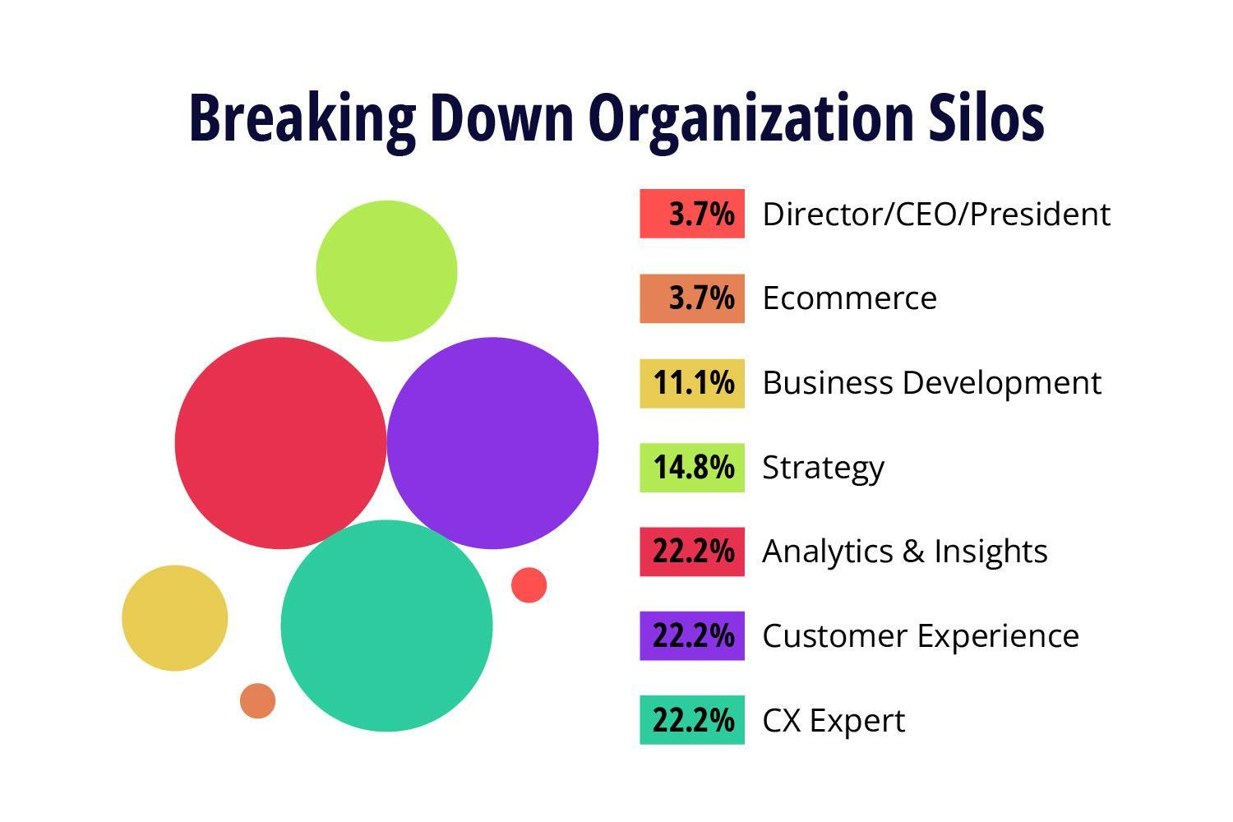
Different functions have their own objectives and priorities. These priorities may clash if a cross-functional team is not in place, resulting in bad trade-offs.

For example, IT may be tasked with reducing web page load times while the marketing team may require richer design features to persuade customers to buy a premium item such as luxury cars or jewelry.

Imagine if IT removed some of the material to satisfy load-time targets in a silo, it might have severe ramifications for the business. The app experience suffers as a result of a lack of cross-departmental coordination, as does the bottom line.

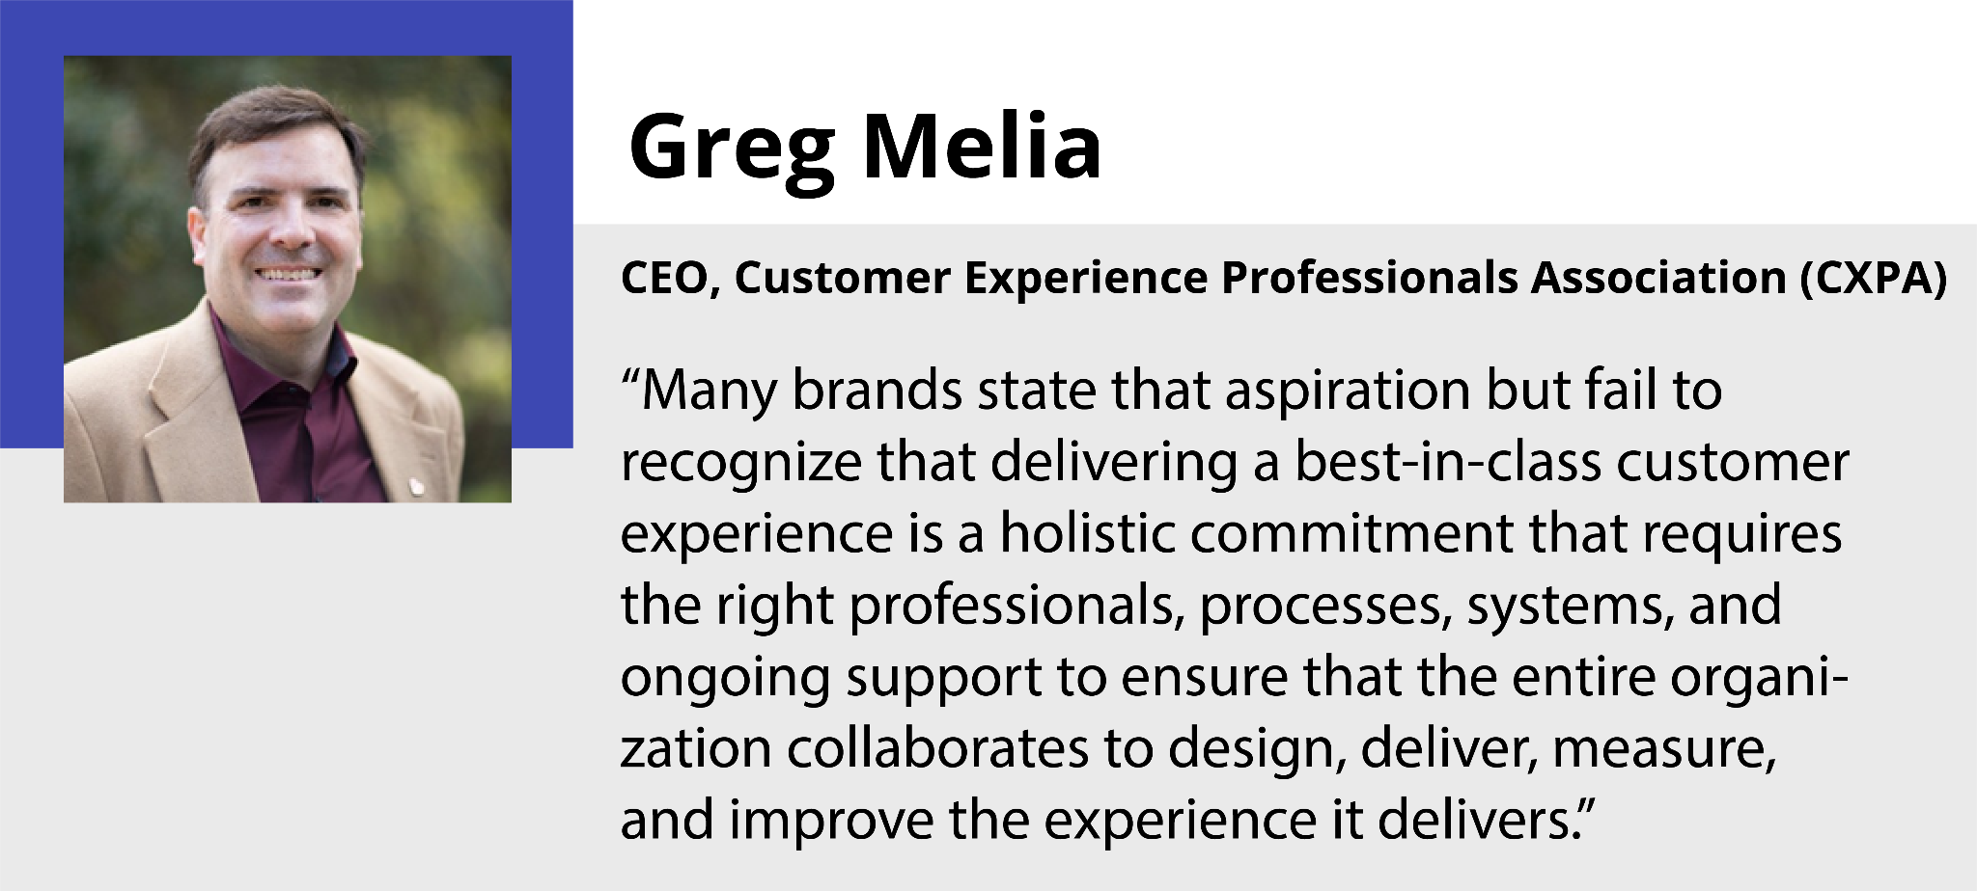

The experience through everything like website, app, packing, delivery, etc., plays a vital role in building an overall customer experience. Departments should work individually and effectively with interconnection and cooperation between them says Greg Melia, CEO, CXPA.

The interconnections and collaboration of departments should start from the basics. Connecting them is essential, but it requires a seamless flow of customer insights across all the departments.

To encourage firms to adopt a cross-functional approach, it's common to form teams focused on a single problem and then give them complete decision-making authority and control.

Challenge #4 - Brands Are Not Listening To Customers

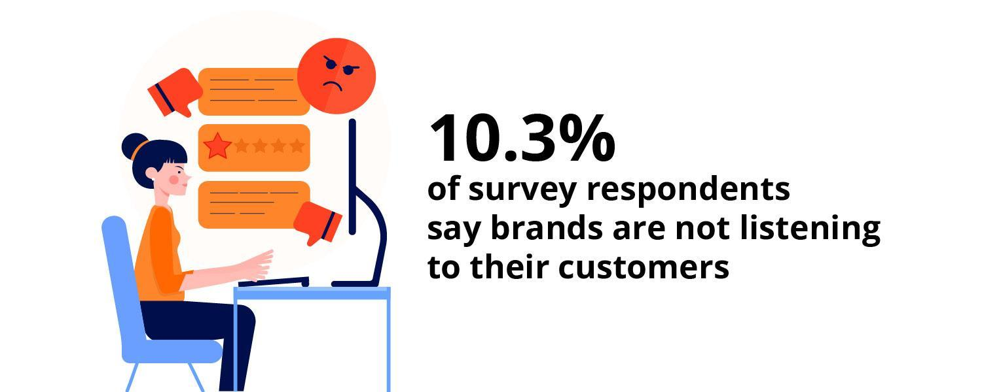

Dan Gingiss, Chief Experience Officer, The Experience Maker, LLC, says brands are not listening enough to customers which surprises him as the business does not exist without customers.

Many brands are not listening to their customers, or sometimes they are asking questions that can propagate answers that they wish to hear from customers. This will lead their CX practices in the wrong direction.

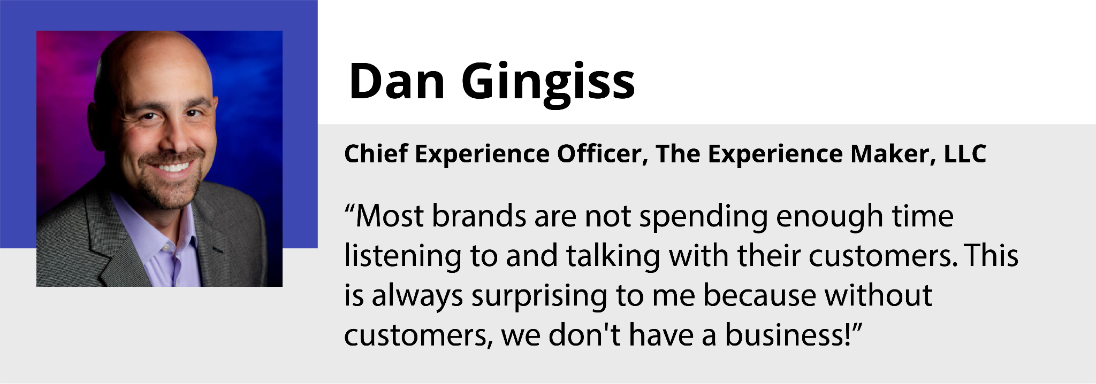

Listening through multiple touchpoints, including the helpdesks, live chat, and social media handles, will give a deep insight into the pain points, frictions, and even the point where a lead usually converts into sales.

A thorough analysis of this will open up the place for improvements. Better if brands often try to walk in customers’ shoes as a typical customer without any biases.

Challenge #5 - Lack Of Uniform Vision Of Customer Experience
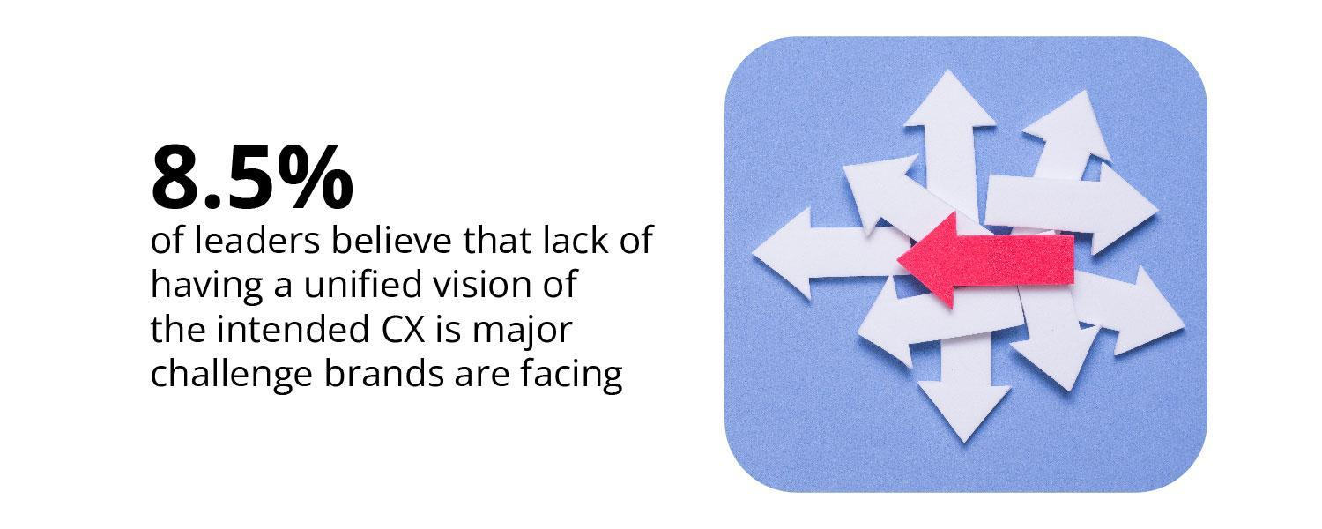
It's the responsibility of a brand to keep upgrading with the changing market trends and investing in the latest technologies according to the purpose and intention of the experience they wish to deliver.

For that, there should be a strong CX vision on which the employees should work together. Not having a uniform vision of CX will lead the CX practices to scatter in random departments.

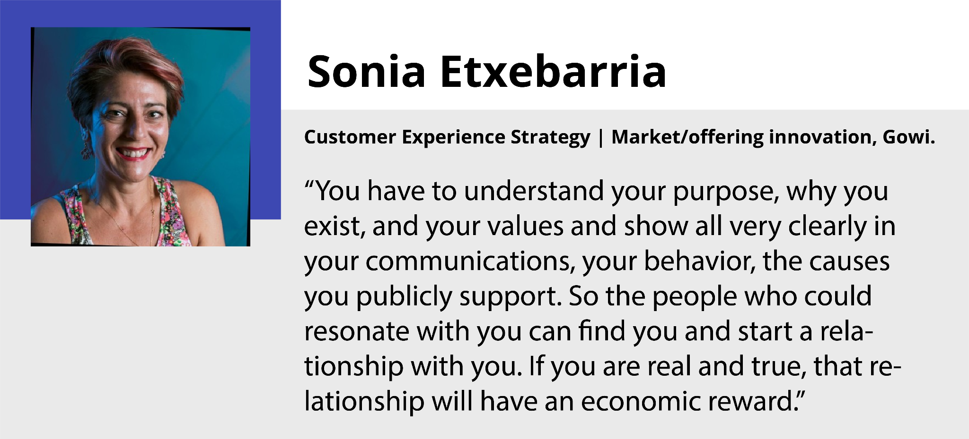

The industry leaders say the fundamental problems start with 'not having a unified customer experience vision.' Many brands have aspirations and intent to improve their customer experience, but they are not encouraged to have a unified vision of CX.

5 Solutions To Improve CX as Recommended by CX Experts

Giving customers a memorable customer experience is the most effective approach to keep them coming back. How can a business enhance its customer experience?
The 102 CX professionals from various industries across the world weigh in on a few improvements that a brand may make to give its customers an outstanding experience.
Here are the top 5 solutions recommended by the industry experts.
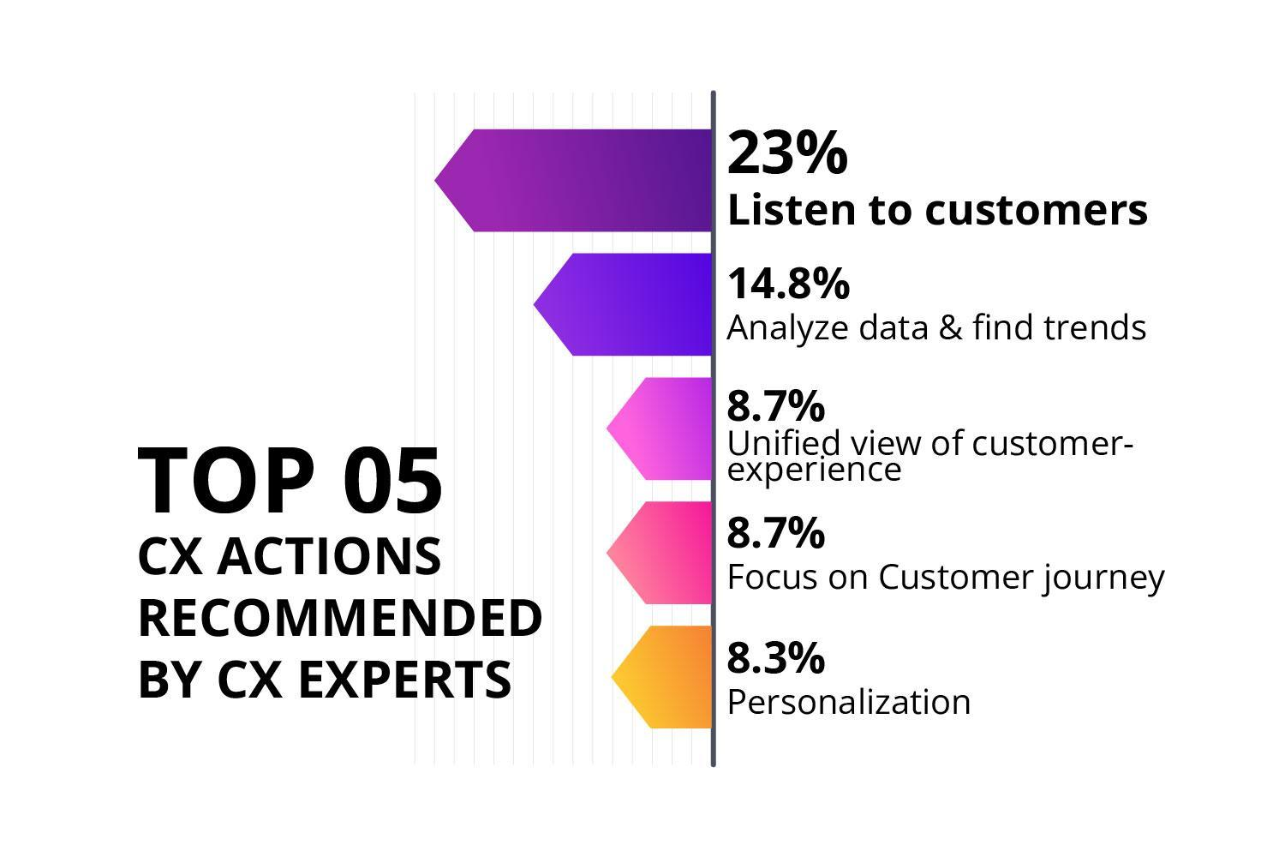

Recommendation #1 - Listen To What Customers Are Saying and More Importantly, What They are Not Saying
23% of leaders from the survey suggest listening to the customers directly and through various channels and touchpoints is the vital solution to the majority of the CX challenges.
Allow your customers to lead the way. With your product, customers are on the front lines. You can acquire useful insights on how to enhance customer experience by asking for and listening to customer feedback, both positive and negative.
Most companies are reluctant to hear customer feedback. But, by doing this, companies can understand the needs of customers and the issues they are facing, which would be the best way to figure out the areas for improvements.

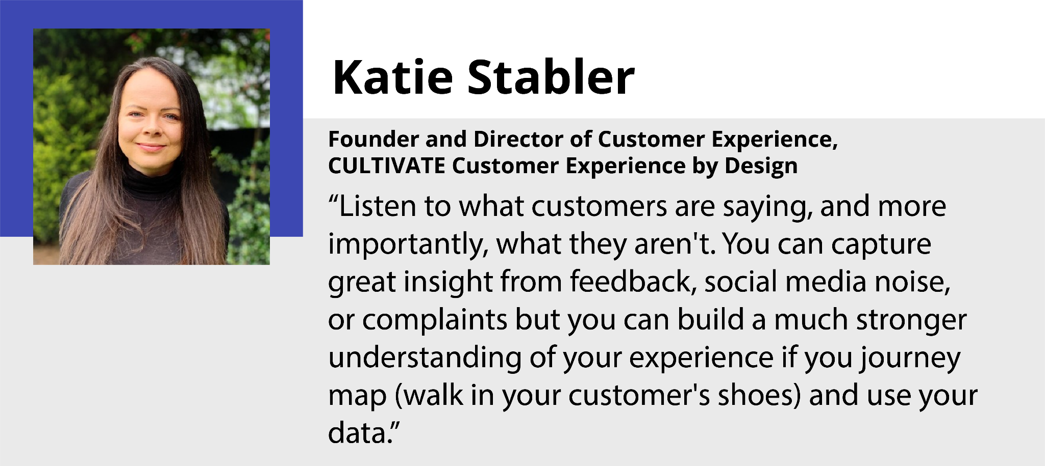

Recommendation #2 - Analyzing Customer Data is Key
14.8% of the professionals who took part in the survey suggest analyzing the rich source of customer data as the effective solution to improving the customer experience.
Collect and use customer data. Our consumers provide us with a significant amount of data, and they want us to listen to them and use that data to provide a personalized experience.
Even though brands already have massive amounts of data, it takes a lot of time for humans to analyze and act on it. Just listening to customers is not enough; working on it is essential. With the help of robust 3rd party CX tools, brands can tap into rich insights in a shorter time.
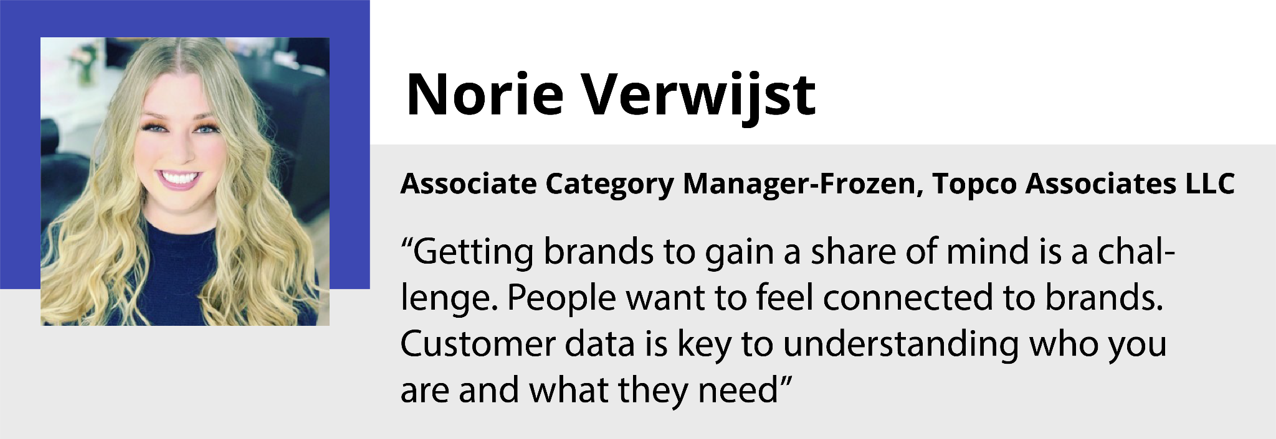
Develop technologies that allow you to collect, store, and apply data about each consumer in order to provide them with a seamless experience. It is their expectation, and they are disappointed when brands fail to meet it.
Analyzing and finding the key trends is as important as listening to customers. Maybe your brand is doing well right now, but it can never withstand competition if you don't understand what really happens in your customers' journey.

Recommendation #3 - Unified View Of Intended Customer Experience
8.7% of industry leaders recommend brands to develop a unified view of customer experience.
Every company should have a vision and objectives to reach its CX goals in a predetermined time. The organization has to achieve its goal with unity and collaboration to produce the final result. The siloed work culture in the organization is a barrier to this.

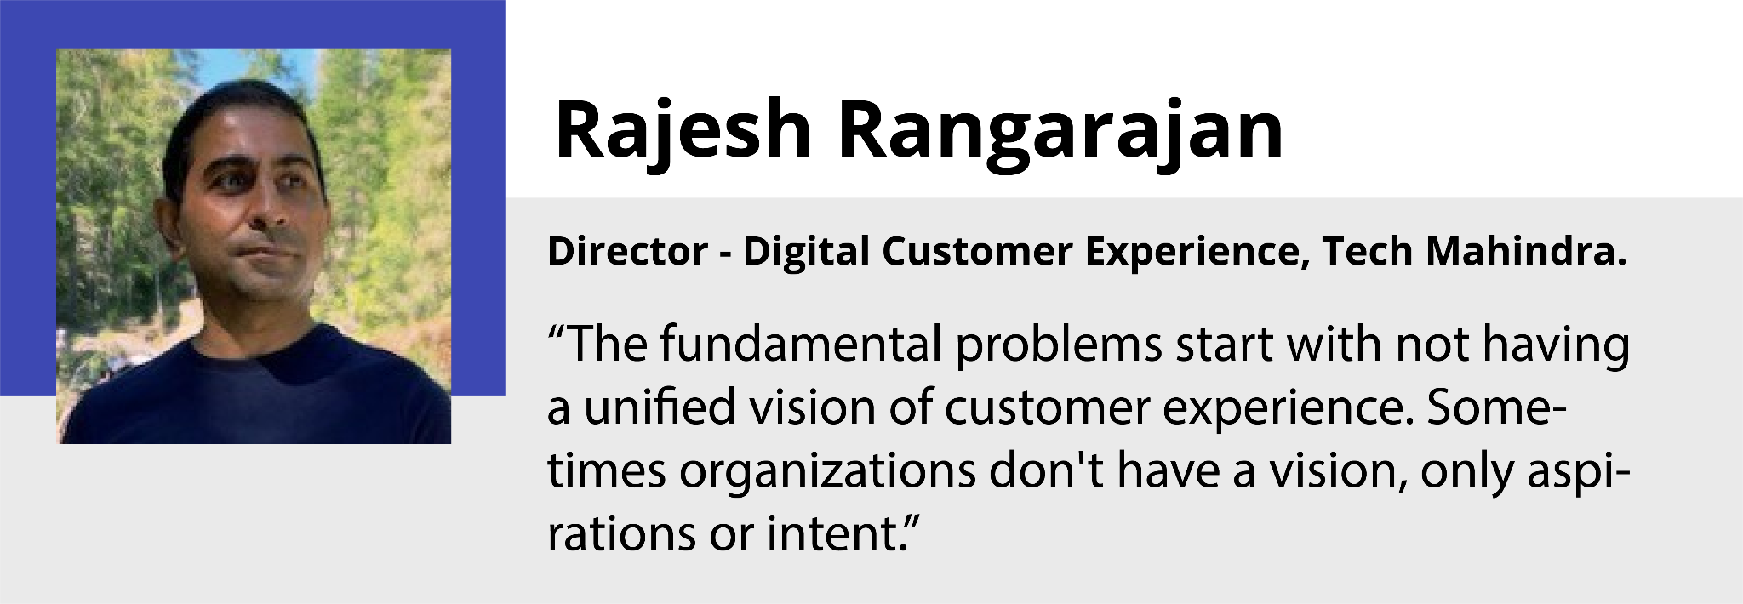

Organizations struggle to deliver the high-quality experiences that customers expect today without a single customer perspective and real-time information.

Understanding customers and listening to them is not just the work of one department, but it's the responsibility of each frontline employee in the organization. Companies must practice a unified view of the intended customer experience to encourage employees to work together for the ultimate CX goal.

Recommendation #4 - Focus On The Customer Journey
8.7% of customer experience experts stated that focusing on the customer journey is one of the top actions brands should take.
Significantly few companies value customer journeys and try to walk in customers' shoes to know the sentiment and satisfaction of customers. The customer journey map helps to locate each customer's touchpoint, and it tracks down the customer's behavior in every communication.
Analyzing customer journeys can provide unique trends, preferences, and drop-off points.

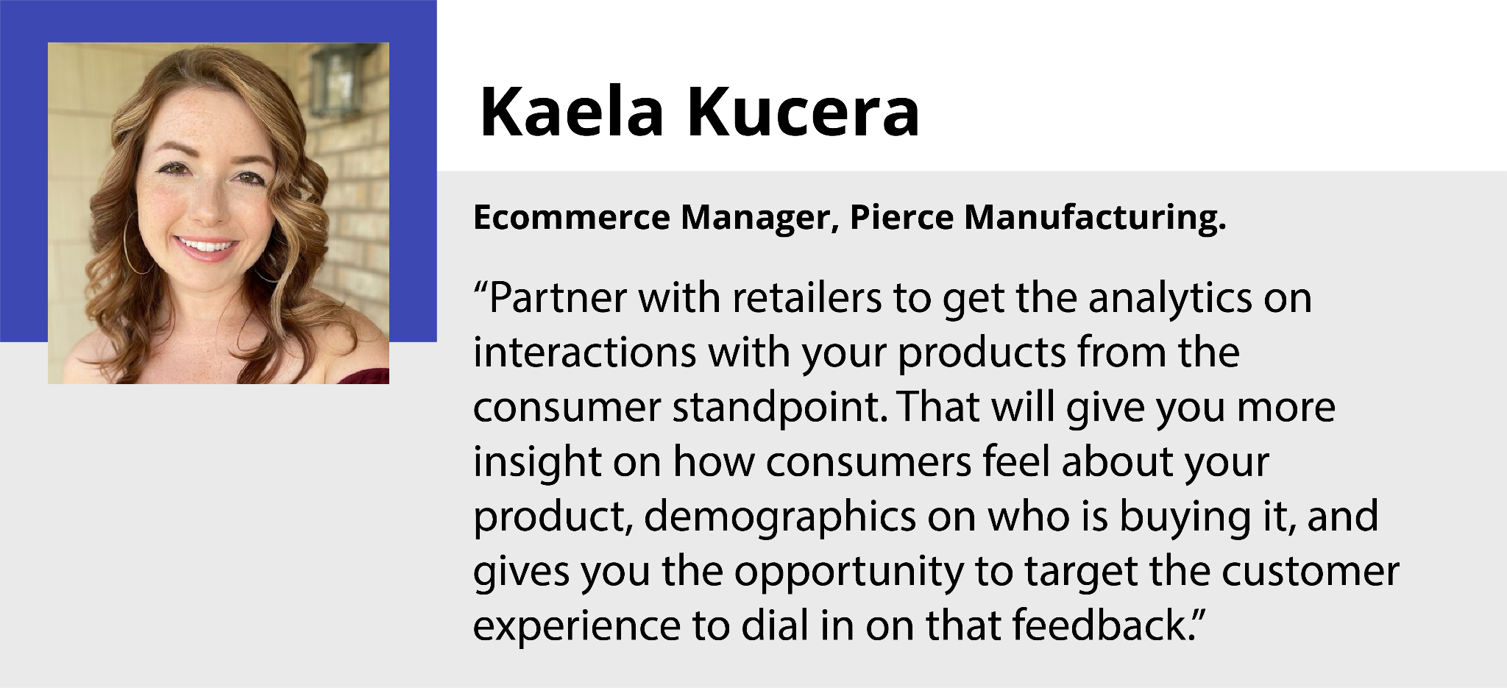

An engaging story can be produced by documenting a customer's demands throughout their encounters and illustrating how each interaction negatively or positively affects the customer's relationship with your brand. Because a good customer experience story may be easily understood and comprehended by stakeholders at all levels of an organization.

A customer journey map depicts customer experience and assists you in determining which adjustments would yield the best results. Your journey map becomes a focus of your customer experience planning process by pinpointing the steps in the customer experience that have the most impact.

Recommendation #5 - Highly Tailored Customer Experiences
8.3% of experts from the survey suggested that personalization of customer experience is one of the top actions brands need to take.
Personalization has become an essential driver in any business. Customers expect brands to personalize their shopping experience and provide a seamless purchase journey. They hope brands understand their unique tastes and preferences. Hence brands need to understand different personas and segment customers to provide the experience they want.
Competitors will find it difficult to replicate highly tailored customer experiences when delivered to millions of individual customers using proprietary data. When done correctly, such experiences allow firms to not only stand out but also earn a long-term competitive advantage. Furthermore, tailored experiences increase both consumer loyalty and revenue.
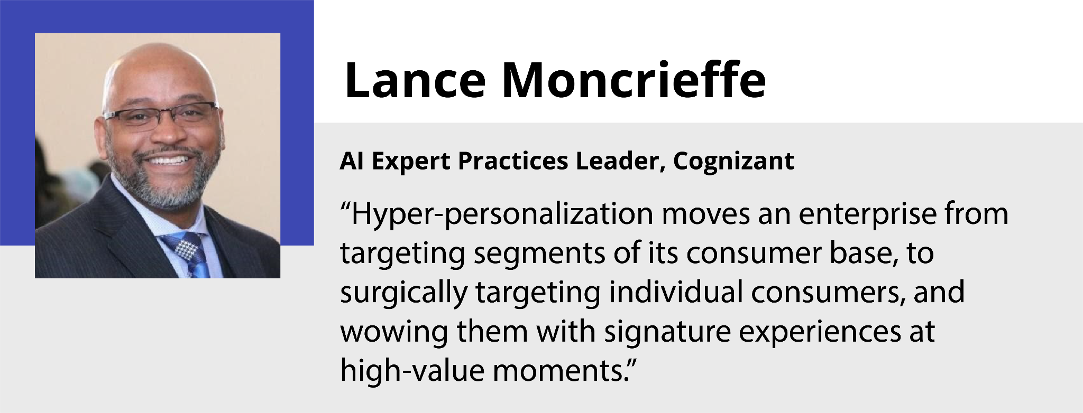
Personalization has evolved from being confined to targeted offers to encompassing the entire customer experience. Customers desire personalization throughout their interactions with a shop, with several unique touchpoints that allow them to prioritize their time and money based on their preferences.

What to do Next?

If there is a problem, there is a solution. All the CX challenges a brand faces today and in the future can be identified, analyzed, and resolved with systematic approaches and teamwork, as discussed above.

Extract the insights from customers' voices and identify customers' frictions and pain points through continuous listening. Offer hyper-personalization through all the touchpoints.

These are just five challenges and recommendations discussed here, and there are many more that came up during the interview with 102 CX experts.

To learn more about all the challenges and solutions recommended by CX experts, download the complete report here!

