SUBSCRIBER
WELCOME
PACKET

[INSERT COMPANY NAME]
[INSERT COMPANY ADDRESS LINE 1]
[INSERT CITY, STATE, ZIP]
[INSERT COMPANY WEBSITE]

[INSERT CUSTOMER NAME]
[INSERT DATE]

TABLE OF CONTENTS

Our Dedication to Service Excellence ……………………………….……………………… 2
How to Contact Us …………………………………………………………………………….. 3
Information We Need to Effectively Assist with Your IT Issues….…………………………4
Our Availability & Response Levels …………….…………………………………………… 5
Issues We Can Help You Solve………………….……………………………….……..…… 6
Our After Hours Maintenance Procedures……………………………………………......... 7
How We Gather Your Feedback…………………………………………………………..…. 7
Best Practices You Can Implement to Improve Your Experience ……………………...... 8
Services We Offer……………………………………………………………………………… 10

OUR DEDICATION TO SERVICE EXCELLENCE
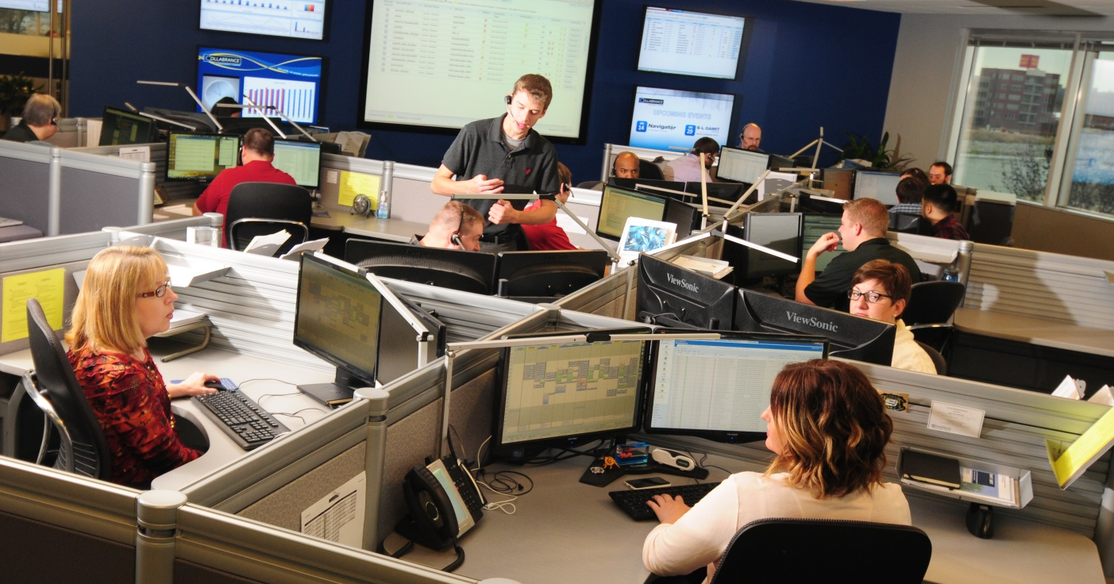

Thank you for choosing [INSERT COMPANY NAME] to support your technology needs.
This packet includes important information you need to know regarding the service and support you receive from us. Please take time to read it to ensure that you are prepared to play your role in helping us provide you an exceptional IT support experience!

[INSERT INFO ABOUT YOUR COMPANY and/or WHY DID YOU GET INTO MANAGED IT SERVICES?]

We are passionate about delivering an exceptional service experience and want to be your one-stop shop for all your technology needs. We will remediate your IT issues, provide advice and manage your technology vendor relationships.

Day in and day out, we continually monitor the performance of all your network devices. We provide proactive maintenance to optimize your systems, and automate daily tasks like updates and patches. Our Service Desk is available to answer and resolve your technology questions.

HOW TO CONTACT US

INSERT YOUR
COMPANY LOGO

Available Monday – Friday, 8:00am – 5:00pm.
Emergency support available at an additional fee.

1-877-715-8484

______@myitrequest.com

Contact us via chat: During the onboarding process, we will add a system tray icon to your computer in the toolbar at the bottom right-hand of your screen that resembles a life saver. If you click on this icon, it allows you to start a chat session with our Service Desk, and gives you information about your computer that will help us identify your machine and start working to resolve your issues quicker.

Contact us via email at _______@myitrequest.com: By selecting the system tray icon, you have the option to “Submit a Service Desk Ticket.” It will open a new email with a few questions for you to answer. To ensure your issue is handled in a timely manner, please provide the requested information upfront to the best of your ability before sending us the email. Upon receipt, we will respond to you with a ticket number via email.
Contact us via phone at 1-877-715-8484: If you prefer to call us, we will ask the name of your computer which can be located by clicking on the system tray icon.

INFORMATION WE NEED TO EFFECTIVELY ASSIST WITH YOUR IT ISSUES
The more information you can provide the Service Desk, the quicker we can get you to a resolution. Because of the number of people calling in each day, we will ask you to be able to provide us with the following:
- Company name
- Your name
- Computer name
- Preferred contact phone number
- New request or pending ticket (ticket #)
- Detailed description of your IT issue, including:
  - Does this issue impact anyone else? How many people are affected?
  - Is this a recurring issue?
  - How long has this issue been happening? When did it begin? Is it happening frequently?
  - What prompted the issue to occur?
  - Is this issue preventing you from completing critical business activities?
  - Other information as needed.
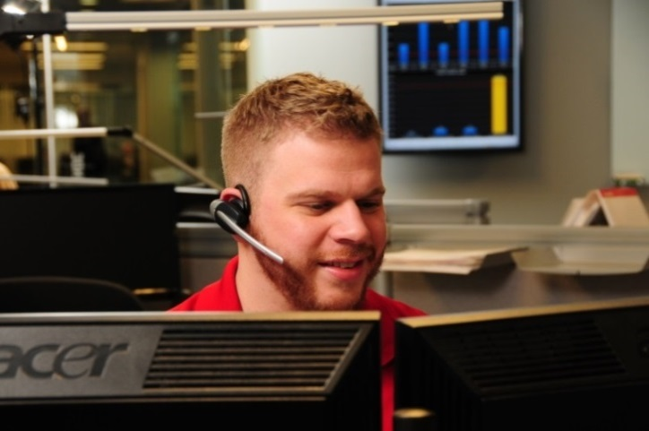

OUR AVAILABILITY & RESPONSE LEVELS
Availability: Our Service Desk is available Monday through Friday from 8:00am-5:00pm, except during major holidays. Emergency and after hours support is available as needed for an additional charge.

Contact Method | Response
Phone | A Service Desk technician answers your phone call in  2 rings or less to help resolve your IT issue.
Email | Your email gets sent to our dispatchers who will assign  your ticket to a technician to resolve your IT issue.
Incident  Detected | Your monitored equipment triggers an alarm to our  Service Desk, who will proactively work on your IT issue.
**For urgent or critical issues, please call the Service Desk. A live person will be available to speak with you directly.**

Response Levels: Issues are addressed based on priority. Priority is determined by evaluating the severity of the issue (urgency) and the level of work stoppage (impact). We will do our best to resolve issues as quickly as possible.

Priority Level | Definition | Initial Tech Work Begins  (Business hours)
1 | Critical issue that requires immediate  and sustained effort through resolution | 30 minutes
2 | Significant disruption of business, many users impacted, does not require sustained effort | 2 Hours
3 | Operations are restricted but a workaround is available | 12 Hours
4 | The product is not working as designed. There is a minor impact to usage, but it is acceptable. A workaround has typically been deployed | 24 hours
If you are not getting the response you expected, please call the Service Desk.

TICKET REFERENCE

The Service Desk will assign a ticket number as a reference to your IT issue. A series of emails with your ticket number will be sent to you updating you on the progress of your IT issue. Use this ticket number if you need a status update, or you would like to provide more information regarding your issue.

ISSUES WE CAN HELP YOU SOLVE
In order to provide excellent support, the Service Desk needs to be aware of all technology in an environment. Please contact the Service Desk before purchasing or installing any additional technology.

Technology issues covered by the Service Desk include, but are not limited to:

- Desktop and server operating systems
- Network and internet connectivity and performance
- Productivity software suites (i.e. Microsoft Office)
- Email
- Internet browsers
- Line of business applications
- Virus/spyware removal
- File restoration
- Email on a mobile device

Some issues might require the software/hardware vendor or an on-site visit from our technicians. These include, but are not limited to:
- Line of business applications (I.e. Quickbooks, CRM applications)
- Copier issues
  - Video
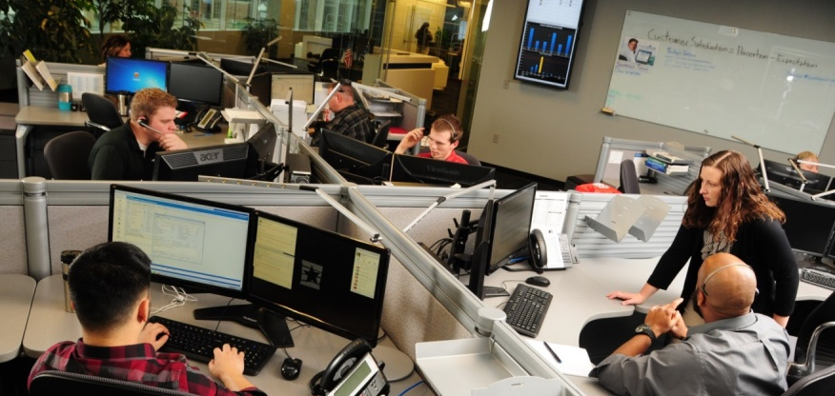
  - Security/Alarm
  - Phones
  - MiniMainframes
  - Unix, Linux, Sunsparc

OUR AFTER HOURS MAINTENANCE PROCEDURES
The Service Desk performs routine maintenance procedures on PC’s, servers, and networking gear in order to provide you with a healthy technology environment. These procedures are performed outside of normal business hours to avoid affecting your productivity.

To effectively protect your computers and network environment, while preventing disruption to you during the workday, we request that your computers remain ON, but in a LOGGED OFF state when you leave for the day, Monday through Thursday. Prior to logging off, please save your work and close all applications. If you do not leave your machine on and logged off, your computer will not receive its appropriate updates and could be vulnerable to security threats.

All workstations and laptops install patches weekly on Thursdays and reboot as needed. Thursday evening is when all workstations and laptops are scheduled for reboot.

HOW WE GATHER YOUR FEEDBACK
Our Customer Satisfaction Survey will be sent to you via email every time we close a ticket with you. This is an opportunity for you to provide feedback and let us know how we are doing when assisting you with your IT issues. Surveys are actively monitored by team leaders. They are used to celebrate great performance, and present learning opportunities to our technicians.
We average a Customer Satisfaction Survey score of 4.8 out of a 5.0 scale, but we know there is always room for improvement. If you have any suggestions or concerns, please feel free to contact us directly to share your feedback. We take your feedback very seriously. If our service does not meet your expectations, we will call you to learn what we can do better.
BEST PRACTICES YOU CAN IMPLEMENT TO IMPROVE YOUR EXPERIENCE

Here are some quick tips to help protect your information and ensure your technology runs more efficiently:

- Data
  - Save your information and data files before closing an application.
  - Save your information to company designated locations (i.e. on the server) to ensure it is backed up and recoverable. Contact us if you are unsure of what data is backed up.
  - Be cognizant of personal and sensitive information. To ensure things are securely and permanently deleted off your machine, press Shift+Delete.
  - Password protect sensitive data files.

- Internet and Software
  - The Service Desk will regularly check for and download your computers’ Windows Updates. Please leave your machine ON and LOGGED OFF when you leave for the day to ensure your computer gets its updates. Contact us if you need assistance or have questions.
  - Do not visit malicious websites (i.e. Gambling).
  - Do not click on pop-up windows, links, or attachments in emails that you have not requested, even if you know the sender.
  - Be wary of any wireless networks, especially those in public places because sensitive and personal information can be easily stolen in public wireless environments.

- Passwords
  - Minimum length of nine (9) characters must be used for network login.
  - Passwords must be complex and include lowercase and uppercase letters, numbers, and symbols to prevent security issues.
  - Seven (7) consecutive incorrect password attempts will cause the user’s account to log out. Please call the Service Desk to unlock.
  - Do not repeat or reuse a password.
  - Do not share passwords via email or any other form of electronic communication.
  - Do not click on the option to “show password” when typing it in.
  - Never have web browsers, email, or other programs save (or ‘remember’) accounts and/or passwords.
- Workstations
  - Log off or password-lock your computer when it is not in use or when you leave your workstation.
- Phishing
  - Do not open emails or attachments from unknown senders.
  - Be cautious of websites that request to download components or applications.
  - Never reply to emails that request personal information! Legitimate businesses will never ask in an unsolicited manner for personal information in an email or over the phone.

- Change of Employment
  - Contact the Service Desk when you have a change of employment. This includes new additions to your staff or when a staff member leaves.
  - Allow 2 business days upon submitting your request to have a new user created and setup.

- Technology Upgrades/End of Life
  - The Service Desk will proactively work with you to upgrade your technology when it is no longer functioning properly, is no longer supported by the manufacturer, or is a threat to your network.

We strive to keep your data and PCs safe with Anti-Virus installed on every machine. We also deploy email and web filtering tools, and network firewalls. But please realize that no solution can be implemented that will be 100% effective against malicious attacks.

Strong passwords, vigilance on websites, and opening emails only from legitimate sources, are some of the most important ways you can help prevent malicious attacks. If there is an event or incident, a proven backup solution that is monitored and tested will ensure your business is back up and running as soon as possible.

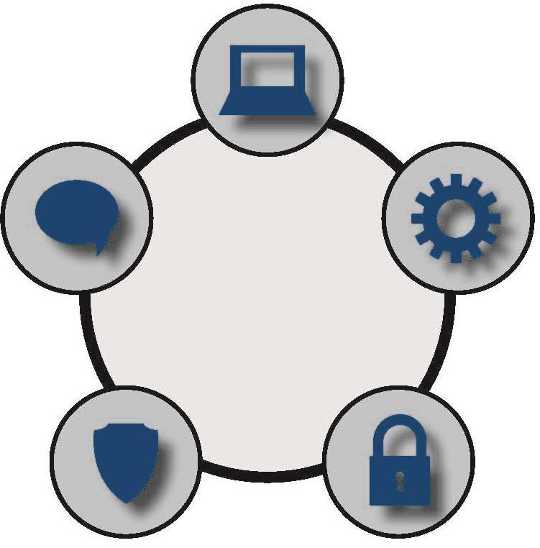
SERVICES WE OFFER
COMMUNICATION

Email and mobile solutions that are secure and affordable.

SUPPORT

Our friendly and knowledgeable Service Desk is ready to listen and respond to your IT issues.

To provide you with an exceptional service experience, we provide a standard set of comprehensive solutions for Hardware, Software, Security, Data Protection, Communication and Support.
SECURITY

Protection from the latest threats.

SOFTWARE

Centralized management for application issues.

DATA PROTECTION

Customized data backup and recovery.

HARDWARE

Standardized, current technology at a fixed monthly cost.

