CRUSHBANK TEAMS INTEGRATION - CONFIGURATION MANUAL

CRUSHBANK TEAMS INTEGRATION - CONFIGURATION MANUAL 1
CONFIGURATION IN PORTAL AZURE 1
CONFIGURATION IN MICROSOFT TEAMS APPLICATION 4
ADD THE APP TO TEAMS APLICATION 4
ADD THE APP TO THE TEAM WHICH INFORMATION IS GOING TO BE INGESTED 6
CREATE THE INTEGRATION IN CRUSHBANK 9
GET TENANT ID 9
CREATE TEAMS INTEGRATION 10

CONFIGURATION IN PORTAL AZURE
To have permissions to get the public channels and their messages, it’s necessary:
- Login in the portal azure
- Open this link https://login.microsoftonline.com/common/oauth2/authorize?client_id=7e704276-aa03-426b-abef-c6f43b7b57c0&prompt=admin_consent&response_type=code
in another tab in the same browser and accept the required permissions
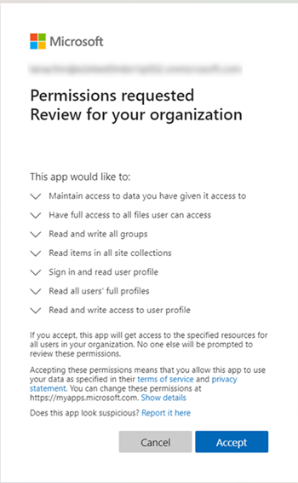
- Verify that in the portal azure in enterprise applications the app is already added.

Go to the Azure active directory
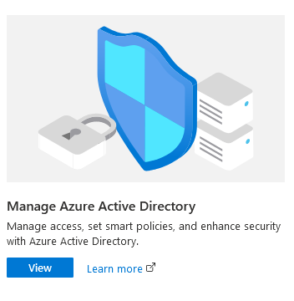
Select Enterprise applications
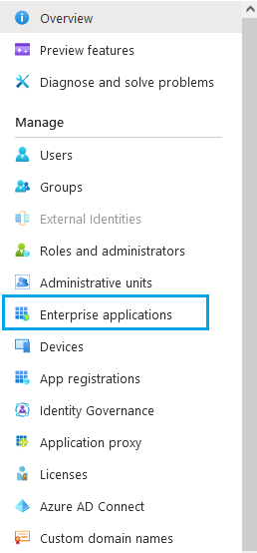
The Crushbank Integration should appear in the list
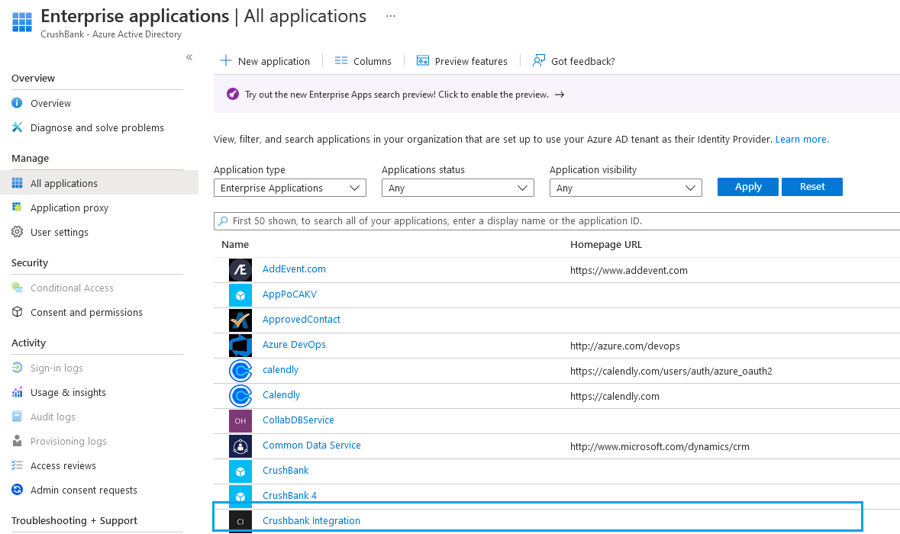

CONFIGURATION IN MICROSOFT TEAMS APPLICATION
To have permissions to get the public channels and their messages, it’s necessary to install an application on each public team from which its information needs to be ingested. Follow the next steps to do it:

ADD THE APP TO TEAMS APLICATION

- Click Apps button in Teams application

- Click Submit to app catalog
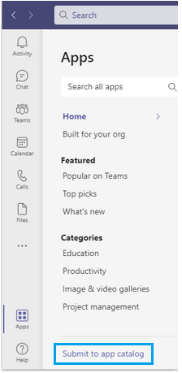
and then click on Submit an app
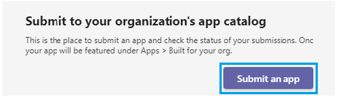
a window should open to add from your computer the CrushbankIntegration.zip file that was provided.

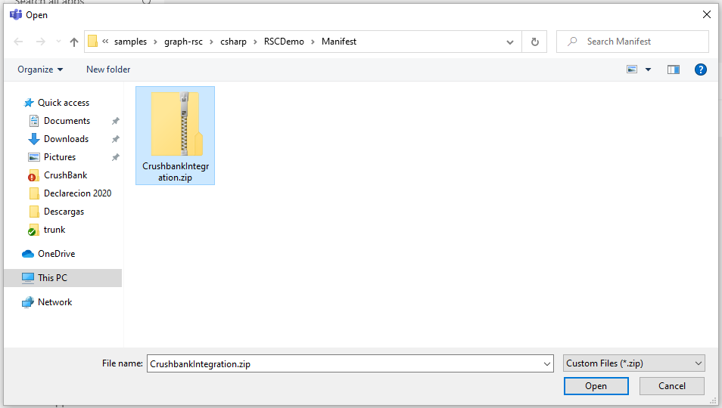

- The administrator or owner of Teams must approve the application. To do this, go to Apps then click on Submit to app catalog to see the apps pending for approval.
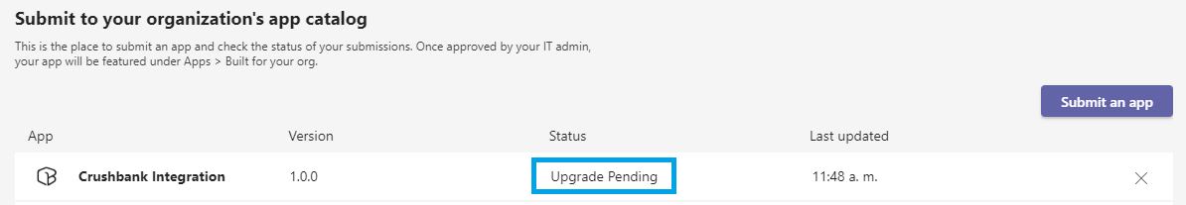
- After the app has been approved sign out and log in again
- Go to apps again and the Crushbank integration app now should be appear in the app catalog
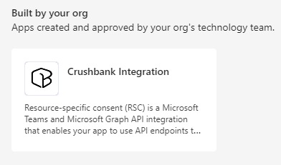

ADD THE APP TO THE TEAM WHICH INFORMATION IS GOING TO BE INGESTED

- Select a public team, click on more options and select manage team

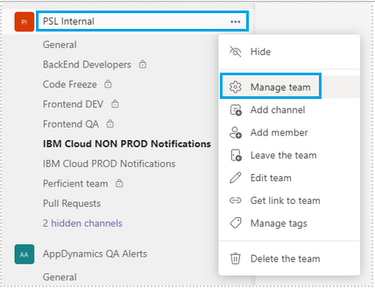

- Go to Apps tab and click on more apps

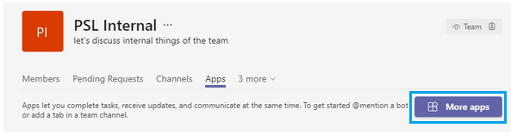

In the apps catalog the Crushbank Integration should appear, click on it and add it to the team. Only the owner of the Team can add the application.

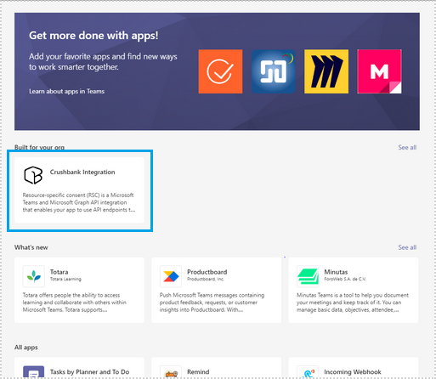

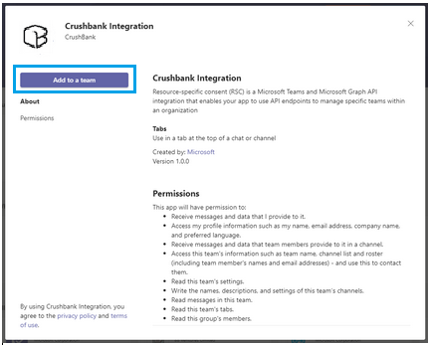

CREATE THE INTEGRATION IN CRUSHBANK

To create the integration, the tenant ID is required.

GET TENANT ID
Steps:
- Log-in in portal Azure with the same office 365 account
- Select Manage Azure Active Directory
- In the overview copy the tenant ID

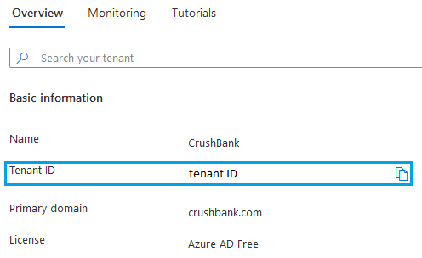

CREATE TEAMS INTEGRATION
To create the Teams integration in CrushBank follow the next steps:

- In the company Admin module create/edit the company
- Click on Add new Integration and select the Teams button

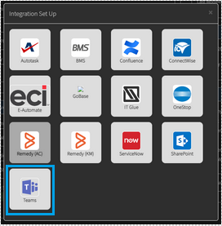

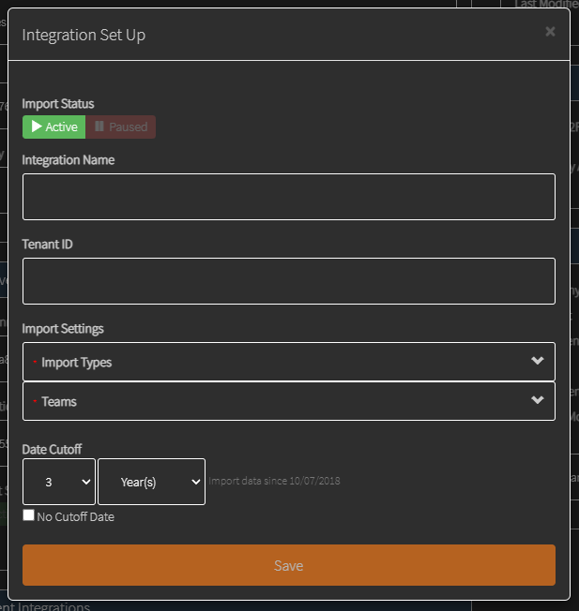

- Fill the form.
- After the Tenant ID field is filled in the Teams section all the public teams and its channels are loaded.

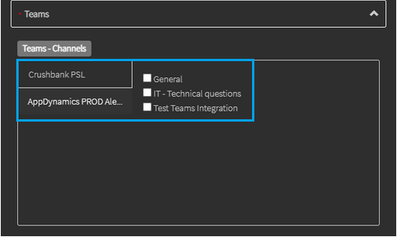

Check the channels from which the information should be ingested

- Save the integration

