SOME PPP LOAN LANGUAGE SAMPLES
The following are samples of recent purchase agreement provisions drafted by attorneys concerning PPP loans. Benchmark International does not express any opinion about these clauses other than that they are representative of the PPP loan related terms being proposed by buyers’ counsel in their first drafts. Consult legal counsel prior to drafting, editing, or accepting any contractual language.
From a stock purchase agreement – this is typical of the representation and warranty being requested by buyers on the succinct end of the spectrum:
Payment Protection Program Loan. The Company asserts that it has received seven hundred thousand dollars ($700,000) in funds as a loan from the federal government as part of the Payment Protection Program (“PPP”) under Section 1106 of the Coronavirus Aid, Relief, and Economic Security Act (CARES Act). The Company, Seller, and Buyer acknowledge that these funds are eligible for loan forgiveness or partial loan forgiveness if certain requirements are met within the Paycheck Protection Program Interim Final Rules. The Company and Sellers have provided and included the PPP loan documents, including SBA Form 3508, 3508EZ, and assert that the Company is in compliance with all requirements for loan forgiveness through the Closing Date. Additional information and details about the PPP loan are included in the Disclosure Statement.
From a membership interest purchase agreement – this is typical of the representation and warranty being requested by buyers on the detailed end of the spectrum:

PPP Loan. The Company has obtained a “Paycheck Protection Program” loan through the U.S. Small Business Administration (the “PPP Loan”) under the CARES Act. At the time of application, and at the time the PPP Loan was funded, the Company satisfied and the Company continues to satisfy all of the applicable criteria for the PPP Loan set forth in the Small Business Act (15 U.S.C. 636(a)) and the CARES Act (based on applicable Law, including any official public guidance of the relevant Governmental Body on the CARES Act, existing as of the date of submission of the Company’s application for the PPP Loan), [including, that (a) the uncertainty of current ‎economic conditions make the PPP Loan necessary to support the ongoing operations of the Company,] (b) the proceeds of the PPP Loan will be used solely for CARES Act Permitted Purposes, ‎‎(c) the Company does not have an application pending for a loan under subsection 7(a) of the ‎Small Business Act or the CARES Act for the same purposes and duplicative of amounts applied ‎for or received under the PPP Loan, and (d) during the period beginning on February 15, 2020 ‎and ending on the date hereof, the Company has not received amounts under subsection 7(a) of the ‎Small Business Act for the same purpose and duplicative of amounts applied for or received under ‎the PPP Loan. The application materials and supporting documentation with respect to the PPP Loan delivered by the Company to the financial institutions providing the PPP Loan were true and correct in all material respects. The loan forgiveness application materials and supporting documentation with respect to the PPP Loan delivered by the Company to the financial institutions providing the PPP Loan were true and correct in all material respects.
From a membership interest purchase agreement – typical language setting up the escrow in the closing mechanics section of the purchase agreement

The Buyer shall deposit (a) $350,000 (the “Indemnity Escrow Amount”) by wire transfer of immediately available funds into a separate escrow account (the “Indemnity Escrow Account”) and (b) $457,579.15 (the “PPP Escrow Amount”) by wire transfer of immediately available funds into a separate escrow account (the “PPP Escrow Account”), each such account to be established with [______] Bank (the “Escrow Agent”) pursuant to an escrow agreement (the “Escrow Agreement”). The amount contained in the Indemnity Escrow Account shall secure the Sellers’ indemnification obligations and the amount contained in the PPP Escrow Account shall secure the Seller’s indemnification obligations pursuant to Section 8.1(b)(ix).

From an asset purchase agreement - provisions mentioning PPP loans specifying it as an excluded liability and then again in the indemnification clause

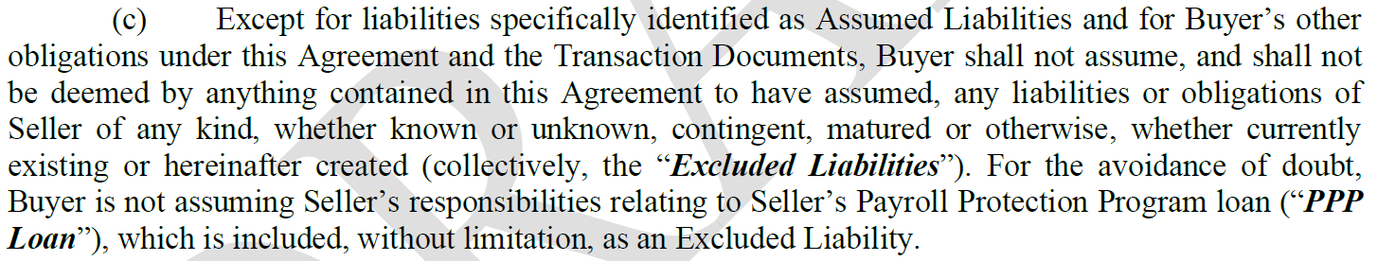

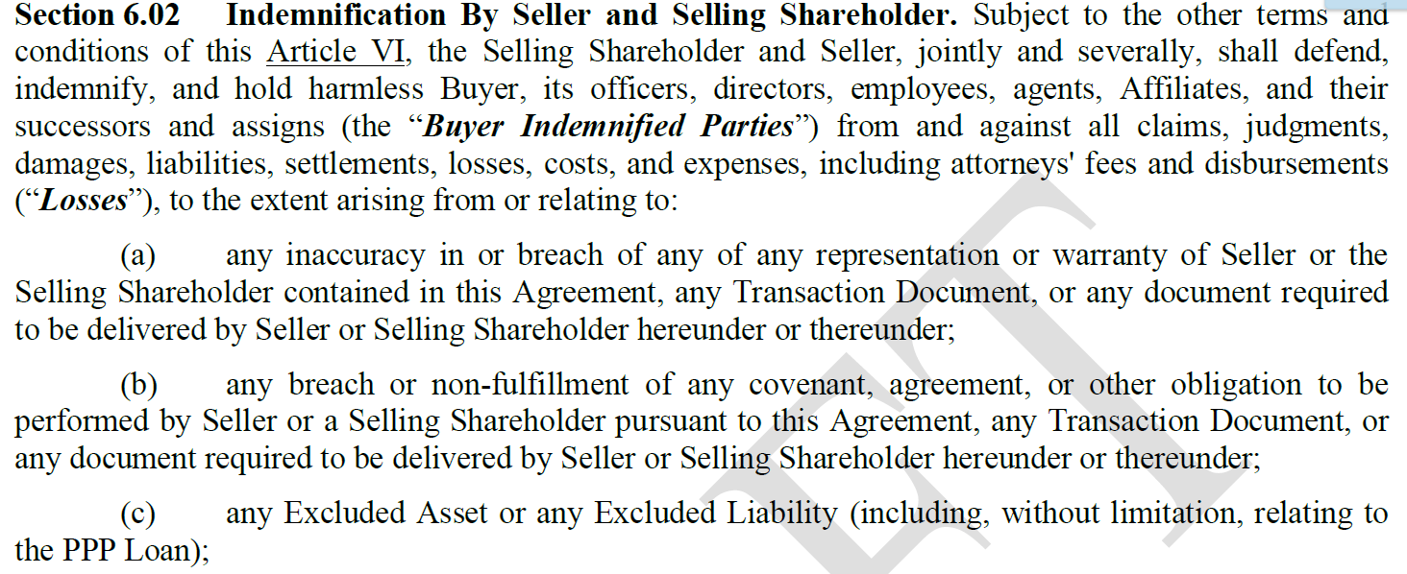

NTD: Indemnity Escrow to be released in 12 months per the Escrow Agreement.
NTD: PPP Escrow to be released upon forgiveness of PPP loan by the SBA.

