LOOK HOW EASY IT HAS BECOME TO AFFORD MUSIC LESSONS
AT LIBERTY CHRISTIAN SCHOOL
THE PSALMS OF DAVID SCHOOL OF MUSIC HAS MADE IT EASIER TO AFFORD
ONLINE INSTRUMENTAL MUSIC LESSONS
INSTEAD OF PAYING $500.00 IN THREE PAYMENTS OF $200, $150 AND $150…
YES, YOU CAN PAY THE WHOLE ANNUAL TUITION ALL AT ONCE. $500.00
HOWEVER, A FAMILY CAN NOW MAKE PAYMENTS OF $100 FOR FIVE MONTHS
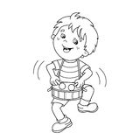
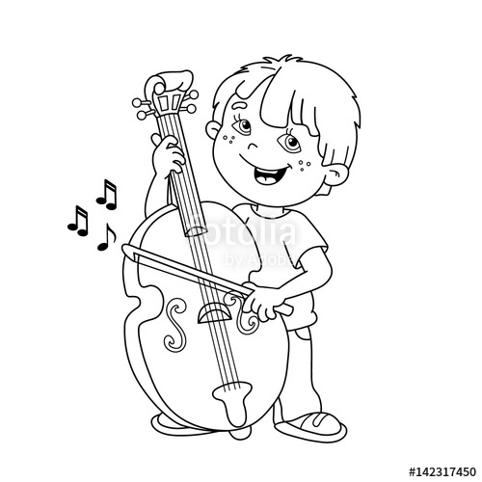
YOU JUST MAKE: 5 EASY PAYMENTS
SEPTEMBER 125.00
OCTOBER 125.00
NOVEMBER 125.00
DECEMBER 125.00
TOTAL $500.00
LESSONS WILL TAKE PLACE ONLINE WEEKDAY AFTERNOONS FROM 4-6 PM. EACH WEEK YOUR CHILD WILL RECEIVE ONE TWENTY MINUTE PRIVATE LESSON. GRADES 1-2 KEYBOARD ONLY
TUESDAY, WEDNESDAY, THURSDAY
KEYBOARD, GUITAR, BASS, DRUMS, TRUMPET, SAXOPHONE, CLARINET, VIOLIN, VIOLA, CELLO
FOR MORE INFORMATION CONTACT DAVID L FIELDINGS davidfieldings@yahoo.com / text 443 519 8658
------------------------------------------------------------------------------------------------------------------------------------------
PARENT NAME __________________________ STUDENT NAME ____________________________
INSTRUMENT ____________________________ AGE/GRADE _______________________________
EMAIL __________________________________ CELL ______________________________________

LESSONS BEGIN ON SEPTEMBER 15- THE SECOND WEEK OF SCHOOL

