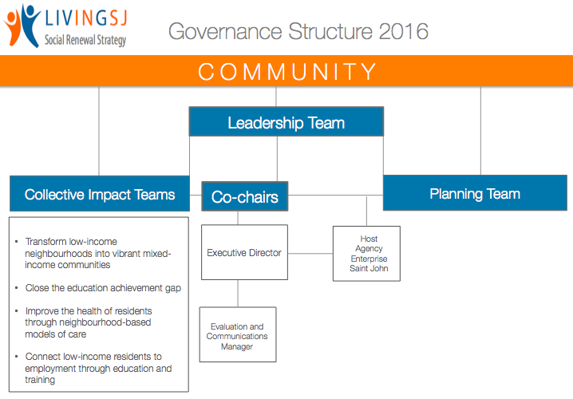

LIVING SJ LEADERSHIP TEAM: TERMS OF REFERENCE

Living SJ is the shared vision and unprecedented action plan that will transform low income neighbourhoods, close the education achievement gap, improve the wellbeing of our citizens and invest in our workforce. Living SJ will focus on longer-term “break the cycle” solutions that are sustainable, comprehensive and holistic in approach.

The Living SJ Leadership Team will provide strategic and collaborative guidance in the implementation of the five-year social renewal strategy for Greater Saint John.

Key Responsibilities:
The Living SJ Leadership Team will ensure the governance, partnerships and resources are in place to support Living SJ. Their role is to:
- Provide strategic and collaborative guidance in the implementation of Living SJ;
- Endorse the strategies of the four Collective Impact Teams;
- Monitor metrics and achievements for each priority area;
- Identify opportunities with local and provincial priorities and plans;
- Promote capacity of the community to engage in collaborative actions;
- Champion policy development or renewal;
- Ensure accountability is in place with the community through the communication of progress and results; and
- Approve annual budget and leverage resources and investments.

Membership
Members of the Leadership Team are senior level representatives drawn from the three levels of government, philanthropic organizations, community and non-profit organizations, neighbourhoods, educators, and the business sector (See attached). Co-chairs of the collective impact teams are also members of the Leadership Team.

Time commitment for Leadership Team
Members are encouraged to be involved in different opportunities to support the work of Living SJ including ad hoc committees around evaluation, communication, and policy development. All the members are asked to commit to:
- Quarterly meetings
- Two to four hours a month, in meetings or reviewing documents;
- Minimum two-year commitment.

Co-Chairs of the Leadership Team
The Co-Chairs will provide strategic advice and guidance to the Leadership and Planning Teams and will serve as the public voice to the community.

Key Responsibilities
- Chairs Leadership Team;
- Strategic engagement with stakeholders;
- Executive Director reports to Co-Chairs;
- Spokesperson to the media;
- Provides overall strategic guidance in the implementation of Living SJ;

Time commitment for Co-Chairs
- Minimum of two years;
- Approximately six hours a month.
Living SJ Leadership Team
Business
- Introhive, David Alston, Chief Innovation Officer
- Business Community Anti-Poverty Initiative, Brice Belyea, Board member*
- Delta Hotel, Paulette Hicks, General Manager, and Co-Chair of Living SJ
- Enterprise SJ, Steve Carson, Chief Executive Officer
- Keir Consulting, Jack Keir, President, and Co-Chair of Living SJ

Provincial and Municipal Government
- City of Saint John, Mayor Don Darling
- City of Saint John, John MacKenzie, Councillor*
- City of Saint John, Jacqueline Hamilton, Commissioner, Growth & Community Development
- City of Saint John, Phil Ouellette, Executive Director, Office of the City Manager
- Federal MP, Saint John-Rothesay, Wayne Long
- Town of GrandBay-Westfield, Grace Losier, Mayor
- Horizon Health Network (Community Health & Extra Mural), Dawn-Marie Buck, Director*
- Horizon Health Network, Scott Crawford, Regional Lead Community Development*
- Horizon Health Network & Dalhousie Medicine New Brunswick, Dr. Sarah Gander, Pediatrician
- Horizon Health Network (Mental Health), Sue Haley, Director*
- NB Economic & Social Inclusion Corporation, Stephane LeClair, Executive Director
- NB Department of Justice and Public Safety, Bruce Kingston, Regional Director
- NB Department of Post-Secondary Education, Training and Labour, Paul Graham, Acting Regional Director
- NB Department of Social Development, Dan Cameron, Regional Director
- Provincial MLA representative, Matt Garnett for Minister Doherty

Education
- New Brunswick Community College, Chris Toole, Regional Director*
- Anglophone School District South, Zoe Watson Superintendent*
- University of New Brunswick – Saint John, Robert MacKinnon, Vice-President
- University of New Brunswick – Saint John, Tracey Chiasson, VP office

Philanthropic, Non-Profit and Community Organizations and Neighbourhoods
- Association Regionale de la Communauté francophone de Saint-Jean, Michel Côté, General Manager
- Greater Saint John Community Foundation, Mike Murphy, Chairperson
- Greater Saint John Community Foundation, John Travis, Vice-Chairperson
- Human Development Council, Brian Stephenson, Board Member
- Neighbourhood Action Group, Penni Eisenhauer, Chair, Community Developer *
- Neighbourhood Leader and Community Activist, Juanita Black
- New Brunswick Childrens Foundation, Marilyn Lester, Board Chair
- P.U.L.S.E. (People United in the Lower South End), Mary LeSage, Operations Manager
- RiverCross Church, John Knight, Community Outreach Pastor
- Saint John Boys & Girls Club, Amy Shanks, Executive Director
- Saint John Learning Exchange, Christina Fowler, Executive Director*
- United Way Serving Saint John, Kings, Charlotte Counties, Tanya Chapman, Chair
*Co-chair of Collective Impact Team

