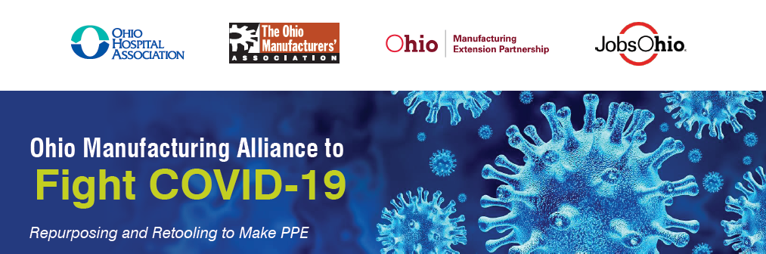

FOR IMMEDIATE RELEASE CONTACT
August 13, 2020 Paul Vetter
(614) 406-4968
Paul.vetter@fahlgren.com
Ohio Manufacturing Alliance Achieves Another Success in Fight Against COVID-19

Ohio manufacturers are collaborating to produce millions of masks
to meet domestic demand throughout Ohio

COLUMBUS, OHIO – Gov. Mike DeWine announced today that the Ohio Manufacturing Alliance to Fight COVID-19 (The Alliance) is collaborating with Buckeye Mask Company and Stitches USA to produce millions of high-quality, cotton face masks to help combat the COVID-19 pandemic.

The companies initially came together through the Alliance to make more than one million masks per month, helping Ohio to meet the continued demand from health care, businesses, public workers and individuals. The Alliance helped identify a new way to mass produce the masks using automation, and at the height of the pandemic invested with the help of JobsOhio in newly designed equipment. This automated equipment will eclipse the state’s original project of manual sewing 150,000 masks per week to 100,000 masks per day. This is the first example of reshoring an Ohio product, at a cost-competitive price, that would otherwise be made overseas.

Eric Burkland, president of The Ohio Manufacturers’ Association, said, “Throughout the pandemic, Ohio manufacturers have shown their ability and willingness to pivot to retool and repurpose their operations to help meet the immediate need for Personal Protective Equipment (PPE) and other products needed in the fight against COVID-19. The innovation and responsiveness of our manufacturers and their supply chains will be critical to the current and long-term recovery of our state.”

Buckeye Mask and Stitches USA are based in Cleveland and Walnut Creek, respectively. The Manufacturing Advocacy and Growth Network (MAGNET), a key partner in the Alliance, has helped the companies by connecting suppliers and providing engineering support to design the equipment, increase efficiency, reduce costs, and pave the way for reshoring. MAGNET is a non-profit consulting group helping manufacturing grow in northeast Ohio as part of the Ohio Manufacturing Extension Partnership (MEP).

“This exemplary reshoring project, which involves companies that normally would be competitors now working together with the State of Ohio, highlights the potential for Ohio manufacturers to pull together quickly in private-public partnerships to make a life-saving difference in battling COVID-19 and make products locally that are just as cost-effective as foreign-produced masks,” said Ethan Karp, president and CEO of MAGNET, “This is Ohio at its best. This shows how technology and our existing manufacturing
base will continue to grow and recapture revenue that is currently in countries like China. It takes collaboration, entrepreneurism and sometimes a leap of faith, but we can do this and so much more.”

Both companies also received funding through an Ohio Retooling and Repurposing Grant administered by the Ohio Development Services Agency. The program helps small- and medium-sized Ohio manufacturers repurpose existing facilities to make PPE or reshore PPE production to Ohio.

“Our priority is to help Ohio businesses and the people of Ohio,” said Development Director Lydia Mihalik. “These funds will help businesses weather the current crisis and keep Ohio workers on the job.”

JobsOhio, another Alliance partner, is assisting Stitches USA with a $1.2 million loan and Buckeye Mask with a $1.8 million loan to ensure they were the first U.S. companies to obtain advanced machinery to mass produce cotton masks. Stitches USA and Buckeye Mask operate six and nine machines, respectively. At full capacity, their mask production is competitive with Chinese facilities.

For more information, visit RepurposingProject.com.

###

