The ALS Team Gives Back!
Posted by The ALS Group on Dec 14, 2020 12:27:44 PM
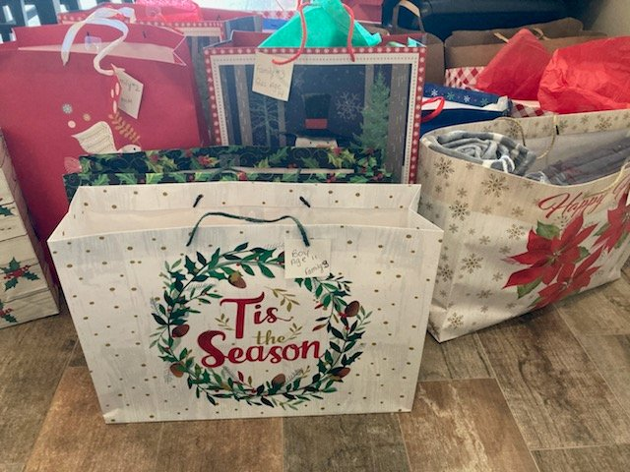
The ALS Team partnered with Bridges of Hope, Staten Island to collect and donate gifts for families who are coping with a particularly difficult holiday season.
Bridges of Hope was started by Grace Murphy in 1998 as a parish social-action outreach effort to create a “bridge” between the community and families in public housing.
They accept donations of clothing, household goods, toys, and school supplies all year round, but during the holiday season in particular, they take care of the wish lists of the families in the program, so that no child is left without gifts.
The volunteers who work at this organization have kindly given us the wish lists of 3 families in the program, for which we purchased dozens of gifts, essentials, toys, and clothing. We thank the ALS Team who, year after year, enthusiastically and fruitfully contribute to our giving initiatives.
The ALS Group participates in several charitable events throughout the year and is committed to giving back to the community. We are so proud and honored to have generous team members who so graciously support our giving goals!
Have a Happy and Healthy Holiday Season!
If you need more information on any of the topics covered in this blog, contact Jessica Aviles, VP of Talent Management, at Javiles@thealsgroup.com or if you need help with any risk related issues please contact Albert Sica, Managing Principal, at 732.395.4251 or asica@thealsgroup.com.
Topics: The ALS Group, 2020 Holiday Season, Happy Holidays, Bridges of Hope Staten Island, Giving

