NAIFA Social Media Posts
NAIFA has teamed up with AARP to share the award-winning interactive training platform that empowers #FinancialAdvisors to protect investors and save your #FinancialServices firm money. Learn more: www.aarp.org/banksafe

[Embed NAIFA sizzle reel]

Protect your senior investors from financial exploitation. See how AARP’s award-winning (and free!) #BankSafe Training can help financial advisors better prevent financial exploitation from happening at your firm: www.aarp.org/banksafe

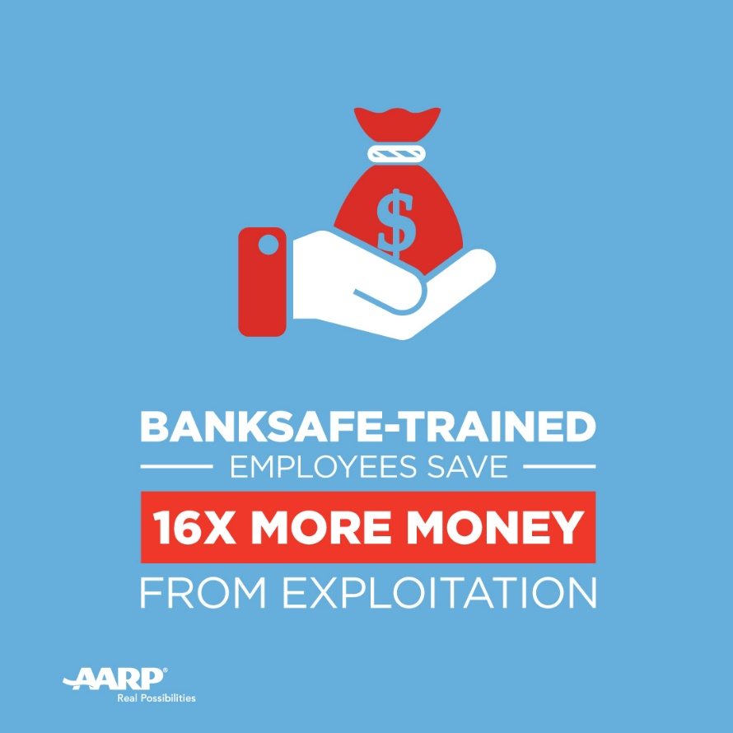
Empower your advisors to spot exploitation and stop it in its tracks with the new AARP #BankSafe training, designed specifically for #FinancialAdvisors: www.aarp.org/banksafe

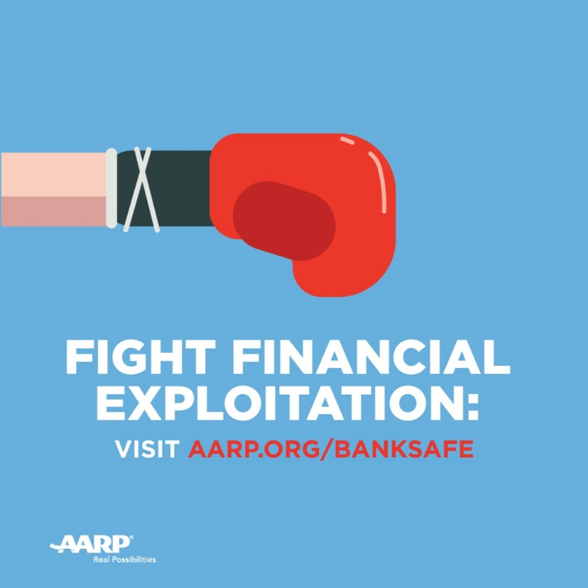

AARP’s #BankSafe Training has already saved over $16 million from #FinancialExploitation. What’s your firm doing to protect your senior #investors? Sign up for the free training today: www.aarp.org/banksafe

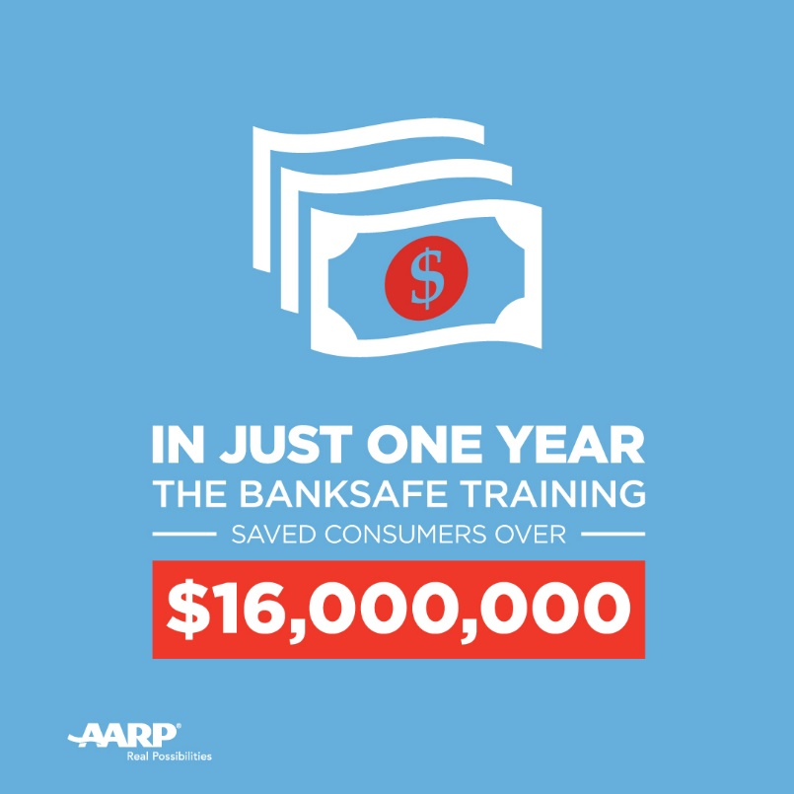
AARP’s #BankSafe Training gives #FinancialAdvisors the knowledge, skills and confidence to stop the financial exploitation of older Americans. Join the fight today: www.aarp.org/banksafe

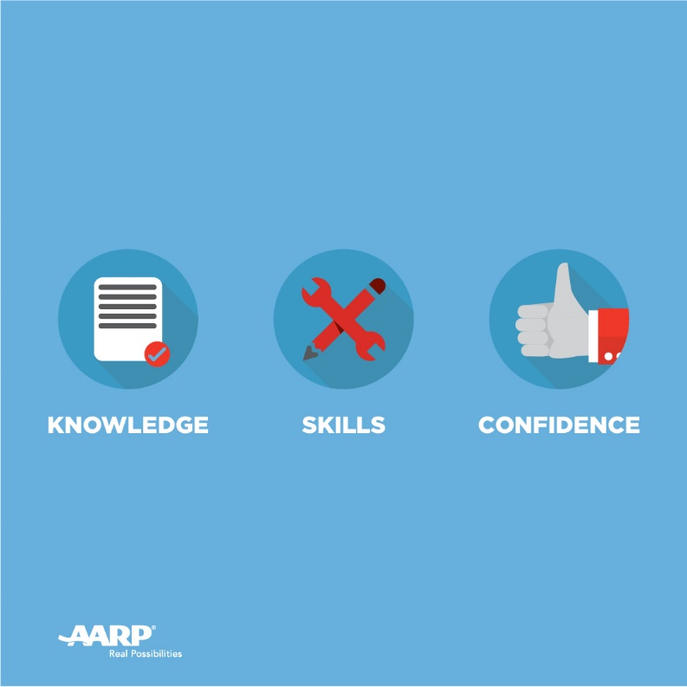

Preferred Hashtags
#BankSafe
#FinancialAdvisors
#FinancialServices
#FinancialExploitation
#investors

