Anthony M. Kurta

Leidos Vice President/Strategic Account Executive, Health and Human Performance
Senior Fellow, CNA Corporation
Volunteer Official, Navy Federal Credit Union
Board, 11th Hour Service

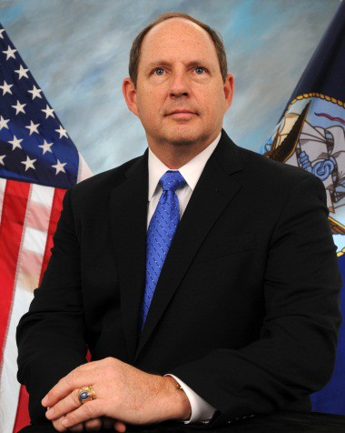
Tony Kurta joined Leidos in August, 2019 after more than 40 years of service, in an out of uniform. Prior to joining Leidos Health, as a member of the Senior Executive Service, he performed the duties of both Under Secretary and Deputy Under Secretary of Defense for Personnel and Readiness in the Department of Defense, where he was the principal staff assistant and advisor to the Secretary and Deputy Secretary of Defense for Total Force Management as it relates to force readiness; National Guard and Reserve component affairs, DoD-VA collaboration; transition to Veteran programs; military health affairs; training; and personnel requirements and management. Kurta was also the Deputy Assistant Secretary of Defense for Military Personnel Policy from 2014 to 2019.

A native of Columbia Falls, Montana, he graduated with merit from the U.S. Naval Academy in 1981, earned an M.A. in National Security Studies from Georgetown University, is a distinguished graduate of the Air Command and Staff College, and was a National Security Fellow at the John F. Kennedy School of Government at Harvard University.

Kurta’s career includes over 32 years on active duty as a Navy Surface Warfare Officer, during which he commanded USS Sentry (MCM 3), USS Guardian (MCM 5), USS Warrior (MCM 10), USS Carney (DDG 64), Destroyer Squadron Two Four and Combined Joint Task Force, Horn of Africa (CJTF-HOA). As CJTF-HOA, his command included Active and Reserve officers and enlisted, Navy, Army, Marines, Air Force, Special Operations, National Guard, inter-agency and coalition personnel. Shore assignments included: Chief, Special Actions Division on the Joint Staff; Director, Surface Officer Distribution Division (Pers-41) at the Navy Personnel Command; Director for Policy, Resources and Strategy for U.S. Naval Forces Europe and Africa; and Director, Military Personnel Policy (N13) on the OPNAV Staff. He retired from the Navy in 2013 as a Rear Admiral.

He has also served as a Senior Leader in the Department of the Navy from December 2013 through September 2014 as the Director of Navy Flag Officer Management and Development where he was responsible for flag officer community management and executive development.

His awards include the Distinguished Service Medal, Defense Superior Service Medals, Legions of Merit, Meritorious Service Medals, Department of Defense Distinguished Civilian Service Award, and the Secretary of Defense Meritorious Civilian Service Award.

He is married to the former Maria Vidro, a native of San Juan Capistrano, California. They have a future retirement home in Whitefish, Montana.

