- To register, visit the Armed Services YMCA Fort Bragg website at: https://www.asymca.org/fort-bragg-home. Then click on the “My ASYMCA” Tab at the top.
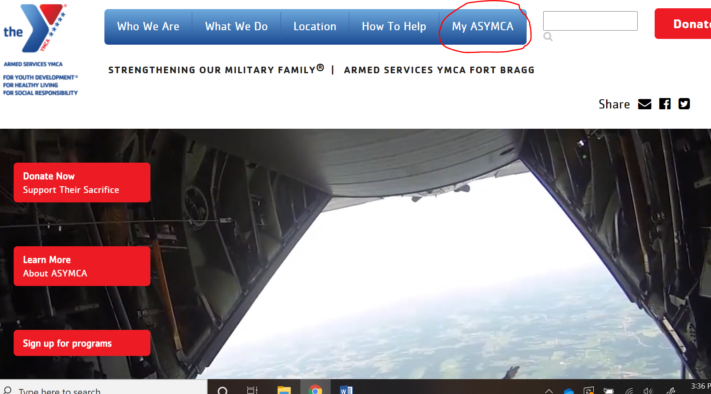
- Scroll down to the “volunteer” button and then click on the word volunteer itself.
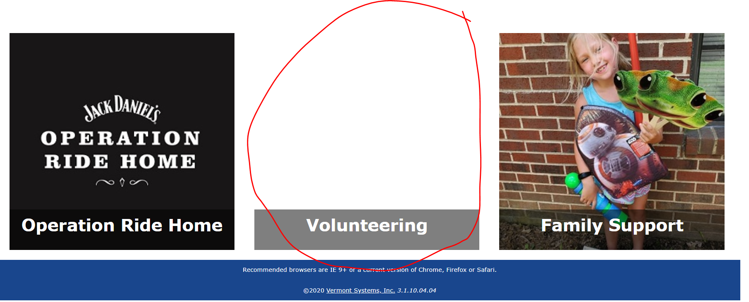
- To search for Volunteers, under the “Category” click “All Categories” and then select the search button in the bottom left corner.
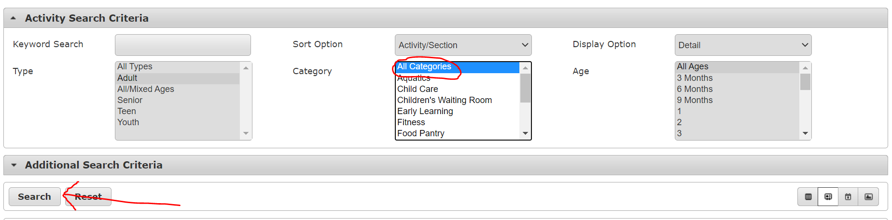
- Scroll to the Volunteer program and then click the green “+” button next to the only listed option. You will then be prompted to “add to cart”.
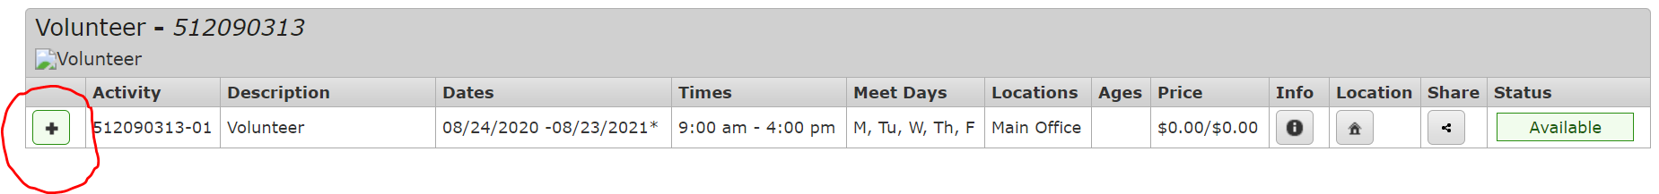
- Once added to cart, you will be promoted to log in.
  - If you have an existing account with us, log in. Your user name is your email. The very first time you log in your password is your zip code.
  - If you do not have an account with us, you will need to create one.
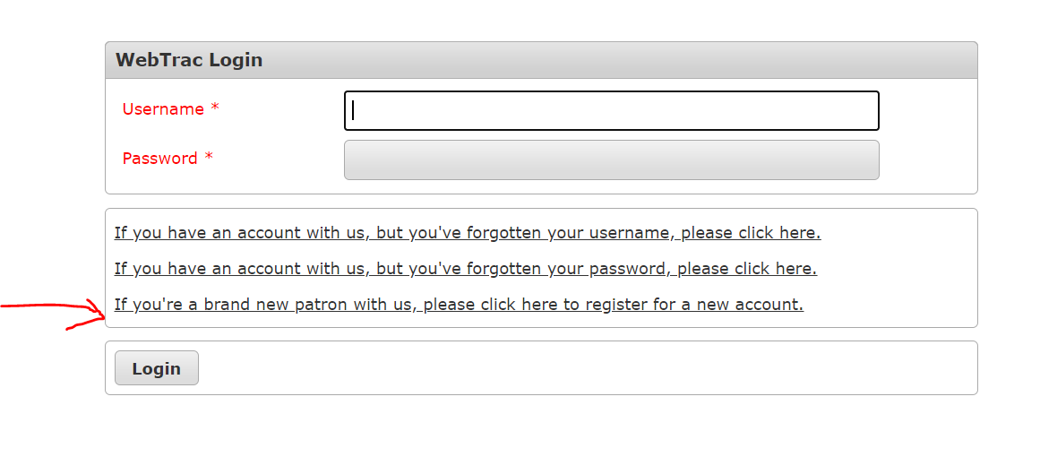
- Once logged in – you will need to complete any sections in Red. Those are required to continue the purchase. Save once you have completed/updated your information.
- From there you will be able to check out after answering a couple of required questions related to the program itself.
- Once you complete the questions, you will receive a confirmation email to register.

