- To register, visit the Armed Services YMCA Fort Bragg website at: https://www.asymca.org/fort-bragg-home. Then click on the “My ASYMCA” Tab at the top.
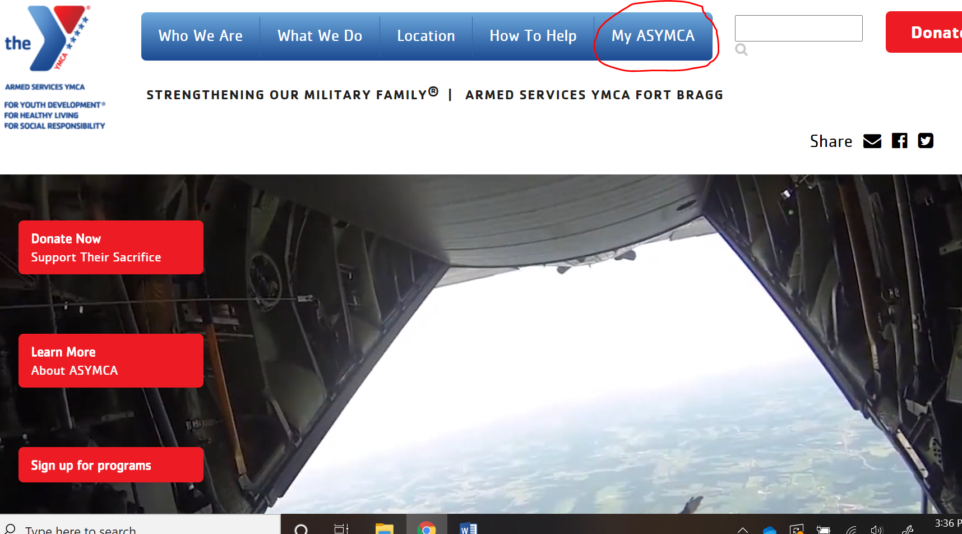
- Scroll down to the “Operation Kid Comfort” Image and then click on the image itself.
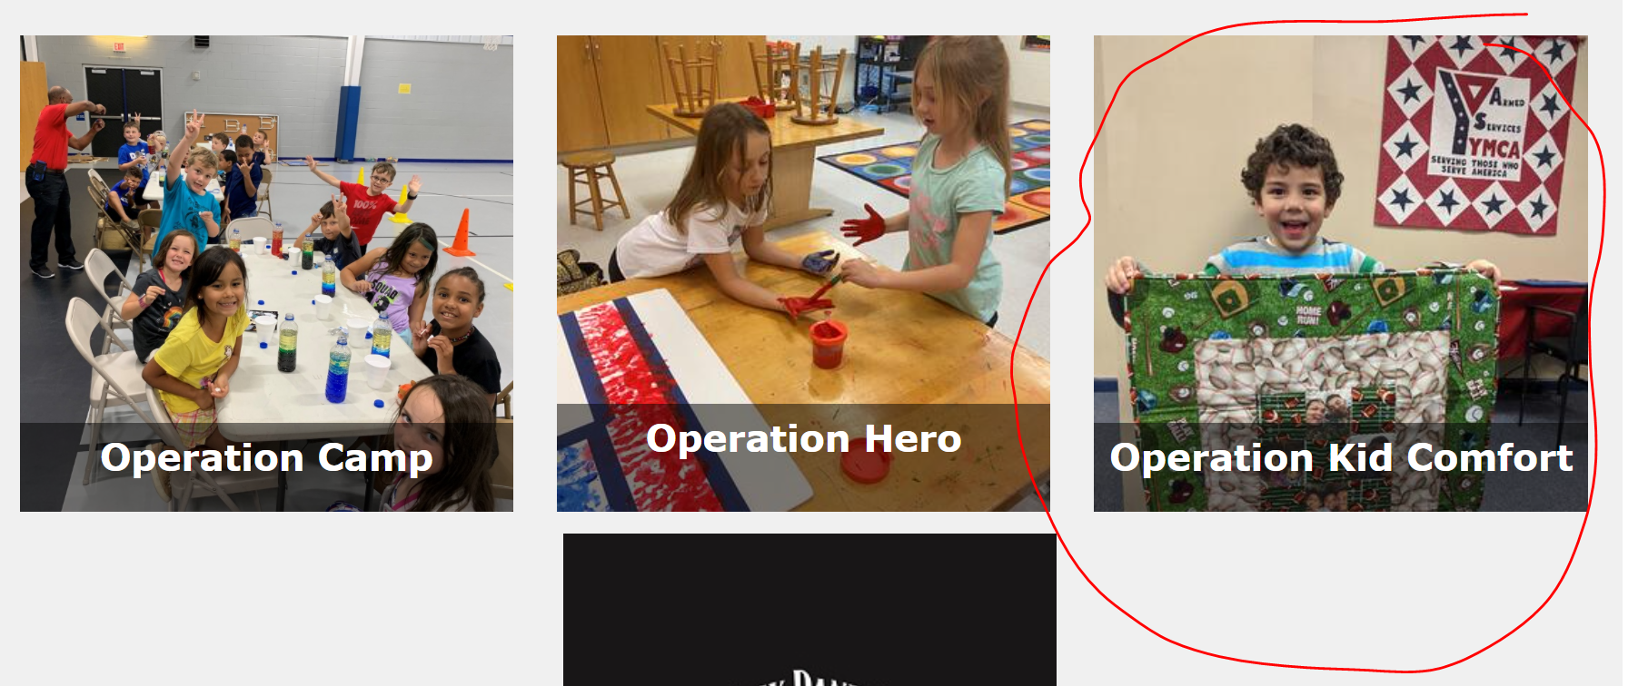
- To search for Operation Kid Comfort, under the “Category Section” click “All Categories and then select the search button in the bottom left corner.
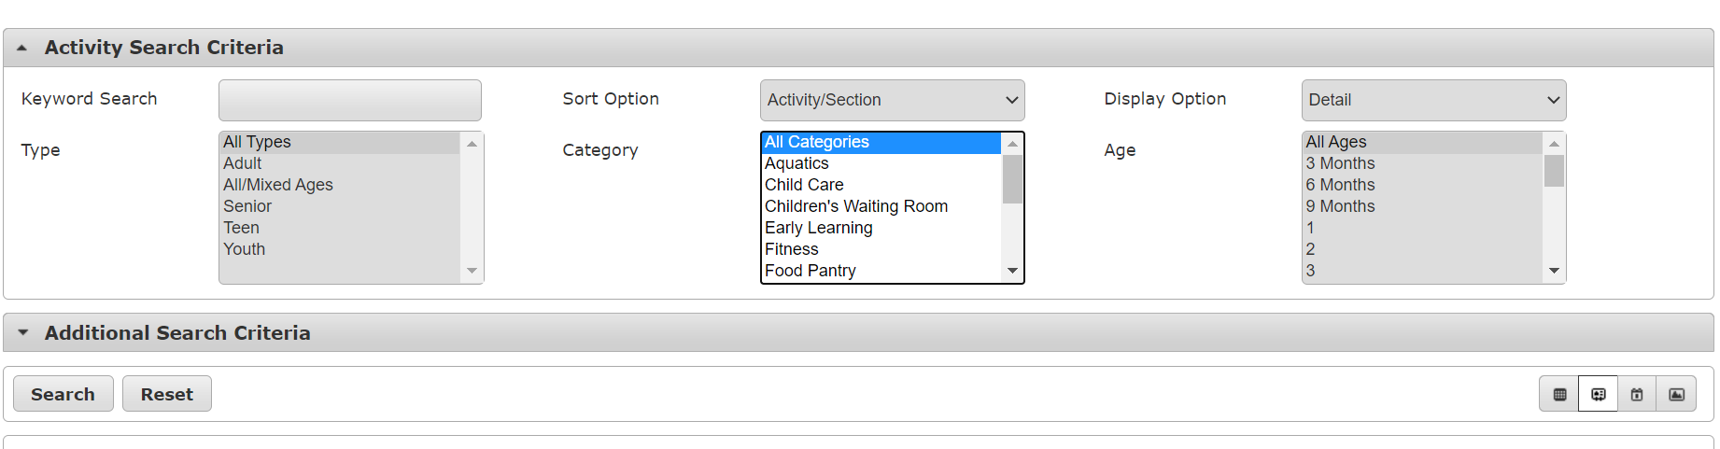
- Scroll to the Operation Kid Comfort program and then click the green “+” button in the bottom left corner. You will then be prompted to “add to cart”.
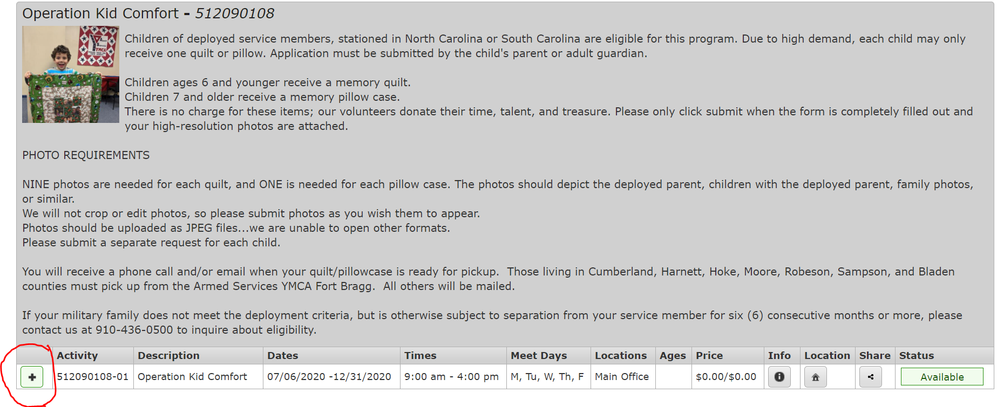
- Once added to cart, you will be promoted to log in.
  - If you have an existing account with us, log in. Your user name is your email. The very first time you log in your password is your zip code.
  - If you do not have an account with us, you will need to create one.
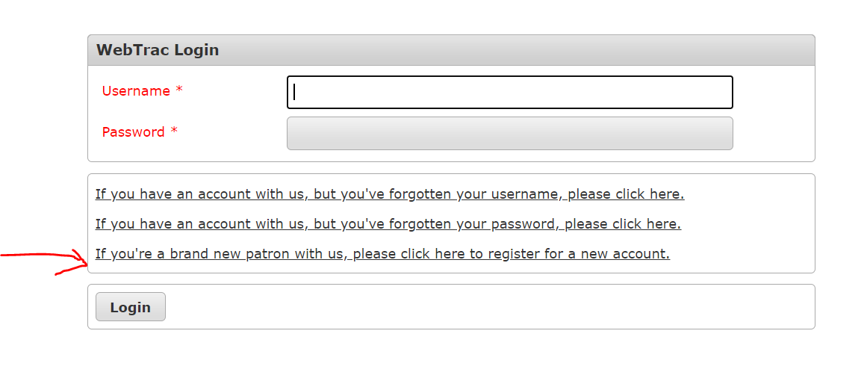
- Once logged in – you will need to complete any sections in Red. Those are required to continue the purchase. Save once you have completed/updated your information. Please be sure to add your child(ren) as family members for the program as you will be registering the child for the program – not yourself.
- From there you will be able to check out after answering a couple of required questions related to the program itself.
- Once you complete the questions, you will receive a confirmation email of your child’s registration. Within a few days of registration you will receive an email from CBenick@asymca.org with information on how to email photos and/or any questions we might have regarding your registration.
At any time if you have questions, please call our office at 910-436-0500 or email cbenick@asymca.org.

