Parent Registration Process:
How to create a RECTRAC account- Brand New Patron
- www.asymca.org/fort-bragg-home
- Go to MY ASYMCA on the tabs at the top
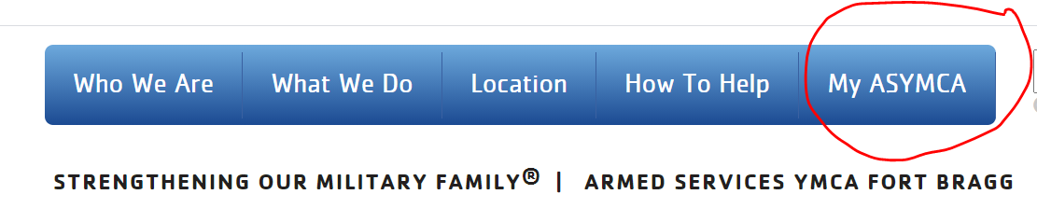
- Log in to your WebTrac account in the top right corner by clicking the login button
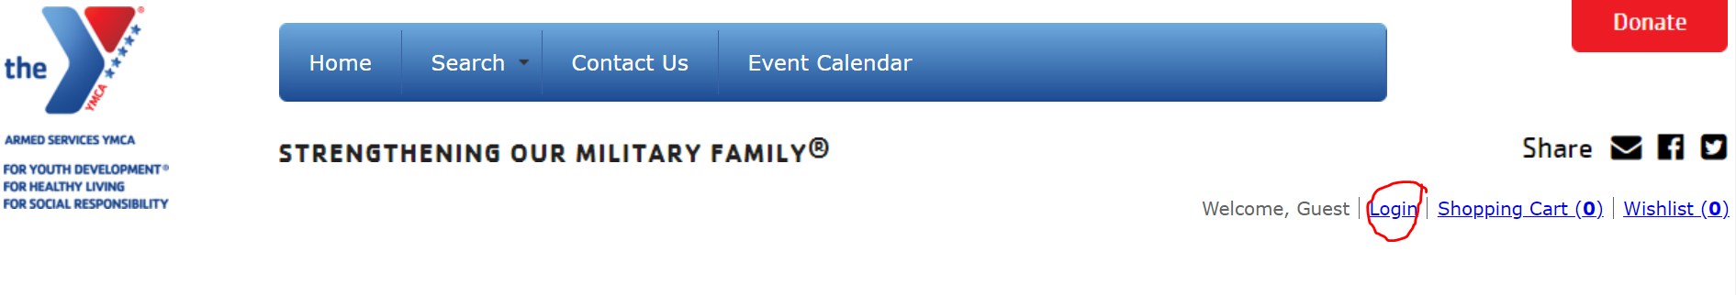
- Click “If you are a brand-new patron with us please click here to register for a new account”
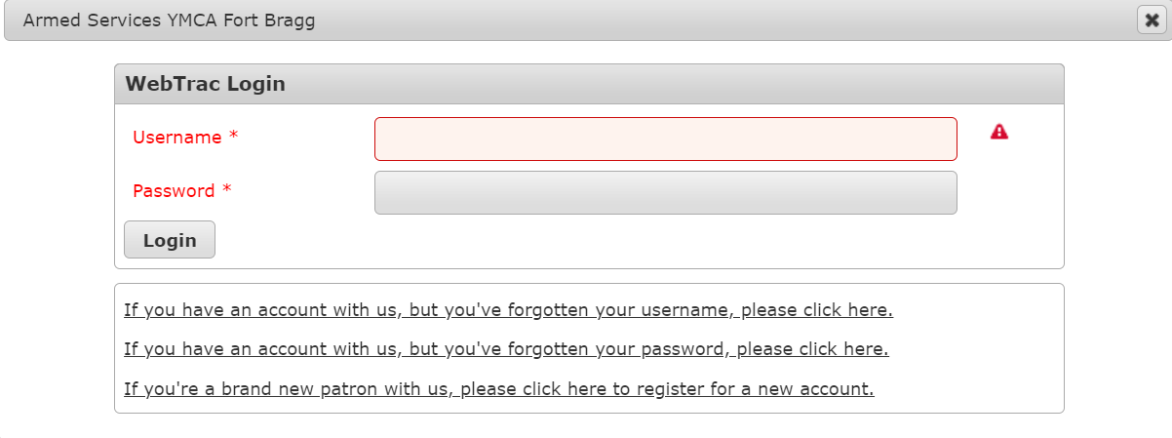
- Create a user name (email address recommended as your username) and password.
- Fill out the Household Primary Person information (this does NOT have to be the service member, but rather the parent who will be using the Children’s Waiting Room service.). Please note that items in red are required.
- Click Add New Member to add any children who will be using the Children’s Waiting Room. Fill out ALL information for that person. Email is not necessary for the child.
- Click SAVE when finished.
- Once the account is created, click the dropdown around under “My Account” tab at the top of the page and click the “Household & Member” under the “Update” heading.
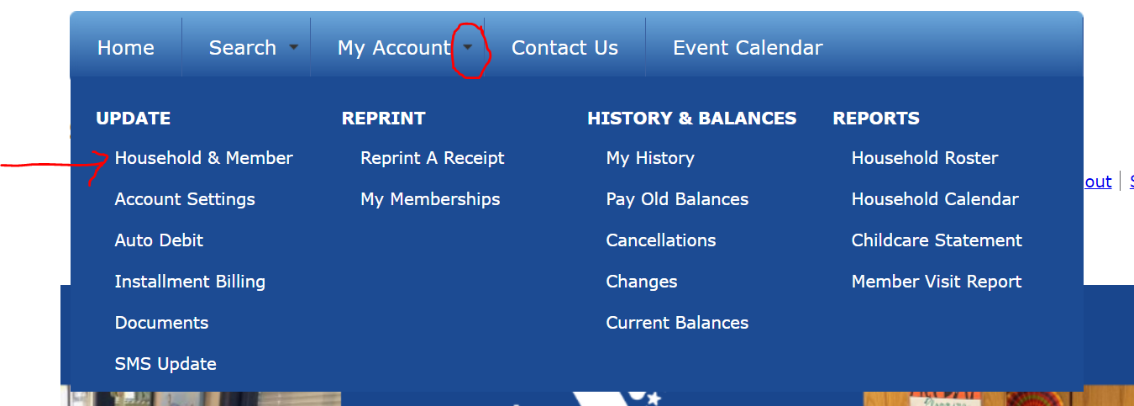
- Scroll to the bottom of the page and update the section “Emergency Contacts”. These should be the people we contact in the event of an emergency, so please verify that all contact information is correct and be sure to include phone number and relation to the family. You can add additional emergency contacts at this time.
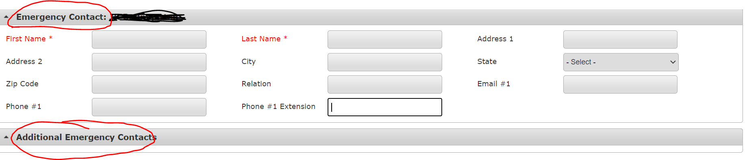
- Once completed, please press the save button at the bottom of the page.

How to sign up for Children’s Waiting Room (after account has been created)
- www.asymca.org/fort-bragg-home
- Go to MY ASYMCA on the tabs at the top
- Log in to your WebTrac account in the top right corner by clicking the login button
- Enter your username (email address associated with your account) and password. Click the login button. Once logged in you will be returned to the program screen.
- Scroll down to the Children’s Waiting Room image and click on the icon.
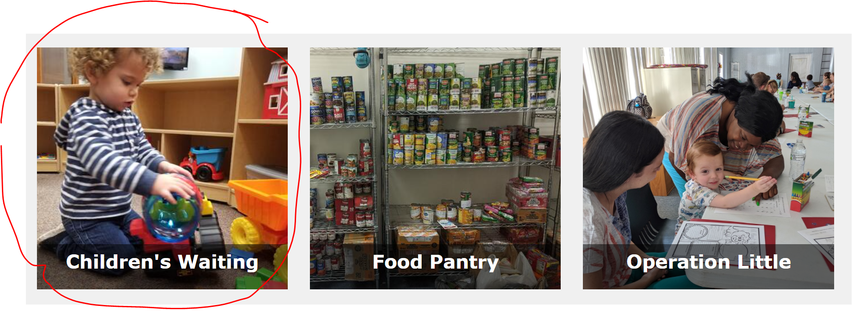
- Once on the registration page, scroll down to see search results.
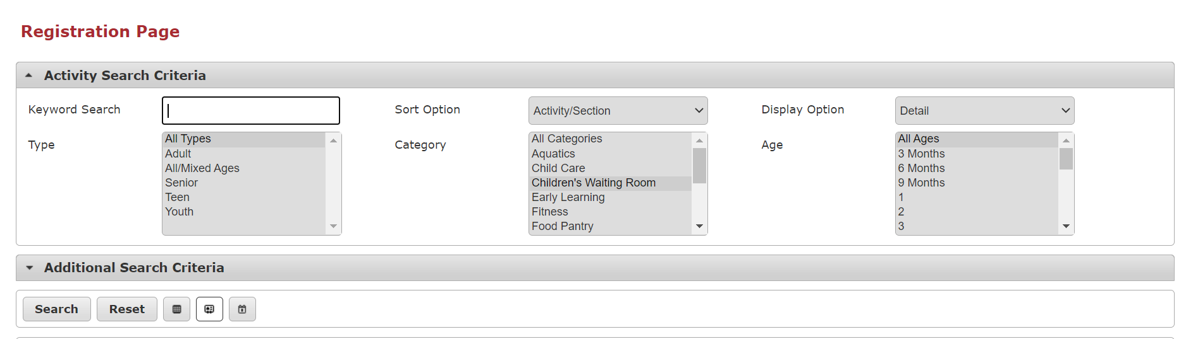
- Next to the activity # there is a plus icon. Click it to add Children’s Waiting Room to add it to your cart. Please note the activity number may differ from the example below.
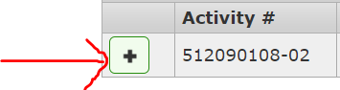
- A box will pop up at the bottom of your screen where you click to add it to your cart
- If you have multiple children, you will be prompted to select the child(ren) who will be utilizing the service. Please select all of those that apply by clicking the checkbox next to their name and then press the “continue” button.
- Answer the questions that appear, please note all questions in red are required to continue registration. All waivers are required to continue with participation in the program.
- Once you complete the required questions your shopping cart will update. If you are ready to complete the registration, select the “Proceed to Checkout” button.
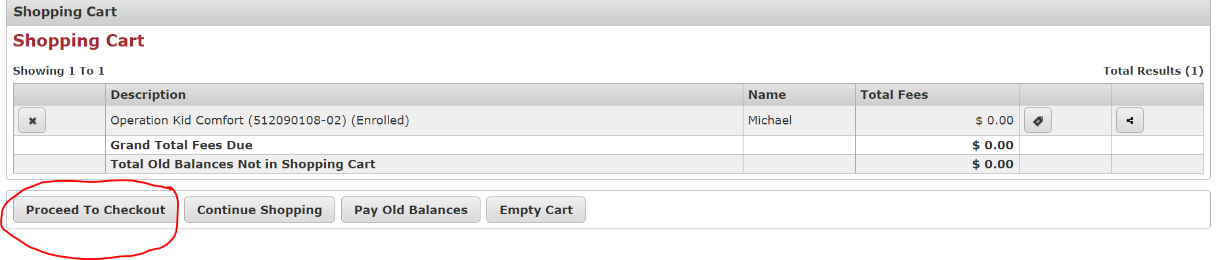
- Complete any billing information that appears (please note Children’s Waiting Room is a no-cost program). Then push the “Continue” button.
- A confirmation of your registration for the program will appear and you will have the option to enter additional email addresses you would like your confirmation receipt sent to. This screen confirms your registration in the program.

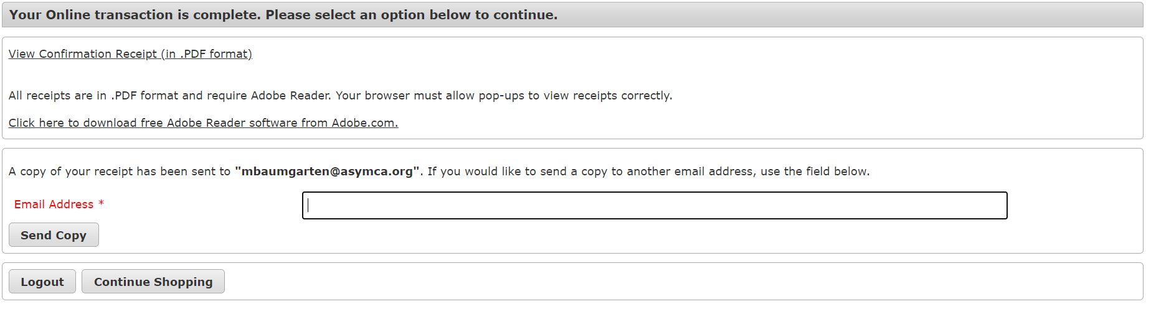
- You will be contacted to review your application and confirm information regarding the child(ren) utilizing the service from an Armed Services YMCA staff member. If you have any questions or do not hear from a staff member within 2 business days, please call our office at 910-436-0500.

