Sunday | Monday | Tuesday | Wednesday | Thursday | Friday | Saturday
 |  |  |  |  | 1 | 2
3 | 4 | 5 | 6 | 7 | 8 | 9
10 | 11  Columbus Day (US)  Indigenous Peoples’ Day  Thanksgiving (Canada) | 12 | 13 | 14 | 15 | 16
17 | 18 | 19 | 20 | 21 | 22 | 23
24 | 25 | 26 | 27 | 28 | 29 | 30
31

Halloween

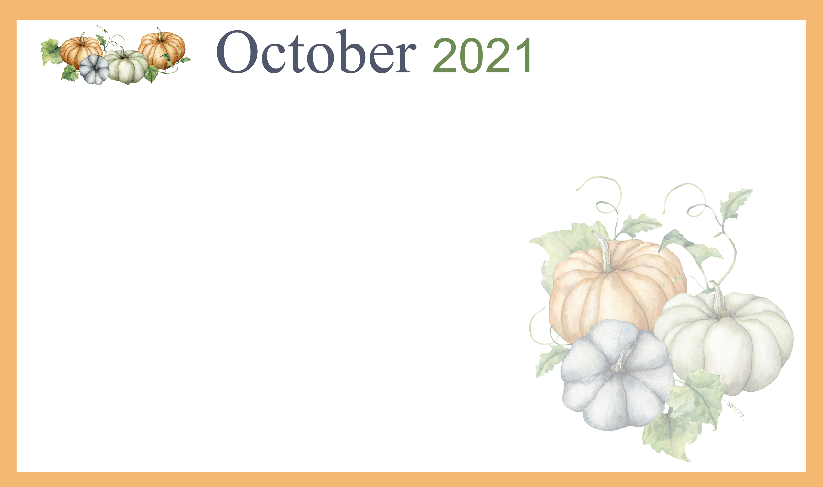  Care Activities |  |  |  |  | 10:00 Music W/ Doug Spartz  1:30 Games  2:30 Coffee Social  3:15 Trivia | 9:30 Walking Club  10:00 Nails  1:30 Residents Choice  2:30 Coffee Social  3:15 Card Club
10:00 Church  1:30 Residents Choice  2:30 Coffee Social/ Interactive Games | 9:45 Brain Teasers  10:30Grandma’s Bakery  1:30 Bingo  2:30 Coffee  3:15 Trivia | 9AM SPA DAY  1:30 Praise & Worship  2:30 Coffee/ Crafty Corner | 9:45 Walking Club  10:30 Scenic Drive  1:30 Bingo  2:30 Coffee Social  3:15 Card Games | 9:45 Exercise  10:30 Ladies Tea  1:30 Praise & Worship  2:30 Coffee Social  3:00 Communion  (ALN) | 9:30 Balloon Ball  10:30 Scenic Drive  1:30 Games  2:30 Coffee Social  3:15 Trivia | 9:30 Walking Club  10:00 Nails  1:30 Residents Choice  2:30 Coffee Social  3:15 Card Club
10:00 Church  1:30 Residents Choice  2:30 Coffee Social/ Interactive Games | 9:45 Brain Teasers  10:30Grandma’s Bakery  1:30 Bingo  2:30 Coffee  3:15 Trivia | 9:45 Exercise  10:30Men’s Sports Club  11 Lunch Club Outing  1:30 Praise & Worship  2:30 Coffee/ Crafty Corner | 9:45 Walking Club  10:30 Scenic Drive  1:30 Bingo  2:30 Coffee Social  3:15 Card Games | 9:45 Exercise  10:30 Ladies Tea  1:30 Praise & Worship  2:30 Coffee Social  3:15 Card Club | 9:30 Chair Yoga  10:30 Scenic Drive  1:30 Games  2:30 Coffee Social  3:15 Trivia | 9:30 Walking Club  10:00 Nails  1:30 Residents Choice  2:30 Coffee Social  3:15 Card Club
10:00 Church  1:30 Residents Choice  2:30 Coffee Social/ Interactive Games | 9:45 Brain Teasers  10:30Grandma’s Bakery  1:30 Bingo  2:30 Coffee  3:15 Trivia | 9:45 Exercise  10:30Men’s Sports Club  1:30 Praise & Worship  2:30 Coffee/ Crafty Corner | 9:45 Walking Club  10:30 Scenic Drive  1:30 Bingo  2:30 Coffee Social  3:15 Card Games | 9:45 Exercise  10:30 Ladies Tea  10:30 Walmart Outing  1:30 Praise & Worship  2:30 Monthly Birthday Music W/ Tim Mosser | 9:30 Parachute  10:30 Scenic Drive  1:30 Games  2:30 Coffee Social  3:15 Trivia | 9:30 Walking Club  10:00 Nails  1:30 Residents Choice  2:30 Coffee Social  3:15 Card Club
10:00 Church  1:30 Residents Choice  2:30 Coffee Social/ Interactive Games | 9:45 Brain Teasers  10:30Grandma’s Bakery  1:30 Bingo  2:30 Coffee  3:15 Trivia | 9:45 Exercise  10:30Men’s Sports Club  1:30 Praise & Worship  2:30 Coffee Social & Music w/ Rick and Loretta | 9:45 Walking Club  10:30 Scenic Drive  1:30 Bingo  2:30 Coffee Social  3:15 Card Games | 9:45 Exercise  10:30 Ladies Tea  1:30 Praise & Worship  2:30 Halloween Party | 9:30 Chair Yoga  10:30 Scenic Drive  1:30 Games  2:30 Coffee Social  3:15 Trivia | 9:30 Walking Club  10:00 Nails  1:30 Residents Choice  2:30 Coffee Social  3:15 Card Club
10:00 Church  1:30 Residents Choice  2:30 Coffee Social/ Interactive Games | Birthdays  2nd Joel  3rd Mike  20th Steve  28th Myrna

