SunBelievable™ Social Media Posts

HOW TO USE THESE POSTS: Use this copy as-is or add your own twist. Be sure to update the bracketed type in all caps or delete it before posting. Pair these posts with the images available on Garden Gateway at https://go.monrovia.com/shareable-content-for-retailers#gardengateway or take your own of your in-store displays. Please try to keep other branded plant material out of the shot and use your best photos. Please be sure to include the Monrovia hashtags and feel free to add your own. Need help or want to feature other Monrovia Plants? Contact Helen Lawson at helen.lawson@monrovia.com.

SunBelievable™ Sunflower
[THIS POST CAN BE SCHEDULED ANY TIME. TIME THE SEASONAL POSTS TO THE SEASONS IN YOUR AREA]
Thousands of flowers on one plant? Sounds unbelievable, but nope…. It’s SunBelievable™! We are so excited to feature this ultra-happy sunflower that keeps spreading sunshine from spring through fall. [OPTIONAL: MENTION AN EMPLOYEE AND WHY THEY LIKE IT/HOW THEY PAIR IT] #SunBelievableShinesOn #YearOfTheSunflower #MonroviaPlants #GrowBeautifully
Right-click the images to download and add to your post (don’t forget to resize for optimal appearance on each platform):
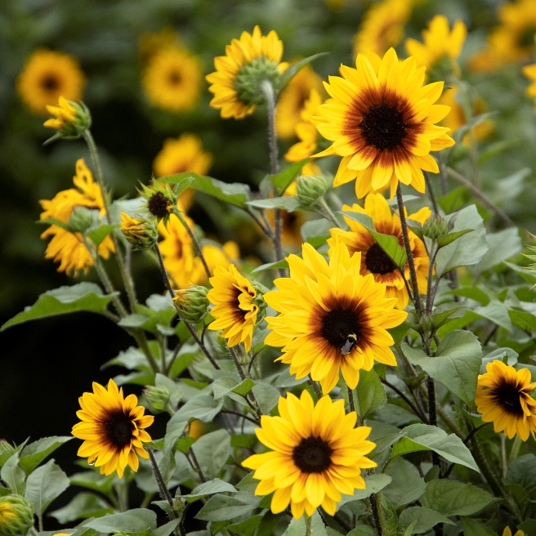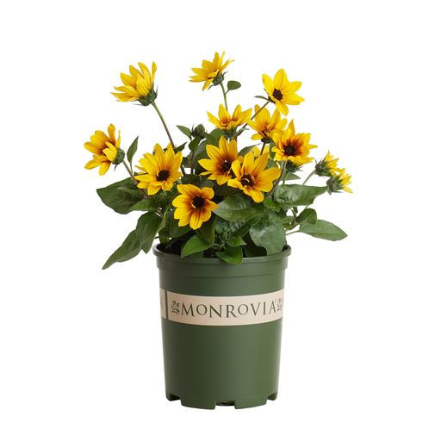

Spring
[PAIR WITH SUNBELIEVABLE-SPRING PICTURE]
We have your perfect all-occasion gift in stock now, ready for you to grab + go (but don’t forget the card!). SunBelievable™ Sunflowers are the cheeriest plant around, with thousands of sunny flowers (yes, really, thousands!) from now until frost. Pick some up and spread the sunshine! [OPTIONAL:] And yes, we are open on Mother’s Day weekend from [MOTHER’S DAY WEEKEND HOURS]! #SunBelievableShinesOn
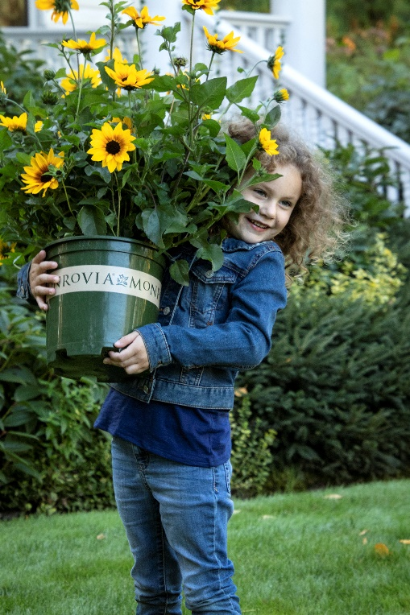

Summer
[PAIR WITH SUNBELIEVABLE-SUMMER PICTURE – OR TAKE YOUR OWN OF A SUMMER CONTAINER FEATURING SUNBELIEVABLE]
SunBelievable™ Sunflower stands up to heat AND stands out in the garden! 1000s of flowers from spring to frost with no summer slump (are you starting to see why @MonroviaPlants calls it SunBelievable™)? Grab a few [STORE HOURS] and bring some color back to your garden. #SunBelievableShinesOn
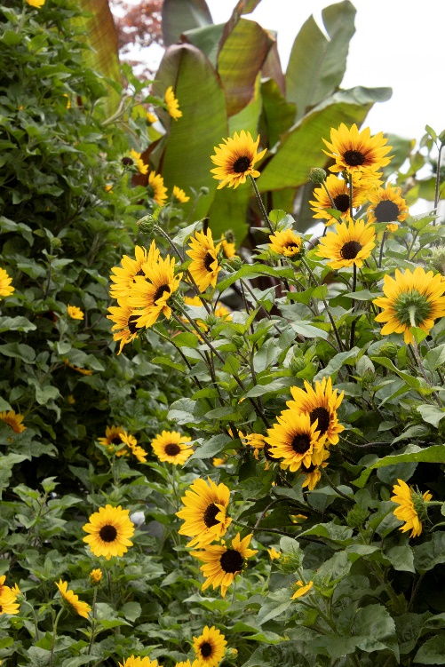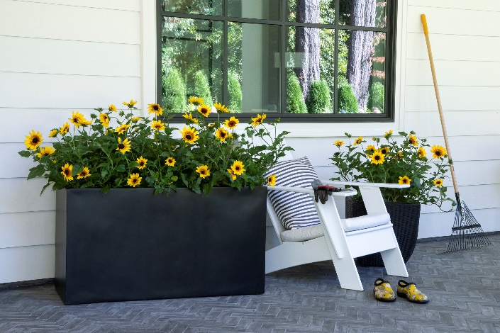

Fall
[PAIR WITH SUNBELIEVABLE-FALL PICTURE – OR TAKE YOUR OWN OF A FALL DISPLAY FEATURING SUNBELIEVABLE]
Feel that chill in the air? SunBelievable™ Sunflower is still shining on in our store! When you stop by to pick up your pumpkins [ADD ANY FALL EVENT INFO HERE], come have a look at how these brown-eyed beauties are giving our fall decor a fresh look. Then grab a few to dress up your own autumn arrangements! #SunBelievableShinesOn

