SunBelievable™ Retailer Toolkit

Newsletter & Email Content and Photos

Copy and paste this content into your newsletters and emails. Right-click the images to download a shareable photo. Please credit Monrovia.

Spring – use in april:
SunBelievable™ Spreads Sunshine
If you’re looking for the feel-good flower of the year, we’ve found it! SunBelievable™ Brown Eyed Girl Sunflower, exclusively from Monrovia, is the happiest way to spread sunshine. The National Garden Bureau has named 2021 as the Year of the Sunflower, noting that it’s a variety that everyone from first-timers to experienced gardeners can enjoy. SunBelievable offers 1,000 blooms that say, ‘Happy Mother’s Day,’ ‘Congratulations,’ and ‘You Mean the World to Me,’ over and over again.
Best of all, this plant does double duty, brightening any garden or container outdoors, and serving as a cut flower indoors. How does SunBelievable do it? Unlike typical seed-grown sunflowers that produce just a few blooms, SunBelievable doesn’t produce seed. This sunflower puts all its energy into blooming, providing plenty of flowers for enjoyment in the garden or in a bouquet.

Spring photo options
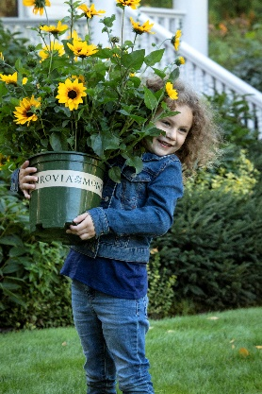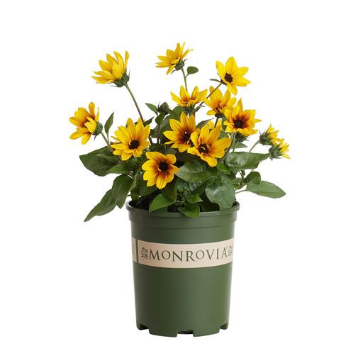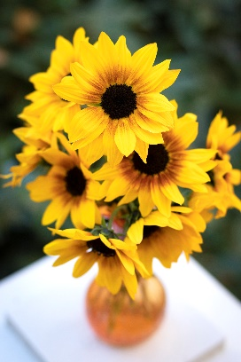

Summer – Send in June or July:
SunBelievable™ Shines On!
The heat of summer is no sweat for SunBelievable™ Sunflower. This annual from Monrovia is very heat tolerant, making it the perfect addition to full sun containers, sunny borders and other hot areas of the landscape. SunBelievable provides constant enjoyment, and consistent color even when other annuals fade. Because there are so many blooms on the plant, there are no worries about cutting a few for flower arrangements. Both the plant and your bouquets will shine on through summer’s warm weather.

Summer photo options
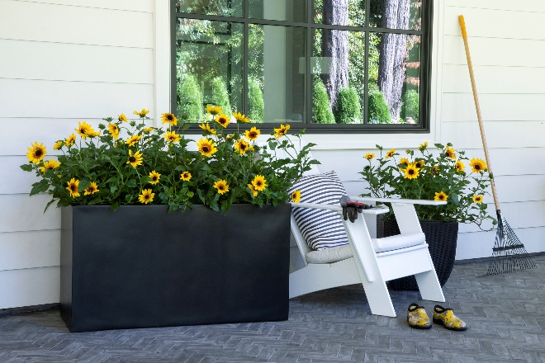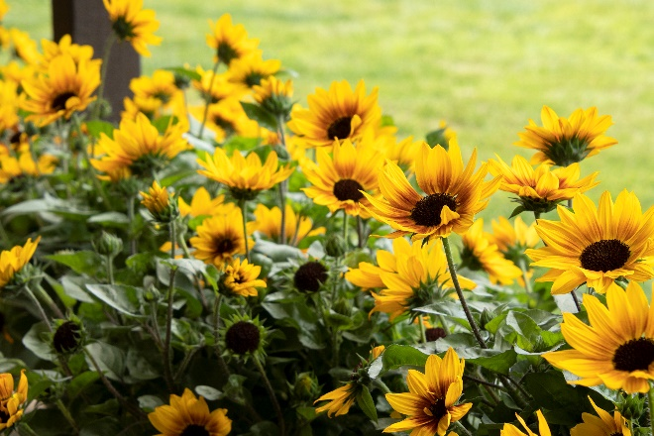

Fall – Use in September or October:
Months of Color with SunBelievable™
Move over mums! If you planted SunBelievable™ this spring, you can keep enjoying it as a fresh look for fall. If you missed picking up this sunny delight, it’s not too late to add it to your fall beds and containers!
SunBelievable™ Sunflower’s sunny yellow blooms surround beautiful deep-brown centers, offering the perfect color palette for fall. In fact, the cooler nights enhance the hues of the foliage and bloom centers, bringing warm fall tones to the garden. SunBelievable, available only from Monrovia, pairs perfectly with pumpkins, hay bales and other fall décor, creating welcoming front porches, entrance ways and table-scapes. You’ll get bushels of flowers from one plant well into fall, for a fresh look to your autumn arrangements.

Fall photo options
