2022 Special Plant Campaigns

Copy and paste these messages to use in your own campaigns
Contents
How to use these in your own marketing: 1
Seaside Serenade® Hydrangeas 1
Social posts 1
Newsletter/Email copy 3
Contest promos 4
Nitty Gritty™ Roses 4
Social Posts 4
Newsletter Copy 5
Evolution™ Coneflowers 6
Social media Posts 6
Newsletter copy 7
Contest promos 7
SunBelievable™ Sunflowers 7
Social posts 7
Newsletter Copy 8
Contest promos 9

How to use these in your own marketing
- Download the shareable photos from Monrovia here: DROPBOX
- Copy and paste the text you’d like to use from this document.
- Add these to your social media feeds, newsletters and emails, websites, and other 2022 marketing pieces.
- Look for upcoming contests to share with your customers, including the Bee a Winner Pollinator Plant giveaway in June.

Seaside Serenade® Hydrangeas

Social posts
Download our shareable images and select the post copy options you like best to create your own social media posts.
Post #1
Get the hydrangea you’ve always wanted. Monrovia’s exclusive Seaside Serenade® Hydrangea Collection brings all the improvements you’ve been looking for (we’re talking sturdy stems, reblooming flowers, no-prune sizes, and wilt-free leaves), plus so many beautiful choices. Pick the one that’s perfect for you (we can help)!
#GrowConfidently #MonroviaPlants #SeasideSerenadeHydrangeas
Post #2
Hand-picked for success in your garden: Seaside Serenade® Hydrangeas have what always wanted in a hydrangea. These new-and- improved hydrangeas have a more compact, bushy growth habit, sturdier stems, thicker leaves, returning blooms, and longer-lasting flowers than other hydrangea varieties. They are great on their own or in mass in formal gardens or as a focal point in containers. And their cut blooms are lovely in a vase. Exclusively from @MonroviaPlants, and in stock for you now!
#GrowConfidently #MonroviaPlants #SeasideSerenadeHydrangeas
Post #3
Be ready to show off! Seaside Serenade® Hydrangeas are here, exclusively from @MonroviaPlants. Lots of colors and varieties to fit your style, and all the breeding improvements to keep them looking good. Come in and see for yourself…
#GrowConfidently #MonroviaPlants #SeasideSerenadeHydrangeas
Post #4
Front-yard worthy hydrangeas are here, exclusively from @MonroviaPlants. These are the ones you’ll love to show off all summer, while you kick back and relax. Come on in and pick your favorite Seaside Serenade® Hydrangea while we still have them in stock.
#GrowConfidently #MonroviaPlants #SeasideSerenadeHydrangeas
Post #5
Designer-quality Seaside Serenade® Hydrangeas from @MonroviaPlants, now available to grow in your own garden. These are the hydrangeas the pros go to when they want something special. We are amazed by the range of colors, flower styles, and easy-care qualities in this series, and think you will be, too.
#GrowConfidently #MonroviaPlants #SeasideSerenadeHydrangeas
Post #6
Excuse us while we sing the praises of Seaside Serenade® Hydrangeas.… We chose to carry this exclusive series from @MonroviaPlants to offer you the best performing hydrangeas in lots of stunning varieties. Reblooming mopheads, lace caps, and even those big white Annabelle-type snowballs, but on sturdy stems that won’t flop. Come on in and let us tell you more!
#GrowConfidently #MonroviaPlants #SeasideSerenadeHydrangeas

Newsletter/Email copy
Get the hydrangeas you’ve always wanted
The Seaside Serenade® Hydrangeas (Zones 4-9) exclusively from Monrovia are here, just in time for you to create your easiest, breeziest garden yet.
These are all reblooming hydrangeas with everything you’ve been looking for:
- Bold, long-lasting flowers from now until fall
- Compact sizes to fit your garden—or even a container
- Thick, wilt-free leaves
- Sturdy stems that won’t flop (and are great in a vase)
Yet each has its own distinctively different, front yard-worthy good looks. See which ones are in stock now to create your own summer seaside retreat at home!
[Insert images/names of the varieties you have in stock:]
Seaside Serenade® Newport Hydrangea – A mophead variety with big, striking flowers that are a deep plum in acidic soils or a more vibrant pink in alkaline soils.
Seaside Serenade® Martha’s Vineyard — Long-lasting, sumptuous pink-red mophead blooms that are not influenced by soil pH. Flowers develop a lovely green tinge as they age.
Seaside Serenade® Cape Lookout – Enjoy the color show as the large flowers emerge pale green, then open to bright white before aging to a soft pink hue. A tetraploid variety with long-lasting blooms, sturdy stems, and beautiful foliage that turns a lovely bronze in fall.
Seaside Serenade® Outer Banks – Delicate lacecap blooms smother this compact hydrangea. Blooms blue in acidic soils and more pink in alkaline.
Seaside Serenade® Hamptons — Features large, color-saturated deep-pink blooms that stand out against large, leathery leaves and last through hot summer days. The foliage has a hint of maroon in spring and turns amber-red in fall.
Seaside Serenade® Cape May — Very large lacecap blooms stand tall, supported by strong, extra thick stems. Flowers will be blue in acidic soils, and more pink in neutral to alkaline soils. Serrated leaves show touches of red and burgundy in the sun as they age.
Seaside Serenade® Cape Cod — A hardy, repeat blooming machine for small spaces with big, mophead flowers, extra-dark green leaves, and a neat, mounded form.
Seaside Serenade® Fire Island — Bi-color blooms of white with rosy-red to deep pink edges really catch the eye.
Seaside Serenade® Bar Harbor Hydrangea — The crisp white snowball look of an Annabelle hydrangea on compact, sturdy stems that won’t flop. Zones 3-8.

Contest promos
Invite your customers to create their own seaside retreat at home. Monrovia’s Easy Breezy Seaside contest will let customers know a relaxing getaway is right in their own backyard with Seaside Serenade Hydrangeas. Your followers can enter by commenting on our post to let us know which is their favorite Seaside Serenade hydrangea. The post will go live March 24 – be ready to share our post to your story (just click the little “paper airplane icon”) to let your customers know about this great giveaway. A winner will be drawn on March 26, so don’t miss the chance to get the word out. If your customer wins, we’ll be sure to include you in the celebration!

Nitty Gritty™ Roses

Social Posts
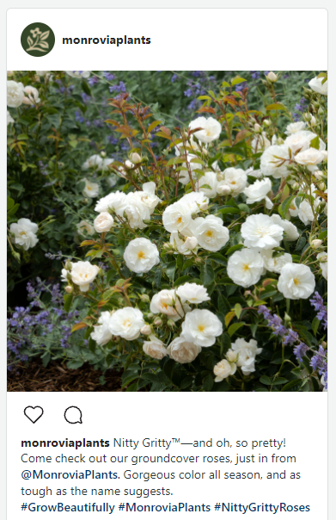
Download our shareable images and select the post copy options you like best to create your own social media posts.
Post #1
Nitty Gritty™—and oh, so pretty! Come check out our groundcover roses, exclusively from @MonroviaPlants. Gorgeous color all season, and just as tough as the name suggests.
#GrowBeautifully #MonroviaPlants #NittyGrittyRoses
Post #2
Talk about an elegant solution. Nitty Gritty™ Roses, exclusively from @MonroviaPlants, solve all sorts of landscape problems, like an unsightly slope, with beauty and style. Come in to see the gorgeous colors we have in stock—but hurry, these will go fast!
#GrowConfidently #MonroviaPlants #NittyGrittyRoses
Post #3
Instantly upgrade your garden with roses! Nitty Gritty™ Roses, exclusively from @MonroviaPlants, are everything you’ve always loved about roses—now on the easiest, toughest, and most reliable groundcover rose ever. Drought tolerant, heat and disease resistant, and no pruning required. Just lots and lots of luscious color!
#GrowConfidently #MonroviaPlants #NittyGrittyRoses
Post #4
Always wanted a rose garden? This is the weekend to start—and finish! Nitty Gritty™ Roses are the no-fuss way to add the beauty of roses without the work. We have them in stock now—but probably not for long. Come in and let us help you pick the colors you like for a garden you’ll love.
#GrowConfidently #MonroviaPlants #NittyGrittyRoses
Post #5
Can you grow roses in containers? You sure can! One of our favorites to try, with its low, spreading shape and repeat flowering now until fall, are the Nitty Gritty™ Roses from @MonroviaPlants. Come in to check out the colors we have in stock and get our ideas for what to pair with them. We can even help you find the right size container!
#GrowConfidently #MonroviaPlants #NittyGrittyRoses

Newsletter Copy
Nitty Gritty™ — and oh, so pretty!
This low-growing groundcover rose stands head and shoulders above the others!
We know you’re looking for beautiful plants that solve your landscape problems. That’s why we chose to offer the Nitty Gritty™ Roses, exclusively from Monrovia, at the garden center this spring.
First, look at those colors!
[Insert images/names of the varieties you have in stock]
Next, know that these are exceptionally disease resistant. Nitty Gritty Roses are own-root roses, not grafted, so they’re as sturdy in tough conditions as you’d expect from their name.
The low-spreading shape on these graceful shrubs lets you cover a lot of ground (but the roots won’t run or sucker, so no worries it will overstep its place). Instead, look forward to a lush garden full of flowers on leafy green plants.
Finally, look forward to a season-long show of color. Nitty Gritty Roses are covered in blooms, then bloom again, repeating from late spring until frost.
Hurry in for the best selection—these are sure to sell quickly. While you’re here, ask us which perennials grow best with roses. [OPTIONAL] A few we suggest: [INSERT IMAGES OF COMPANION PLANTS YOU CARRY]
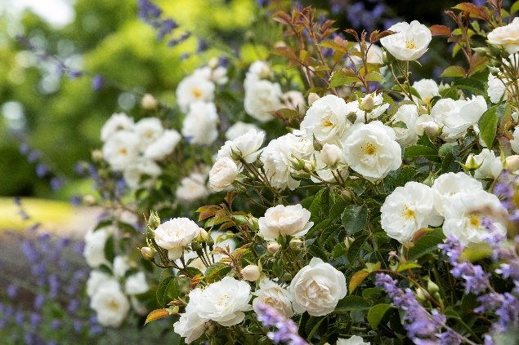
[OPTIONAL SIDE BAR OR EXTRA COPY] Design tip: With their sprawling, spreading shape and long bloom time, these roses work as well in containers as they do as a groundcover. Check out Monrovia’s Be Inspired blog for tips on growing Nitty Gritty Roses in containers (and ideas for what to plant with them). https://www.monrovia.com/be-inspired/best-roses-for-containers.html

Evolution™ Coneflowers

Social media Posts
Download our shareable images and select the post copy options you like best to create your own social media posts.
Post #1
What makes the Evolution™ Coneflowers series from @MonroviaPlants a favorite for pollinators?
Long-lasting nectar source from spring to fall
Wide flowers for an easy landing
Bright colors to attract them (hint: this works on people, too)
Post #2
Here’s your new cutting garden essential: the Evolution™ Coneflower series, exclusively from @MonroviaPlants, have bigger blooms and a tidier habit to make them a standout. See the colors and varieties we have in stock [insert pictures/variety names of the ones you carry]:
Evolution™ Colorific™ Coneflower
Evolution™ Fiesta Coneflower
Evolution™ Yellow Falls Coneflower
Evolution™ Embers™ Fever Coneflower
Evolution™ Embers™ Sparks Coneflower
Post #3
Sail through summer’s heat and drought with Evolution™ Coneflowers, exclusively from @MonroviaPlants and in stock at our garden center now. Lush foliage and sturdy upright stems, plus of course those big, bright flowers from now until fall, keep these drawing in the pollinators along with the compliments.

Newsletter copy
Pollinator Gardening, Perfected
Bring a sense of purpose—and lots and lots of pollinators—to your garden with Evolution™ Coneflowers.
What makes these flowers a favorite with bees, butterflies, and birds? Bright colors, season-long blooms, and a wide landing base make these an easy irresistible target for nectar lovers. Come fall, those flowers will feed seed-eating birds. The more you grow, the more wildlife you’ll attract!
The Evolution Coneflower series from Monrovia adds even more of these benefits to your pollinator garden, with long-lasting flowers that shift through an amazing range of color throughout the season.
And with flowers from spring until fall, there will be enough to spare to make beautiful bouquets, too. Make these your new cutting garden essentials, with bigger blooms and lush green leaves on strong, sturdy stems.
Flowers for you, flowers for friends, and flowers for all the creatures that love to call your garden home. We call that gardening well!

Contest promos
“Bee” in on the interest in pollinator gardening by participating in our “Bee a Winner” Pollinator Gardening Giveaway, exclusively for Monrovia retailers with a qualifying purchase of pollinator plants. You’ll receive 10 beautiful pollinator-friendly plants, plus full in-store and online marketing support, to offer customers a great start to their pollinator garden. Grow your customer loyalty and marketing database at the same time! Ask your Monrovia rep for details and sign up by April 1 to join in.

SunBelievable™ Sunflowers

Social posts
Download our shareable images and select the post copy options you like best to create your own social media posts.
Post #1
Spread sunshine, spring to fall, with SunBelievable™ Sunflowers! These feel-good flowers from @MonroviaPlants bloom and bloom (yes, you can really get 1000 with just one plant!) for months of color. Perfect for gifts or your own garden. Come get them while we still have them!
#MonroviaPlants #SpreadSunshine #SunBelievableShinesOn
Post #2
If you’re looking for the feel-good flower of the year, we’ve found it! SunBelievable™ Sunflowers, exclusively from Monrovia, is the happiest way to spread sunshine. Say, ‘Happy Mother’s Day,’ ‘Congratulations’ or ‘You Mean the World to Me’ over and over again with flowers from now until frost. Exclusively from Monrovia and available from us now!
#MonroviaPlants #SpreadSunshine #SunBelievableShinesOn

Post #3
Skip the summer slump with SunBelievable™ Sunflowers These cheery beauties from @MonroviaPlants don’t take a summer vacation—they keep pumping out the blooms through heat and humidity, and power on into fall.
#MonroviaPlants #SpreadSunshine #SunBelievableShinesOn

Post #4
Get a fresh look for fall with SunBelievable™ Sunflowers! This brown-eyed beauty, exclusively from Monrovia, pairs perfectly with your autumn décor. And with bushels of blooms, SunBelievable is also a hot new alternative to mums. Come see our in-store displays for ideas on how you can spice up your pumpkins with these!
#MonroviaPlants #SpreadSunshine #SunBelievableShinesOn

Newsletter Copy
Spread Sunshine With SunBelievable™ Sunflowers
If you’re looking for the feel-good flower of the year, we’ve found it! SunBelievable™ Sunflowers, exclusively from Monrovia, is the happiest way to spread sunshine. SunBelievable offers 1,000 blooms that say, ‘Happy Mother’s Day,’ ‘Congratulations’ and ‘You Mean the World to Me,’ over and over again.
Best of all, this bright bloomer does double duty, brightening any garden or container outdoors, and serving as a cut flower indoors. How does SunBelievable do it? Unlike typical seed-grown sunflowers that produce just a few blooms, SunBelievable doesn’t produce seed. This sunflower puts all its energy into blooming, providing plenty of flowers for enjoyment in the garden or in a bouquet.
SunBelievable also shines in in the heat of summer and well into fall, for summer color that just won’t quit and a fresh alternative to mums in autumn. With three seasons and three great reasons to grow SunBelievable, don’t miss your chance to grab some while they’re in stock!

Contest promos
Share our “Spread Sunshine” social media giveaway, going live April 28, to give your customers a chance to win a Shop Monrovia gift certificate.

