Adjusting the Check Date and Pay Period

When you click Run Payroll, you will see your calendar and the option to select a different pay period.
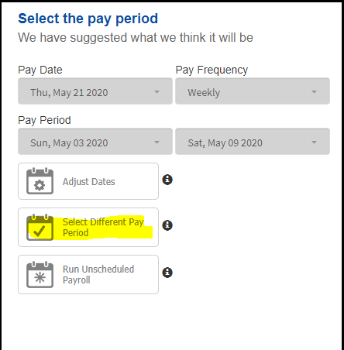

This will bring up your payroll calendar, where you can choose which check date you would like to process.
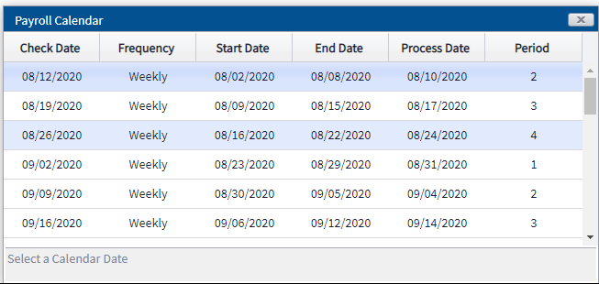
Once you have selected the pay period, you can click to change the Pay Date and Pay Period.

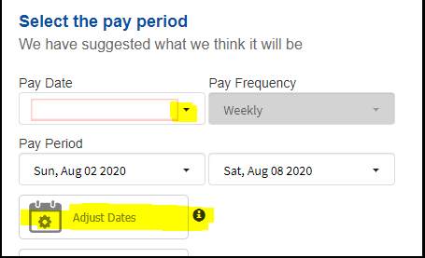

The Pay Date and Pay Period should now reflect your changes, and you can continue to create the payroll.

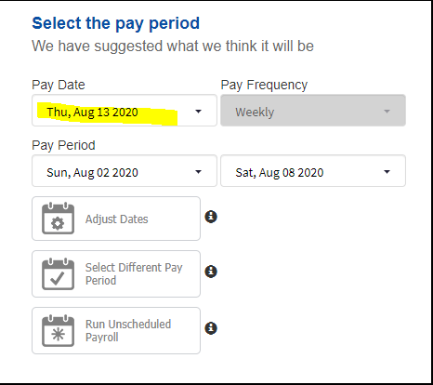

Note: please do not select Run Unscheduled Payroll, as this will open a payroll that is not connected to your payroll calendar.

